STANDARD WHII.6c
The student will demonstrate knowledge of scientific, political, economic, and religious changes during the sixteenth, seventeenth, and eighteenth centuries by
c) assessing the impacts of the English Civil War and the Glorious Revolution on democracy.

Essential Questions
How did the English Civil War and the Glorious Revolution promote the
development of the rights of Englishmen?

Essential Understandings
- Political democracy rests on the principle that government derives power from the consent of the governed. The foundations of English rights include the jury trial, the Magna Carta, and common law.
- The English Civil War and the Glorious Revolution prompted further development of the rights of Englishmen.

Essential Knowledge
Development of the rights of Englishmen
- Oliver Cromwell and the execution of Charles I
- The restoration of Charles II
- Development of political parties/factions
- Glorious Revolution (William and Mary)
- Increase of parliamentary power and decrease of royal power
- English Bill of Rights of 1689
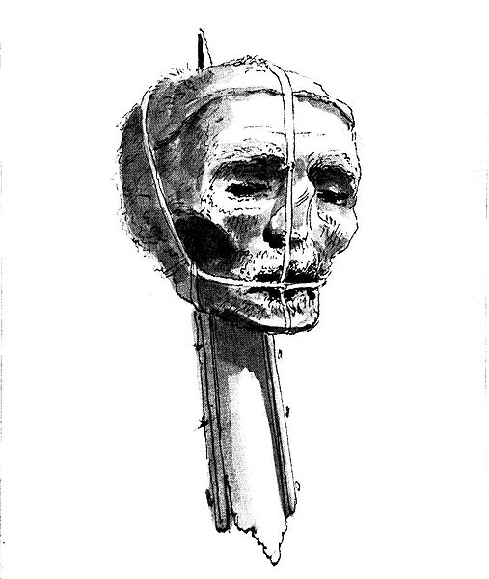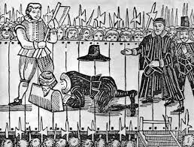
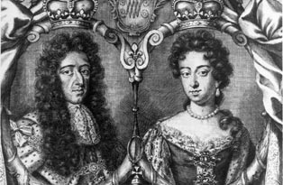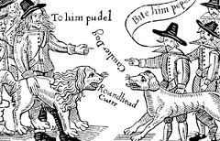
STANDARD WHII.6c
The student will demonstrate knowledge of scientific, political, economic, and religious changes during the sixteenth, seventeenth, and eighteenth centuries by
c) assessing the impacts of the English Civil War and the Glorious Revolution on democracy.

Essential Questions
How did the English Civil War and the Glorious Revolution promote the
development of the rights of Englishmen?

Essential Understandings
- Political democracy rests on the principle that government derives power from the __________ of the governed. The foundations of English rights include the _________ trial, the Magna Carta, and common law.
- The ___________________ and the ______________ Revolution prompted further development of the rights of Englishmen.

Essential Knowledge
Development of the rights of Englishmen
- ____________________ and the _____________ of Charles I
- The restoration of _______________________
- Development of ______________ parties/factions
- ______________ Revolution (____________________________)
- ___________ of parliamentary power and ____________ of royal power
- English ____________________ of 1689

