STANDARD WHI.6a) assessing the influence of geography on Roman economic, social, and political development.

- The city of Rome, with its central location on the Italian peninsula, was able to extend its influence over the entire Mediterranean Basin.

- The Italian peninsula was protected by the sea and the arc of the Alps mountains.

Locations and places
• Rome: Centrally located in the Mediterranean Basin and distant from eastern Mediterranean powers
• Italian Peninsula
• Alps: Protection
• Mediterranean Sea: Protection, sea-borne commerce

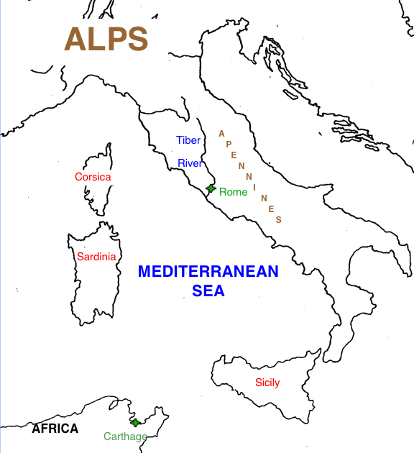
STANDARD WHI.6a) assessing the influence of geography on Roman economic, social, and political development.

- The city of _________, with its central location on the Italian _________, was able to extend its influence over the entire Mediterranean Basin.

- The _________peninsula was protected by the sea and the arc of the _________mountains.

Locations and places
• _________: Centrally located in the Mediterranean Basin and distant from eastern Mediterranean powers
• _________Peninsula
• _________: Protection
• ______________Sea: Protection, sea-borne commerce

