STANDARD WHI.5a
The student will demonstrate knowledge of ancient Greece in terms of its impact on Western civilization by
- assessing the influence of geography on Greek economic, social, and political development, including the impact of Greek commerce and colonies.

Essential Questions
How did the mountains, seas, islands, harbors, peninsulas, and straits of the Aegean Basin shape Greek economic, social, and political development and patterns of trade and colonization?

Essential Understandings
- The physical geography of the Aegean Basin shaped the economic, social, and political development of Greek civilization.
- The expansion of Greek civilization through trade and colonization led to the spread of Hellenic culture across the Mediterranean and Black seas.

Essential Knowledge
Locations and places

- Aegean Sea
- Balkan and Peloponnesus peninsula, Europe, Asia Minor
- Mediterranean Sea
- Black Sea, Dardanelles
- Athens, Sparta, Troy
- Macedonia

Economic and social development
- Agriculture (limited arable land)
- Commerce and the spread of Hellenic culture
- Shift from barter to money economy (coins)

Political development
- Mountainous terrain both helped and hindered the development of city-states.
- Greek cities were designed to promote civic and commercial life.
- Colonization was prompted by overpopulation and the search for arable land.

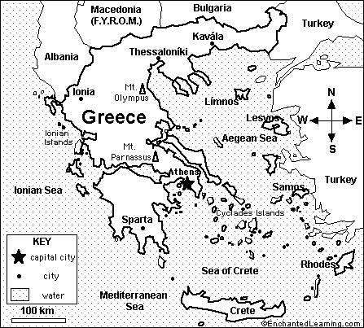

STANDARD WHI.5a
The student will demonstrate knowledge of ancient Greece in terms of its impact on Western civilization by
- assessing the influence of geography on Greek economic, social, and political development, including the impact of Greek commerce and colonies.

Essential Questions
How did the mountains, seas, islands, harbors, peninsulas, and straits of the Aegean Basin shape Greek economic, social, and political development and patterns of trade and colonization?

Essential Understandings
- The physical geography of the _________ ____________ shaped the economic, social, and political development of ______________ civilization.
- The expansion of Greek civilization through trade and colonization led to the spread of Hellenic culture across the _______________ and _____________ seas.

Essential Knowledge
Locations and places

- Aegean Sea
- Balkan and Peloponnesus peninsula, Europe, Asia Minor
- Mediterranean Sea
- Black Sea, Dardanelles
- Athens, Sparta, Troy
- Macedonia

Economic and social development
- Agriculture (limited ___________ land)
- Commerce and the spread of ____________ culture
- Shift from __________ to __________ economy (coins)

Political development
- Mountainous terrain both __________ and ___________ the development of city-states.
- Greek cities were designed to promote _________ and ________________ life.
- Colonization was prompted by __________________ and the search for ______ land.

