STANDARD WHI.10d) describing east African kingdoms of Axum and Zimbabwe and west African civilizations of Ghana, Mali, and Songhai in terms of geography, society, economy, and religion.
African civilizations developed in sub-Saharan west and east Africa.
Trade brought important economic, cultural, and religious influences to African civilizations from other parts of the Eastern Hemisphere.
States and empires flourished in Africa during the medieval period, including Ghana, Mali, and Songhai in west Africa, Axum in east Africa, and Zimbabwe in southeastern Africa.
Axum
• Location relative to the Ethiopian Highlands and the Nile River
• Christian kingdom

Zimbabwe
• Location relative to the Zambezi and Limpopo rivers and the Indian Ocean coast
• City of “Great Zimbabwe” as capital of a prosperous empire

West African kingdoms
• Location of Ghana, Mali, and Songhai empires relative to Niger River and the Sahara
• Importance of gold and salt to trans-Saharan trade
• City of Timbuktu as center of trade and learning
• Roles of animism and Islam

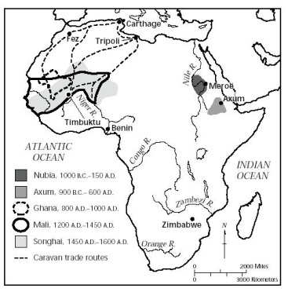

STANDARD WHI.10d) describing east African kingdoms of Axum and Zimbabwe and west African civilizations of Ghana, Mali, and Songhai in terms of geography, society, economy, and religion.
African civilizations developed in sub-Saharan west and east Africa.
Trade brought important economic, cultural, and religious influences to African civilizations from other parts of the Eastern Hemisphere.
States and empires flourished in Africa during the medieval period, including Ghana, Mali, and Songhai in west Africa, Axum in east Africa, and Zimbabwe in southeastern Africa.
Axum
• Location relative to the ______________ Highlands and the ______________ River
• ______________ kingdom

Zimbabwe
• Location relative to the ______________ and ______________ rivers and the Indian Ocean coast
• City of “______________ Zimbabwe” as capital of a prosperous empire

West African kingdoms
• Location of ______________, ______________, and ______________ empires relative to ______________ River and the Sahara
• Importance of ______________ and ______________ to trans-Saharan trade
• City of ______________ as center of trade and learning
• Roles of ______________ and ______________

