NAME_______________________________________________________________________________________________
http://c-spanclassroomdeliberations.org/issues/should-hate-speech-be-protected-by-the-first-amendment/
Username: students Password: C-SPANCLASSROOM
First, define these terms.. Try searching Google or a dictionary for a definition. Finally, use these words in your deliberations and writing activities after you understand all sides of the issue.

Term | Definition
Hate Speech
Majority Opinion
Demographic
Viewpoint Discrimination
Captive Audience Doctrine
Heckler’s Veto
Chilling Effect
Matal v. Tam
Snyder v. Phelps
Hate Speech Self Evaluation

 | In your view, does this constitute hate speech? Why or why not? | In your view, is this speech protected under the First Amendment? Why or why not? Are there any limits to your position (i.e. “This speech is [protected/unprotected] unless…”
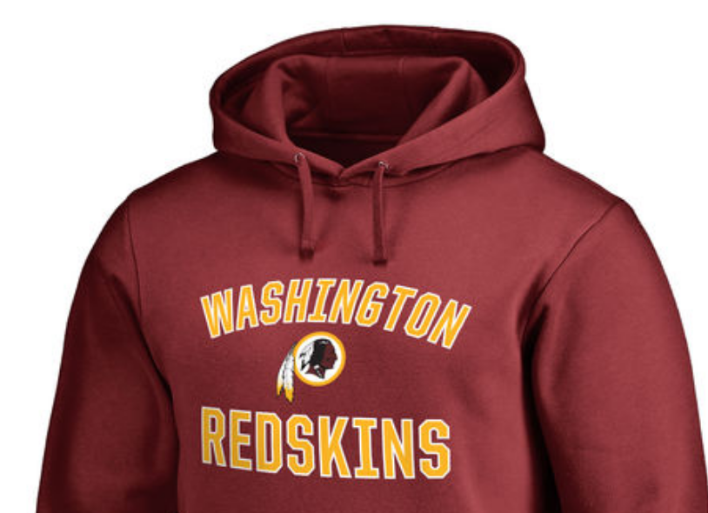
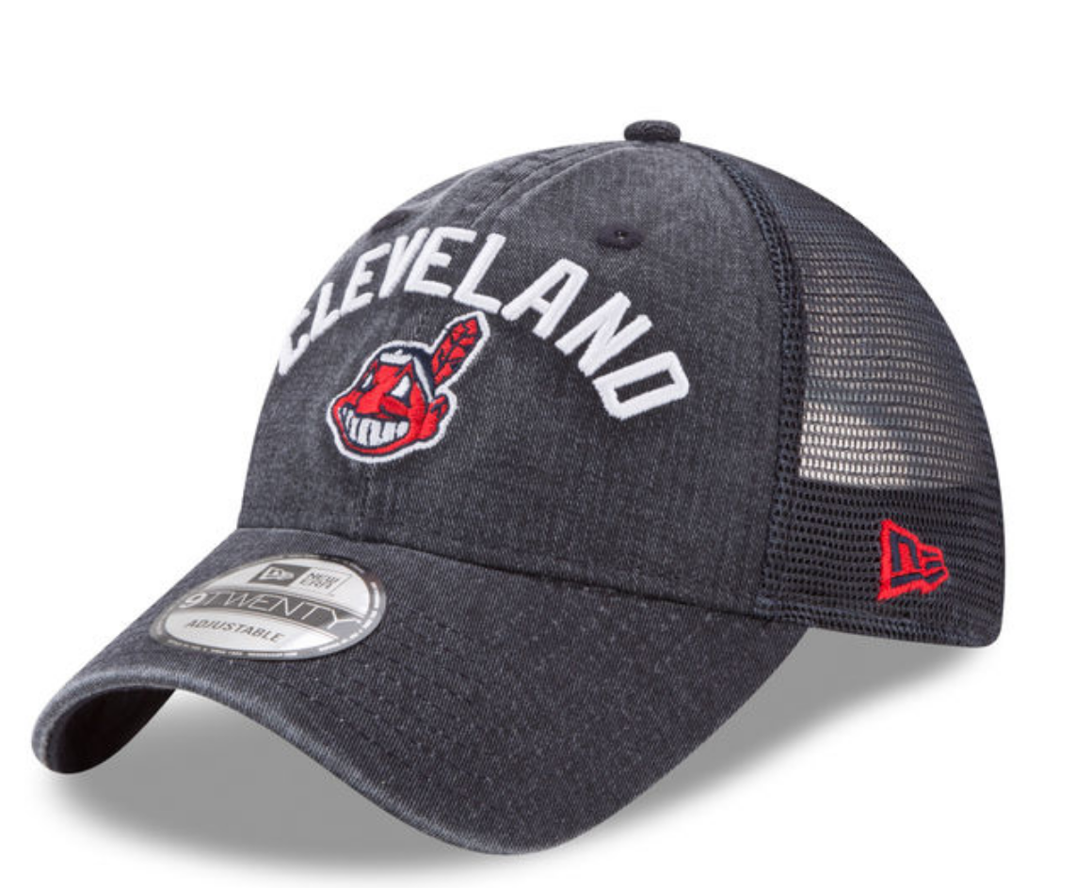
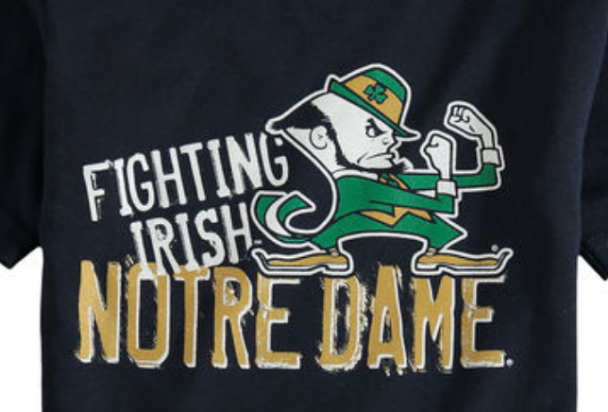
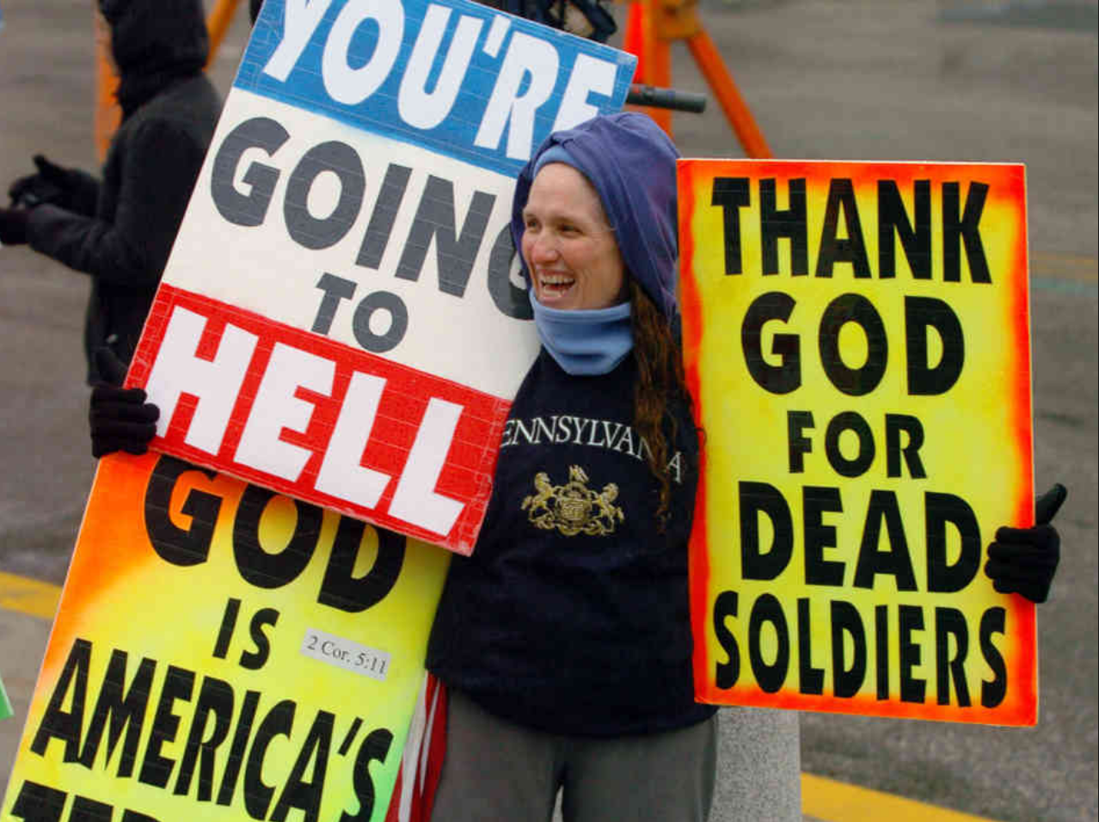
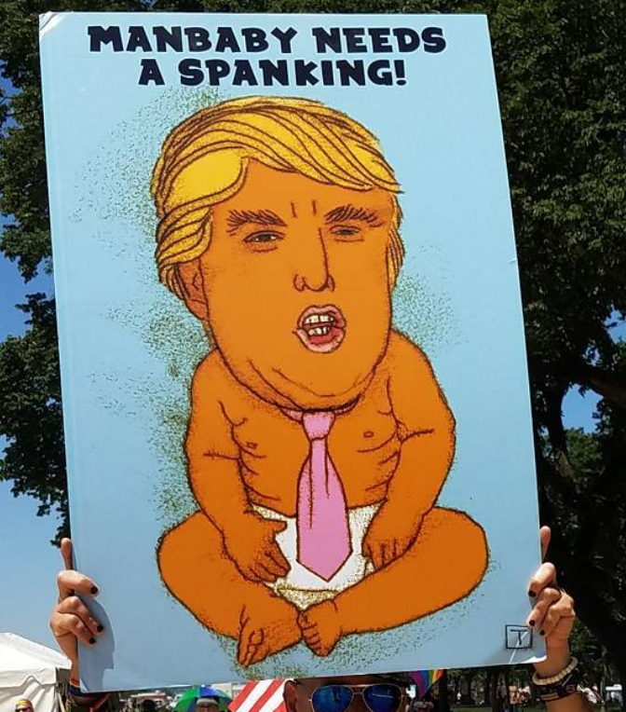
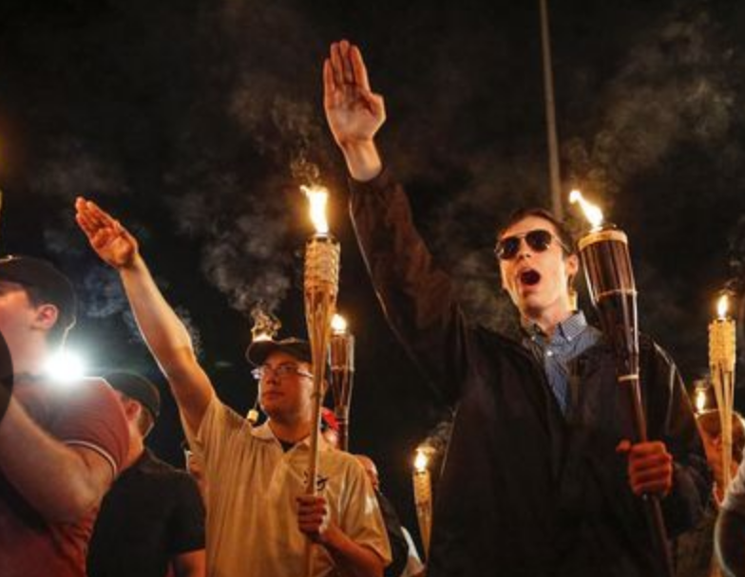
Note-Taking Chart Background
Question: Should Hate Speech Be Protected by the First Amendment?
Directions: Use this chart to take notes on the strongest arguments for and against the question as you watch C-SPAN’s videos and read the linked articles. For each article or video, fill in each cell as indicated in the column headers. Be sure to justify your opinions with supporting evidence from the videos and articles. Then use the chart in your classroom deliberation, debate, or simulation.
 | Description/Summary - What are the key points outlined in this video? Does it leave you with any questions? | What arguments in this video would support a position in favor of restricting hate speech? | What arguments in this video would support a position opposing the restriction hate speech?
OVERVIEW VIDEOS: Hateful Speech and First Amendment Protections
OVERVIEW:
Not The Necessary Byproduct of Freedom of Expression
 | Description/Summary - What are the key points outlined in this article? Does it leave you with any questions? | What arguments in this article would support a position in favor of restricting hate speech? | What arguments in this article would support a position opposing the restriction hate speech?
Debating Hate Speech

From cross burning to funeral protests, hate speech enjoys broad protection
 | Description/Summary - What are the key points outlined in this video? | In your estimation, what is the strongest argument made by the speaker in support of his position? Why? | In your estimation, what is the strongest counterargument to the assertion(s) made by the speaker in this video? Why?

POSITION:

The First Amendment Correctly Protects Hate Speech

POSITION: Hate Speech Should Not Receive First Amendment Protection
Question: Should Hate Speech Be Protected by the First Amendment? Case Studies
 | Description/Summary - What are the key facts and circumstances surrounding this incident? | Personal Opinion - Should hate speech be protected in this instance? What test(s) should be used to determine when hateful speech crosses the line from protected to unprotected? Why? | Court/Legal Result - How was this actually resolved? How did the government handle the instance of hate speech in regards to the 1st Amendment? Do you think the Supreme Court reached the correct conclusion in this case? Why or why not?
Case Study 1: Snyder v. Phelps

Case Study 2: Matal v. Tam

 | Description/Summary:  What are the issues/conflicts currently surrounding many invited speakers on college campuses? What are the key arguments supporting and opposing controversial speakers? | Precedent: Which elements of the Supreme Court’s decisions in Snyder v. Phelps and Matal v. Tam would apply to campus speakers? How would they apply? | Protocol: Which of the different approaches to controversial campus speakers discussed in the videos do you think is the most appropriate? Why?
Case Study 3: College Campuses & Guest Speakers

