Bollywood: India's Movie Industry
By Matt Rosenberg
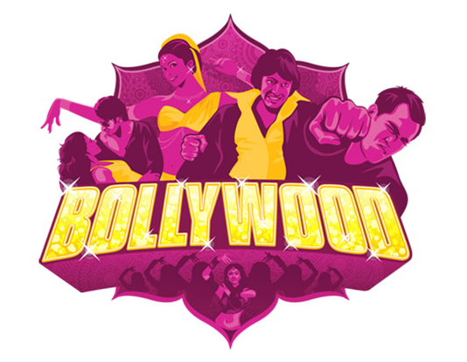
The world's movie capital is not Hollywood but Bollywood. Bollywood is the nickname for the Indian film industry located in Bombay (now known as Mumbai, though Mollywood hasn't quite caught on.)
Indians are in love with movies, even though most films follow a similar format called masala (the word for a collection of spices).
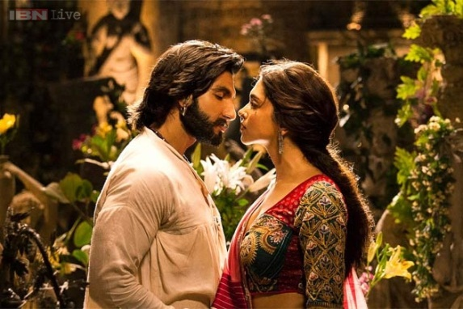
Movies are three to four hours long (and include an intermission), include dozens of songs and dances (featuring 100 or so choreographed dancers), top stars, the story between the songs of boy meets girl (without any kissing or sexual contact), lots of action (though no bloodshed), and always - a happy ending.

Fourteen million Indians go to the movies on a daily basis (about 1.4% of the population of 1 billion) and pay the equivalent to the average Indian's day's wages (US $1-3) to see any of the over 800 films churned out by Bollywood each year. That's more than double the number of feature films produced in the United States.
Although American-made films have been edging into India, only the blockbuster Titanic has ever made India's top five list. One hundred and fifty U.S. films arrived in India in 1998. However, Indian films have become somewhat of an international obsession.
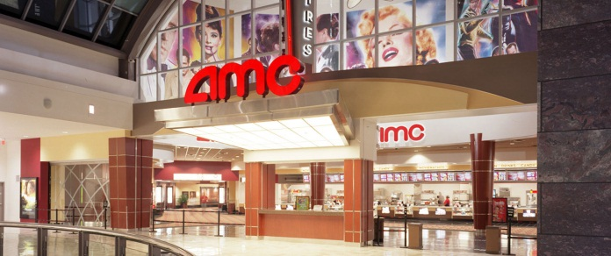
Bollywood films are being shown in American and British theaters on a more and more frequent basis. These theaters have become community foci for the South Asian communities around the world. Though separated by a vast distance from home, South Asians have found Bollywood films to be a great way of staying in touch with their culture and their fellow South Asians.
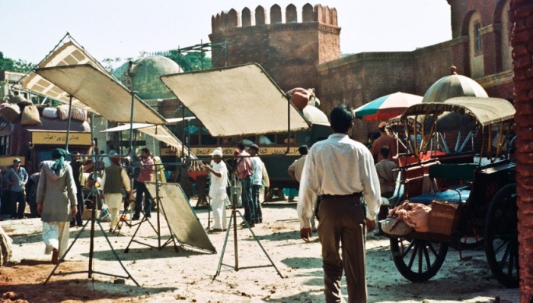
Since India is a country of sixteen official languages and a total of twenty-four languages spoken by over a million people each, some portions of the film industry are fragmented. While Mumbai (Bollywood) leads India in film production, its specialty lies with Hindi movies. Chennai (formerly Madras) produces films in Tamil and Kolkata (formerly Calcutta) is the Bengali movie capital. Neighboring Pakistan's Lahore calls itself Lollywood.
Bollywood's film production center is a government-owned studio facility known as "Film City" in the northern suburbs of Mumbai. Bollywood traces its start to 1911 when the first silent Indian feature film was released by D.P. Phalke. The industry boomed and today there are over 250 theaters in Mumbai alone.
The stars of Bollywood are very popular and highly paid, considering the budget of the films. The lead star in a film often receives as much as 40% of the US $2 million budget for the typical masala film. Stars may be in such high demand that they're working on ten films at once. Photographs of Bollywood stars grace shop windows and homes throughout the country.
Providing three to four hours of escapism is the primary objective of Bollywood and it's a recipe done well. Indian movies are becoming more and more popular around the world so watch for them in theaters and video stores near you.

