Blocked in Quebec: U.S. stores shut down English-only web sites when they open hereEva Friede, Montreal Gazette
November 12, 2014

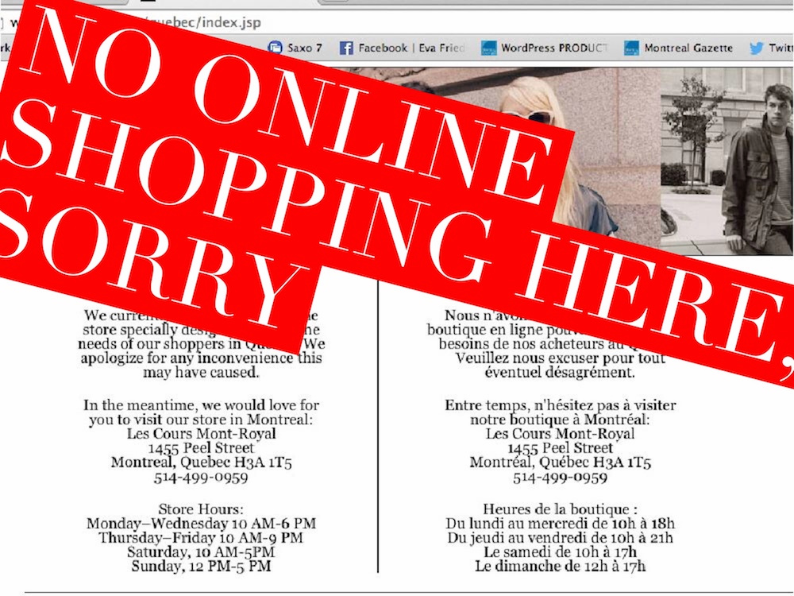
Many retailers have closed their sites to Quebec traffic due to language restrictions.

As the invasion of U.S. retailers continues and as the Internet increasingly becomes the marketplace and the research centre of consumers, some Quebecers are getting unpleasant surprises: some companies have blocked access to their websites here either because they have voluntarily complied with the French Language Charter or because they have received a notice from the Office québécois de la langue française.

The latest sites to shut down are Williams-Sonoma, West Elm, Pottery Barn and Pottery Barn Kids, all part of the same San Francisco-based company and all arrived in Quebec within the last two years. The sites shut down on Oct. 22, according to a company spokesperson.
But a quick survey shows many prominent U.S. retailers with brick-and-mortar stores in Quebec continue to operate English-only shopping sites here.
The probable reason: the Office québécois de la langue française, charged with ensuring that Quebec’s French Language Charter is respected, sends notices to retailers only if complaints are filed, said spokesman Jean-Pierre Le Blanc.
The Williams-Sonoma spokesperson confirmed in an email that the brands have ceased e-commerce activities in Quebec for an undetermined period in order to comply with Quebec language regulations. The home pages and other information pages are available in English only, but clicking on the shopping link takes you to a redirect loop.
“We are actively working with the stores in order to find ways to continue to make the shopping experience memorable for our Quebec customers,” the spokesperson wrote.
BCBG, Club Monaco and Urban Outfitters are among other retail brands that block access to shopping or to their entire sites in Quebec.
Urban Outfitters and Anthropologie, part of the same Philadelphia-based company, blocked access to their websites when they opened stores here. Anthropologie, which opened in Montreal in late 2012, launched its French website 13 months later. Urban Outfitters remains blocked. But Free People, also part of the chain, does not have a store here and the site is accessible, either for research or Internet sales.
Similarly, Club Monaco shut its site in Quebec when it launched an online shopping site. A visit to its home page invites customers to visit its store, which is soon to expand and move to a prominent location at Ste-Catherine St. W. at Metcalfe, from Les Cours Mont-Royal. Founded by Canadian Joe Mimran in Toronto in 1985, Club Monaco is now owned by Ralph Lauren and headquartered in New York.
Not only can Quebec customers not browse the trends, but web-only discounts are not available to Quebecers. Club Monaco’s site also does not ship to Quebec.
Club Monaco and Urban Outfitters did not respond to requests for further information.
BCBG, which has several pages translated to French (owner Max Azria is a francophone), also does not ship to Quebec.
Many major U.S. retailers have, of course, translated their sites. The Gap, for instance, has a bilingual site and ships from Canada.
A few readers of this newspaper have written letters to protest the rules.
Frédéric Côté, one of the writers, said he finds it unfair that his government restricts access to websites. He goes to the Williams-Sonoma site for its recipes, he says. “It’s really irritating me,” Côté said.
“Is Bill 101 going too far?” Dorley Gartner asked in a letter to the editor. “Is it within the government’s power to revoke an individual’s right to visit or not visit a website that targets worldwide shoppers?”
Well, yes, Le Blanc explains.
“The rule is that if you have a business in Quebec — if you have a website that does advertising or sells products, it must be in French. It can be in English, as well,” he said.
The Office does not demand that the business shut down its site, he emphasizes, but that they translate it. About 98 per cent of complaints are resolved with collaboration, he said.
The specific complaints are confidential, he added, pointing out the Office website shows there were 3,107 complaints in 2013-14 about language infractions, 13 per cent or about 400 of them relating to websites on a whole range of issues.
“Catalogues, brochures, folders, commercial directories and any similar publications must be drawn up in French,” reads Article 52 of Chapter 7, on the language of commerce and business.
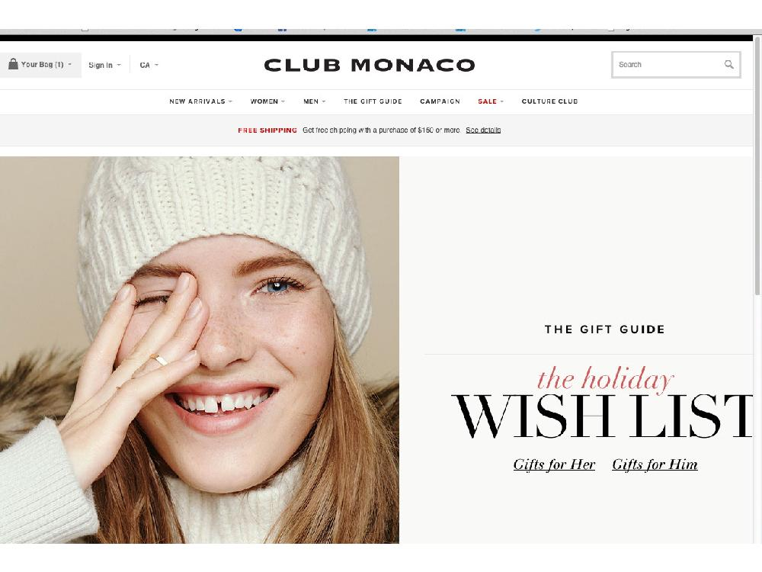
The Club Monaco website for Canada, as seen in the rest of Canada but not in Quebec.
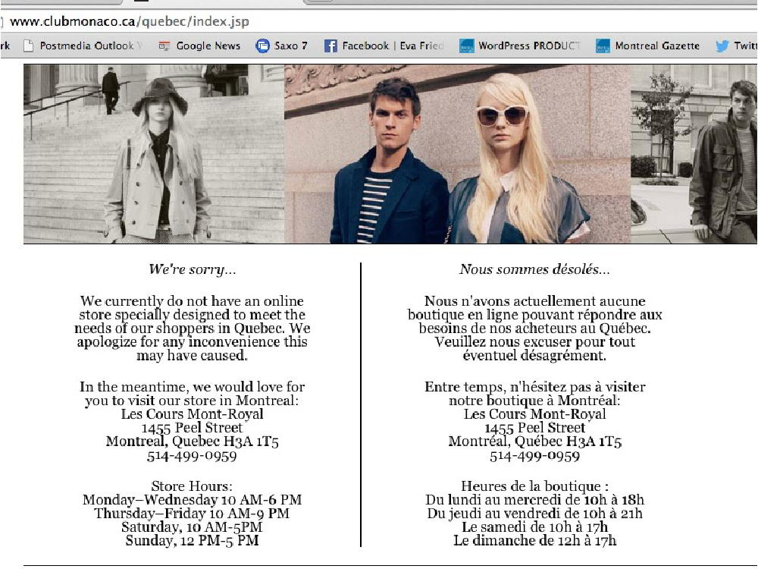
Club Monaco’s website for Quebec residents invites customers to visit its store.
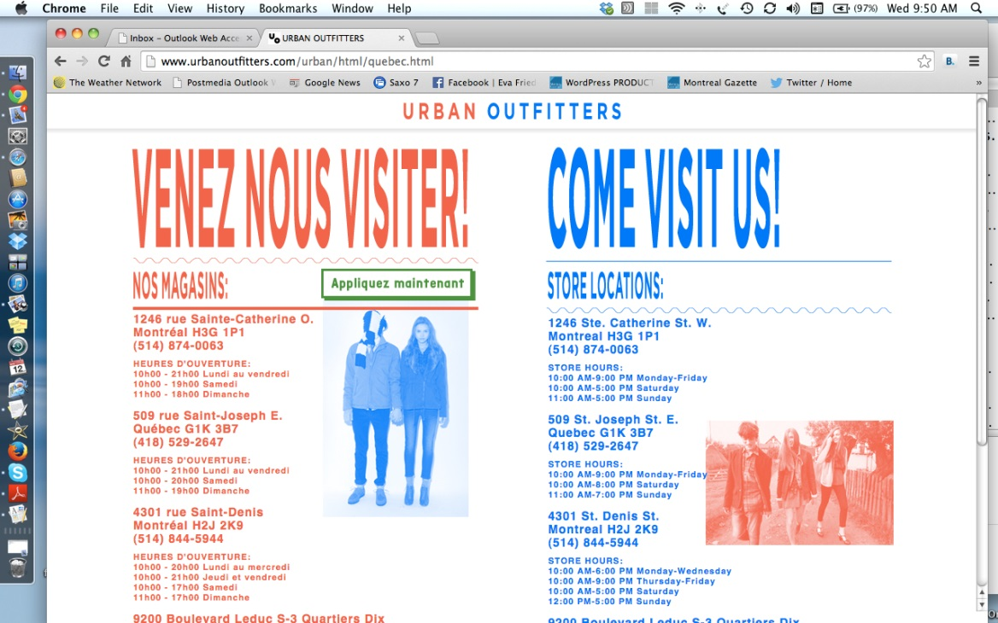
The Urban Outfitters website, as seen in Quebec.
Source: http://montrealgazette.com/business/local-business/retail/blocked-in-quebec-u-s-stores-shut-down-english-only-web-sites-when-they-open-here

