Bilingual education: Prop 58 leads when voters don’t know it would undo ban
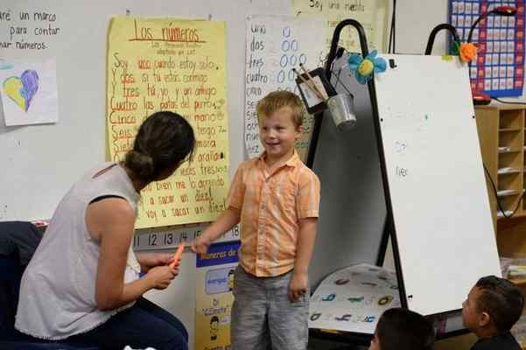
By Sharon Noguchi, Bay Area News Group
POSTED: 10/05/16, 10:37 PM PDT | UPDATED: 3 HRS AGO
0 COMMENTS
Proposition 58, which touts English proficiency but could pave the way to the return of bilingual education, would win easily if the election were held today — as long as voters only read the ballot summary, according to a recent Field-IGS Poll.
The online poll of more than 1,400 likely voters found that 69 percent supported Proposition 58 when read the ballot title and summary, with 14 percent opposed and 17 percent undecided. It needs a simple majority to pass.
But when pollsters mentioned that the proposition, titled the “English proficiency multilingual education” initiative, would repeal key portions of the “English-only” Proposition 227, support dropped dramatically — down to just 30 percent, with 51 percent opposed and 19 percent undecided.
In 1998, the controversial Proposition 227 generated impassioned debate and passed in a landslide with 61 percent support at the polls. It required that English-learners be taught in English and essentially banned bilingual education, with some exceptions and waivers.
Proposition 58 would undo most of that.
Further, when presented with both an explanation of current Proposition 227-designed law, and the arguments for and against Proposition 58, opponents still outnumber proponents, 41 percent to 39 percent, with 20 percent undecided.
Without any context, “people see the “English proficiency” label and think that’s what the initiative supports, said Jack Citrin, director of the UC Berkeley’s Institute of Governmental Studies, a partner in the poll with the Field Research Corp. “When you tell them it repeals a key portion of Proposition 227, also intended to create English proficiency, they change their tune,” Citrin said.
The measure’s title was chosen carefully. According to Proposition 58 campaign spokeswoman Robin Swanson, 69 percent support is consistent with what backers found in polling with the ballot title and summary.
She added in an email that while learning English should be a priority “giving students a chance to be proficient in more than one language through multilingual education is an incredibly valuable skill in a global economy.”
The poll findings reinforce the beliefs of Palo Alto software entrepreneur Ron Unz, the architect of Proposition 227 who has signed the ballot argument against Proposition 58.
“On an issue that’s not getting a lot of attention, voters tend to vote on how it’s described to them,” he said. “If voters were told a measure that would allow children to not be taught in English for five to seven years, they would oppose it.”
Advertisement
Bilingual-education proponents have argued it takes multiple years for a child to become fluent in English.
The poll found that without the explanation and background, Proposition 58 leads among all sectors of voters — Democrats, Republicans and independents; both genders; all ethnicities and age levels and people of all education levels.
With the added context of Proposition 227, the measure does not a win a majority among any of those groups. And with the inclusion of Proposition 227 background plus the arguments for and against, the measure wins 54 percent support among Democrats and voters ages 18 to 39. But it still doesn’t garner a majority in any other demographic group polled.
The poll was administered online by the internet-based market research firm YouGov for Field Poll-IGS, which queried a demographically representative sample of the California electorate. YouGov divided 1,426 likely voters into three random subgroups and presented each one with a Proposition 58 scenario — one with just the ballot language, one with background and one with both background and summary arguments.
Given that Unz and other opponents to Proposition 58 are not waging much of a campaign against it, the question is whether the background and context will even matter at the ballot box.
“I’m not sure how many voters in California are even aware of what bilingual education is,” Unz said. As the practice receded from most schools, the debate has vanished.
Bilingual education is mentioned in the ballot analysis and arguments, but “you have to do a lot of weeding to get to that,” said Mark DiCamillo, director of the Field Poll. “The question becomes how much voters read and understand when it comes to voting on Proposition 58.”
With 16 other statewide measures on the ballot, plus multiple local, state and federal races, the answer may be not much.

