Americans Will Come to Regret the “Baby Bust” That’s Taking Over America. Older Women Already Do.
America’s baby boom is officially bust.
The fertility rate in the United States fell to its lowest point on record, according to statistics released last week by the federal Centers for Disease Control and Prevention.
In the first three months of 2016, the fertility rate in the US of women between the ages of 15 to 44 fell to 59.8 births per 1,000 women. These numbers are down from 60 births in early 2015.
Most of the drop comes from the continuing decline in the rate of teenage pregnancy. But now, the fertility rate for women in the next two youngest cohorts, 20 to 24 years old and 25 to 29 years old, is also declining:
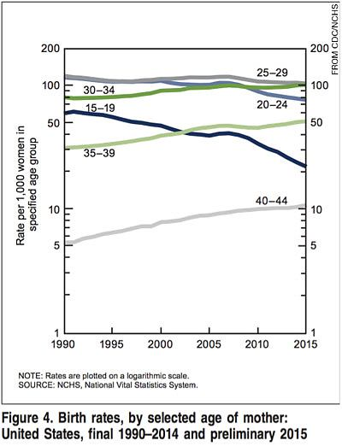
Meanwhile, the birth rates increased among women in their 30s and 40s. Increasingly, American women give birth later in their life.
Millennial women became the slowest of any generation to give birth to their first child in U.S. history. In the 1970s, the average American woman delivered her first baby at age 21. By 2000, she was 24.9. Today she reaches 26 years old before having children.
Delaying motherhood can have consequences for the women who choose to do so.
According to a 2014 Pew survey, 52% of women said their ideal number of children is two. An additional 44% noted their ideal at three or more children. The report notes that 86% of women gave numerical responses, while 14% said the ideal size was: “as many as [someone] wants.”
Despite those ideals, 40% of U.S. women told Pew they have fewer children than their ideal when reaching the end of their child-bearing years. Women in European nations, with more robust childcare systems and maternity leave policies, also report a gap between their ideal and actual number of children:
A 2015 study by the Urban Institute recorded a 15% drop from 2007 to 2012 in fertility for women in their 20s.
“If these low birth rates to women in their twenties continue,” the report notes:
“The U.S. might eventually face the type of generational imbalance that currently characterizes Japan and some European countries, but it is too early to predict or worry about that eventuality.”
If women at the end of their childbearing years today say they have fewer children than their ideal, it leaves open the question of whether Millennial women two decades from now will have the same concern.
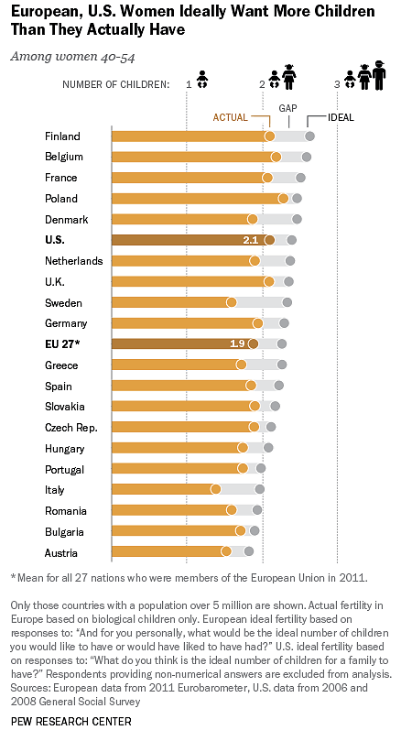
The Urban Institute report credits economic worry and the Great Recession for declining fertility among Millennial women. However, instead of curing financial problems, producing fewer children may only intensify them.
As Pascal-Emmanuel Gobry from The Week notes:
“The fewer young, productive people you have to pay for entitlements for old, unproductive people, the steeper the bill for the entire society becomes.
This basic problem is strangling Europe’s economies. And while the United States is among the least bad of the bunch, it is still headed in the wrong direction.”
Some commentators cast the decline in fertility as a way to combat what they consider global overpopulation. This brings up controversial topics such as the possibility of technological advances to mitigate man’s use of the world’s resources.
But even the best technology can’t make up for a family’s lost time.

