human geography | a division of geography, spatial analysis of human population, cultures, activities, and landscapes
globalization | expansion of economic, political, and cultural processes to the point that they are global in scope, effect all levels
fieldwork | study of phenomena by visiting places and observing how people interact and thereby change those places
physical geography | the branch of geography that studies structures, processes, and location of the Earth's natural phenomena (climate, soil, plants, animals, topography)
spatial | pertaining to space on the Earth's surface,
spatial distribution | physical location of geographic features across space
medical geography | study of health and disease from a geographic context and perspective
pandemics | worldwide outbreak of disease
epidemic | disease particular to a locality or region
spatial perspective | observing variations in geographic phenomes across space
spatial perspective | observing variations in geographic phenomena across space
location theory | logical attempt to explain the location & patter of an economic activity and how producing areas are related
sense of place | state of mind derived from the infusion of a place with meaning and emotion from memories
perceptions of place | belief or understanding about a place from books, movies, stories, or pictures
spatial interaction | degree of flow of people, ideas, and goods among places
distance | measurement of the physical space between 2 places
accessibility | degree of ease with which it is possible to reach a location from elsewhere, varies place to place, can be measured
connectivity | connectedness of a node in the world economy to other nodes
landscape | overall appearance of an area, usually naturally and human induced
cultural landscape | visible imprint of human activity and culture on the landscape, sequentially imprinted
sequent occupance | successive societies leave their cultural imprint on a place, each adding to the cumulative cultural landscape
cartography | science of map making
reference maps | map that shows absolute location of a place and geographic features
thematic maps | maps that tell stories, usually one attribute or movement
absolute location | position on earth's surface, usually by latitude and longitude
Global Positioning system | system for determining the absolute location of places or features, often with satellites
geocaching | a hunt for a cache, the GPS coordinates which are placed on the internet by other geocachers
relative location | regional position of a place (situation), relative to other places
mental map | image or picture based on perceptions and impressions
activity spaces | space in which one's daily activities take place
remote sensing | use of planes or satellites to collect data or information from places physically distant
geographic information systems | collection of pc software and hardware that allows spatial data to be collected, recorded, stored, and utilized
rescale | change the scale or area of study to gain support
formal region | region that has one or more shared physical or cultural traits
functional region | region defined by a set of activities or interactions
perceptual region | region that exists as an idea and not based on a physical entity
culture | sum of knowledge, attitudes, and habitual behaviors shared amongst a group
culture trait | an element of a culture
culture complex | set of cultural traits
cultural hearth | origin of a culture
independent invention | The independent development of a cultural feature in different societies.
cultural diffusion | expansion and adoption of a cultural element
time-distance decay | declining acceptance of an idea the farther it is from the hearth
cultural barriers | attitude that refuses the adoption of another culture's traits
expansion diffusion | spread of innovation or idea through a population, increased the numbers involved
contagious diffusion | spread by immediate and direct contact person to person
hierarchical diffusion | idea that passes from the hearth to the most connected nodes (people or places)
stimulus diffusion | an accepted cultural trait with adaptations
relocation diffusion | trait carried by people who move from one location to another
isotherms | lines connecting similar values like temperature or elevations on a topographic map
possiblism | environment influences culture but man is the final decision maker
cultural ecology | interactions and relationships between a culture and its' environment
environmental determinism | environment determines culture and development
political ecology | study of nature and society relationships and reflects as a result of political and socioeconomic contexts
meridians | lines of longitude
parallels | lines of latitude
Azimuthal Projection  , 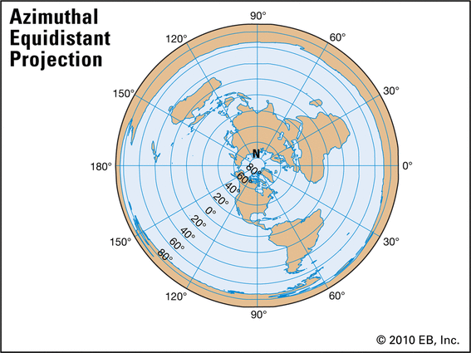 | Shows poles, used by pilots
Mercator Projection  , 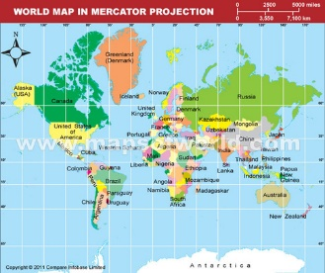 | used for ship navigation, right directions, wrong land mass areas
Fuller Projection  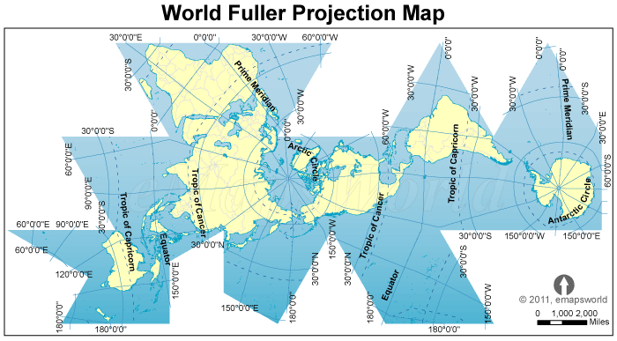 | right size and shape of land, distorted compass
Robinson Projection  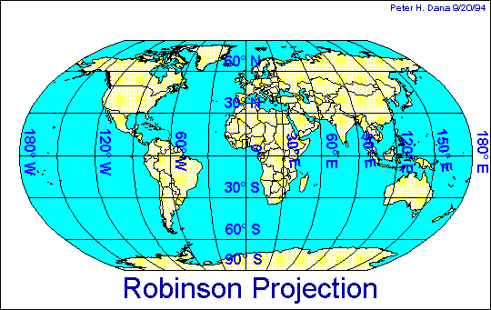 | used by Nat Geo, nothing is accurate but all errors are minimized
Cartogram  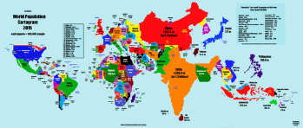 | thematic map where the unit is shown larger due to importance than actual size
choropleth map | thematic map that uses colors of tones or such to represent a particular data
dot map  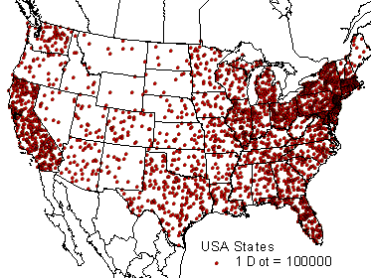 | shows a thematic map with locations marked of a particular idea or occurrence
proportional symbols map  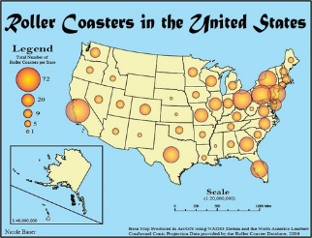 | thematic map where size of symbols denotes importance or size of the given attribute
isoline maps (contour lines)  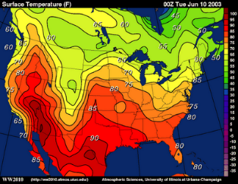 | has lines used to show areas that are relatively equal
reference maps | used to navigate from one place to another
political maps | shows borders and capitals
Times Zones | change 1 hour per 15 degrees
small scale maps | show large area, little detail
large scale maps | show small area in great detail

