The World-systems Theory
By: System Administrator on: Sat 01 of May, 2010 12:42 CDT (4620 Reads)
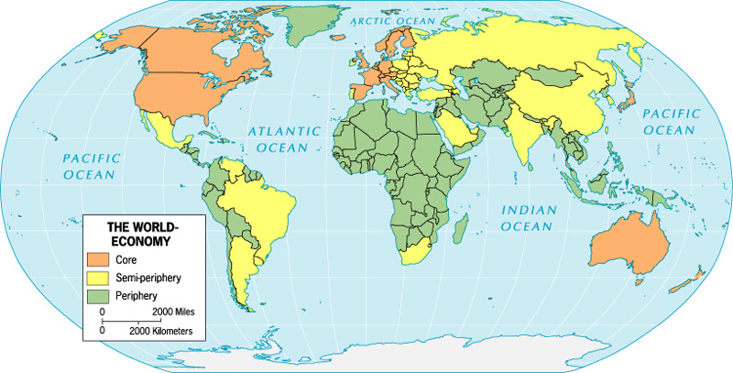
Immanuel Wallerstein, a leading advocate of the approach, uses the same terminology. He characterizes the world system as a set of mechanisms which redistributes resources from the periphery to the core. In his terminology, the core is the developed, industrialized, democratic part of the world, and the periphery is the underdeveloped, raw materials-exporting, poor part of the world; the market being the means by which the core exploits the periphery.
Nowadays, this has changes as the core countries are moving into 3rd and higher level sector jobs and the periphery is taking on the second sector factory jobs.
The core nations primarily own and control the major means of production in the world and perform the higher-level production tasks. The periphery nations own very little of the world’s means of production (even when they are located in periphery nations) and provide less-skilled labor. Like a class system with a nation, class positions in the world economy result in an unequal distribution of rewards or resources. The core nations receive the greatest share of surplus production, and periphery nations receive the least. Furthermore, core nations are usually able to purchase raw materials and other goods from noncore nations at low prices, while demanding higher prices for their exports to noncore nations.
Core nations
* The most economically diversified, wealthy, and powerful (economically and militarily)
* Highly industrialized
* Tend to specialize in information, finance and service industries
* Produce manufactured goods rather than raw materials for export
* More often in the forefront of new technologies and new industries. Examples today include high-technology electronic and biotechnology industries. Another example would be assembly-line auto production in the early twentieth century.
* Have more complex and stronger state institutions that help manage economic affairs internally and externally
* Have a sufficient tax base so these state institutions can provide infrastructure for a strong economy
* Have more means of influence over noncore nations
* Relatively independent of outside control
Periphery nations
* Least economically diversified
* Tend to depend on one type of economic activity, such as extracting and exporting raw materials to core nations
* Are often targets for investments from multinational (or transnational) corporations from core nations that come into the country to exploit cheap unskilled labor for export back to core nations
* Tend to have a high percentage of their people that are poor and uneducated.
* Inequality tends to be very high because of a small upper class that owns most of the land and has profitable ties to multinational corporations
* Have relatively weak institutions with little tax base to support infrastructure development
* Tend to be extensively influenced by core nations and their multinational corporations. Many times they are forced to follow economic policies that favor core nations and harm the long-term economic prospects of periphery nations.
Semiperiphery nations
Semiperiphery nations are those that are midway between the core and periphery. They tend to be countries moving towards industrialization and a more diversified economy. “While they are weaker than core societies, they are trying to overcome this weakness and are not as subject to outside manipulation as peripheral societies.”
Core conflict and hegemony
Note: these ideas by Wallerstein listed below may be a little antiquated and apply better to earlier times. See the note after.
Throughout the history of the modern world-system there has been a group of core nations competing with one another for access to the world’s resources, economic dominance, and hegemony over periphery nations. According to Immanuel Wallerstein, a core nation dominates over peripheries when it has a lead in three forms of economic dominance over a period of time:
1. Productivity dominance allows a country to produce products of greater quality at a cheaper price compared to other countries.
2. Productivity dominance may lead to trade do trade dominance. Now, there is a favorable balance of trade for the dominant nation since more countries are buying the products of the dominant country than it is buying from them.
3. Trade dominance may lead to financial dominance. Now, more money is coming into the country than going out. Bankers of the dominant nation tend to receive more control of the world’s financial resources.
Note: parts of this definitely apply better to colonial times rather than more modern times.
-conflict over dominance was more colonial
-production now tends to take place in the periphery
-today, one could argue that the core countries still consume and use more and the periphery produce materials for them to use and that most trade revolves around that.

