The myth of India’s population explosion
June 22, 2016, 5:29 PM IST Rema Nagarajan in Staying Alive | India | TOI
As an Indian travelling abroad, the population “explosion” in India is something you get asked about all the time. It has been no different in Germany. A billion and how much? It’s asked with varying degrees of concern, pity or controlled horror. By now, I almost have a prepared speech in readiness. For whatever it is worth, here it is, reproduced for anyone who would care to listen: No there is no population EXPLOSION. Not only is the population growth rate falling, the pace of the decline has actually picked up in the last few decades.
In fact, India’s total fertility rate — a measure of the number of children born to a woman during her lifetime — was down from 5.9 in 1951 to 2.3 in 2011. A fertility rate of about 2.1 is a ballpark figure for ensuring a broadly stable population. India is expected to reach replacement level fertility of 2.1 by 2020, just four years away, much faster than was expected. So, India is actually close to stabilizing its population and far from exploding, and this has been achieved without a draconian one-child policy or coercive contraception.
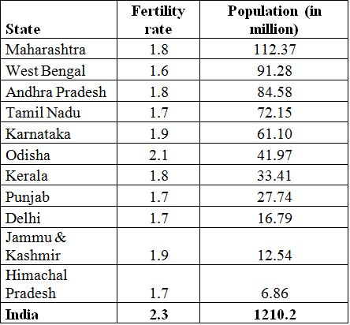
Incidentally, the fertility rate in urban India is 1.8, close to the European Union’s 1.6. True, the urban population is less than a third of the total, but a third is still about 400 million people. The rural fertility rate is 2.5, not great, but not too bad either. India has 29 states and seven federally administered territories. Fertility data for 2013 is available for 20 states and the federally administered national capital territory. In 10 of these states and the national capital, the fertility rate has fallen below replacement level and in one state it is at the replacement level. The nine small states and seven even smaller federally administered territories, for which data wasn’t available, are also estimated to have below the replacement level fertility. Together, the 11 states and the smaller states and territories account for almost half the population (48.7%). Even of the remaining nine states, only the two most underdeveloped have a fertility rate of more than three children per woman.
11 large states with fertility rate at replacement level or below it
Unlike most other countries or parts of the world, India, like China, has always been a heavily populated country. In 1900, India’s population was roughly 238 million. Even as far back as the 1800s, the Indian sub-continent (including Bangladesh and Pakistan) had about 200 million people. The population grew quite slowly due to famines and epidemics that killed millions during the colonial period but increased steadily following independence in 1947.
As for the imagery of a population bomb or explosion, we can thank American biologist Paul Ehrlich for his 1969 book titled Population Bomb, in which India became a metaphor for the world’s population explosion problem. While Ehrlich’s prediction of millions dying from famine as the earth became incapable of producing enough food for everyone never came true, and his recommendation of compulsory contraception was never needed, the population did increase dramatically in India.
The population started soaring in the 1950s and saw the highest decadal growth of 24.8 per cent in the 1960s and 24.7 per cent in the 1970s. Since the 1980s, decadal growth has been falling and the 1990s saw a significant fall. The 2011 census confirmed that the fall is picking up pace. For the first time since the early 1900s, the first decade of the new millennium saw fewer people added to India’s population than in the previous decade.
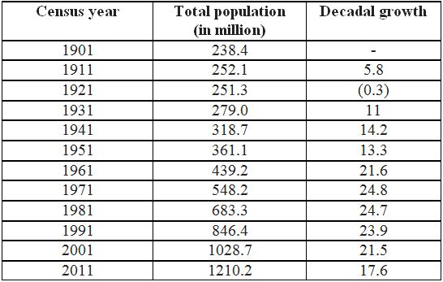
So will India’s population soon start shrinking? Not really. Not anytime soon. Current estimates are that it will keep growing till it peaks at about 1.75 billion around 2060. Long before that, by 2022, the UN estimates that India would have crossed 1.4 billion and overtaken China as the most populous country in the world.
This continued increase in population despite reaching replacement level fertility is thanks to something called demographic momentum. It’s like a very large vehicle travelling at several hundred miles per hour. You might apply the brakes, but the momentum will take the vehicle quite a distance before it stops. India’s huge population of young people in the reproductive age (59% of the population below the age of 25 and 65% below the age of 35) will add to the momentum. So to expect a country with over a billion to abruptly halt is both impossible and illogical.
Population and its growth: India 1901 to 2011
The challenge of providing health, education and employment for its bulging youth population is a daunting one. And this bulge also portends that India will soon have to start dealing with an ageing population. By 2050, an estimated 330 million Indians will be over 60 years.
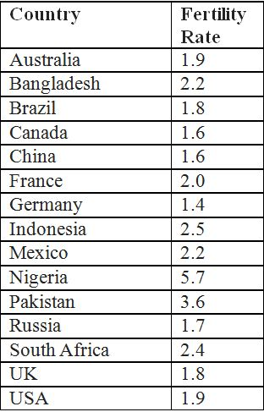
Once I have explained these numbers, most people want to know why and how the fertility rate is falling. Governments would like to suggest it is their family planning efforts (a euphemism for contraception services targeted largely at women) that have done the trick. While this might have played a small part, it is well accepted that the best contraception is development. As women become more literate, as their status in society gets better and they have access to contraceptive services, they opt to have fewer children. And men too prefer smaller families as they get more civilized. So the mantra’s simple. Empower the women, and they’ll defuse the bomb.
For a quick comparison internationally
This piece originally appeared in Der Spiegel online in German.

