AP Human Geography

Massively Gigantic Review Packet

Chapter 1 – Basic Human Geography Review
What are the big ideas?
- The big ideas are the terms that you definitely need to remember & understand for the AP Exam.
- This does not mean that the other ideas & information from the chapter are any less important, it just means that these are the things we know students have some difficulty on & things that are big ticket items for College Board.
- Most of this information you have seen before, some may be new to you (different textbooks cover different information), or it may be information you do not remember.
- MAKE SURE TO TAKE NOTES EVERY DAY!!! KEEP THIS PACKET WITH ALL YOUR NOTES & STUDY THEM ON A DAILY BASIS BEFORE THE TEST DATE…DO NOT WAIT TO STUDY EVERYTHING RIGHT BEFORE THE EXAM.
Basic Human Geography Big Ideas
- Latitude & longitude
- Absolute vs. Relative Location
- Site & Situation
- Map Projections
- Types of Maps
- Scale
- Sense of Place
- Spatial Perspective
- Environmental Determinism
- Possibilism
- Geospatial technologies
- World Regions & key Countries
Latitude & Longitude
- Latitude (aka _________________)
  - Horizontal lines on maps & globes
  - Distance in ___________________, minutes, & seconds of a point north or south of the Equator.
- __________________ (aka Meridians)
  - ______________lines on maps & globes
  - Distance in degrees, minutes, & seconds of a point east or west of the Prime Meridian (Greenwich)
Latitude lines are stacked like bunk beds as they lay down.
Longitude lines are taking long strides around the world

Absolute vs. Relative Location
- __________________ location
  - The ________________ location of a place using a recognized coordinate system.
    - i.e. World Atlas US office is located at 29°, 16’N, 94°49’W
- __________________ Location
  - The relationship of a place to another __________________ or nearby _________________
    - i.e. World Atlas US Office is located on Galveston Island, which is located in southeastern Texas in the Gulf of Mexico, about 48 miles southeast of Houston.
    - What is your school’s relative location?
Site & Situation
- Site
  - How geographers describe the _________________ of a place
  - The physical ___________________ of a place
    - Includes climate, water sources, topography, soil, vegetation, latitude, & elevation
  - Have always been essential selecting locations for settlement
- Situation
  - The location of a place _________________ to other places
    - Helps us find an unfamiliar place by __________________ its location with a familiar one (its down the road from the courthouse, etc)
  - Helps us understand the _______________________ of a location
    - Many locations are important because they are accessible to other places.
Map Projections
- Mercator
  - Advantages
    - _________ is distorted very little, direction is consistent, and the map is ____________________
  - Disadvantages
    - ________________ size is grossly distorted toward the poles, making high-latitude places look much larger than they actually are
- Goode __________________________ (interrupted)
  - Advantages
    - Show correct sizes & shapes
  - Disadvantages
    - Cannot accurately _____________________ distance & cannot plot a course across an ocean
- Robinson
  - Advantages
    - Correct size & shape of most _________________; accurately shows sizes of oceans & distance across land
  - Disadvantage
    - ________________ regions along the edges
- Peters
  - Advantages
    - Correct areas of landmasses & _____________, directions are accurate
  - Disadvantages
    - Distorts the _______________ of Africa & S. America, making them appear longer & thinner.
- Polar - _____________________Equidistant
  - Allows for directional antenna aiming
  - Advantages
    - All points on the map are at _______________________________correct distance from the center
    - All points are at the correct azimuth (_______________________) from the _______________point
  - Disadvantage
    - ________________________& area distortion grow larger further from the _____________________point
Types of Maps
- Reference
  - ____________________ the geographic location of features
  - Political or _______________________ maps
- Thematic
  - A type of map designed to show a particular ___________
    - Elevation
    - Climate
    - ________________________
    - Vegetation
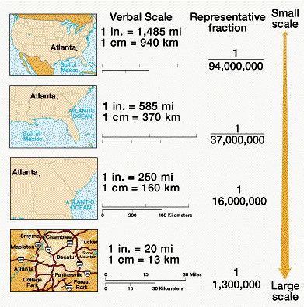
    - ____________________ Use
Scale
- Refers specifically to the ________________ of a feature’s size on a map to its actual size on Earth
- Presented _____ ways
  - ________ or fraction – the ________________ ratio between distances. (for example: 1:24,000 – 1 unit on the map represents 24,000 on the ground)
  - Written scale – the relationship between map & Earth’s distances in ___________. (For example: 1 inch equals = 1 mile means that 1 inch on the map is equal to 1 mile on Earth’s surface.)
  - ________________ Scale – consists of a bar line marked to show distance on Earth’s surface.)
- ___________________________ scale depends on the information being portrayed.
Sense of Place
- Involves the human _______________ in a landscape, the local knowledge & ____________________.
  - Grows from __________________ oneself in relation to a particular piece of land on the surface of the Earth.
- A __________________ for the features that contribute to the distinctiveness of a particular spot on Earth
  - Hometown, a vacation destination, or a part of the country.
Think of a place that is special for you. What makes it special?

Spatial Perspective
- Things happen on Earth in space & in _______________ places
  - Focuses on the __________________ of humans as it ____________________ to interaction
  - Studies physical locations to determine how people ___________________ on the Earth surface.
Environmental Determinism
- Argued that the general laws sought by human geographers could be found in the ____________________ science.
- Geography was the study of how the ______________________ caused our activities
  - Notable geographers – Alexander von Humboldt, Carl Ritter, Friedrich Ratzel, Ellen Churchill Semple, Ellsworth Huntington
    - Humboldt-Ritter: geographers should apply laws from the _________________ sciences to understanding _________________________ between the physical environment & human actions.
    - Ratzel-Semple: claimed geography was the study of the ___________________________ of the natural environment on people.
    - Huntington – _____________________ was a major determinant of civilization.
Possibilism
- The physical _____________________ may limit some actions, but people have the ability to _______________ their human actions
  - For example – climate influences our activities, especially food production. We learn what crops thrive in different climates, (rice needs to be wet & wheat needs to be dry, but wheat grows better in cold climates). But you still have the ability to choose the crops that you grow & still be compatible with the environment.
Geospatial Technologies
- Remote sensing – _________________ scan Earth’s surface, & the images are ___________________________ in digital form to a receiving station on Earth.
- GPS (Global Positioning Systems) – includes _____ elements.
  - Satellites placed in ____________________________ orbits; tracking stations to monitor & control satellites; a _____________________ to locate the satellites
  - Most commonly used for _____________________ – found in ships, aircraft, car nav-systems, even cell phones.
- GIS (Geographic Information System) – computer ________________ that stores, queries, ___________________, and displays geographic data.
  - Used to produce _____________ that are more accurate & attractive than those drawn by hand.
Major World Regions & Key Countries
- Many of the regions ______________ or have __________________________ boundaries (Brazil – part of Latin America, but has Portuguese colonial heritage).
  - Some defined by _________________, physiographic features (sub-Saharan Africa)
  - Not all geographers _______________ on how each region is defined
    - Are Armenia & Azerbaijan part of the Middle East or Central Asia?
    - Is it the Middle East or Southwest Asia?

Mental Mapping – draw a mental map of your neighborhood, either from your home or where you live. Make sure to indicate where you live, along with any relevant landmarks & pathways

Label the below map with the different world regions (per AP Human Geography)
AP Human Geography World Regions – A Big Picture View
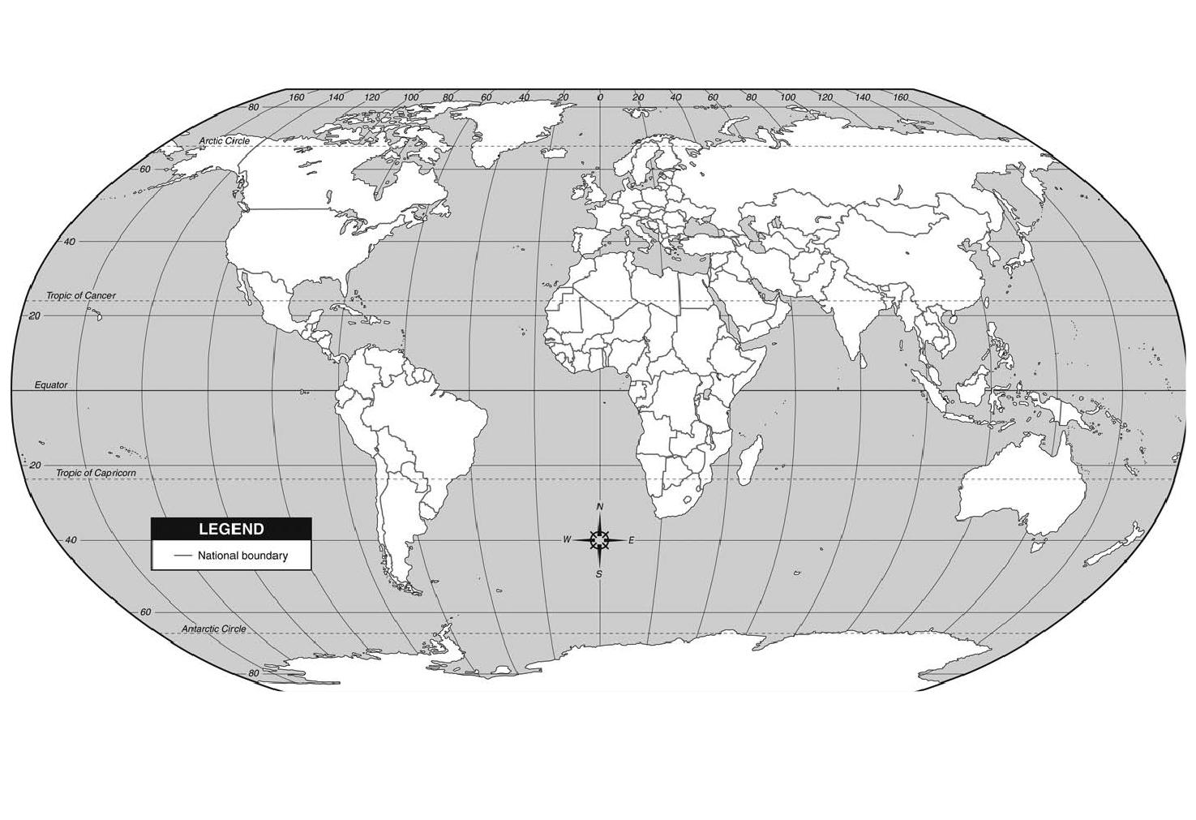
AP Human Geography World Regions – A closer look

Knowing where your countries are is extremely important (Identifying mystery countries has been in previous FRQs). Write in the nations in each of the below regions.
North America

1.
2.
3.
4.
5.
6.
7.
8.
9.
10.
11.
12.
13.
14.
15.
16.
17.
18.
19.
20.
21.
22.
23.
24.
25.
26.
27.
28.
29.
30.
31.
32.
33.
34.
35.
36.
37.
38.
39.
40.
41.
42.
43.
44.
45.
46.
47.
48.
49.
50.

Central America & the Caribbean

1.
2.
3.
4.
5.
6.
7.
8.
9.
10.
11.
12.
13.
14.
15.
16.
17.
18.
19.
20.
21.
22.
23.
24.
25.
26.
27.
28.
29.
30.
31.
32.
33.

South America

1.
2.
3.
4.
5.
6.
7.
8.
9.
10.
11.
12.
13.
14.
15.

Europe

1.
2.
3.
4.
5.
6.
7.
8.
9.
10.
11.
12.
13.
14.
15.
16.
17.
18.
19.
20.
21.
22.
23.
24.
25.
26.
27.
28.
29.
30.
31.
32.
33.
34.
35.
36.
37.
38.
39.
40.
41.
42.
43.
44.

Asia (SW, Central, East, SE, & South)
1.
2.
3.
4.
5.
6.
7.
8.
9.
10.
11.
12.
13.
14.
15.
16.
17.
18.
19.
20.
21.
22.
23.
24.
25.
26.
27.
28.
29.
30.
31.
32.
33.
34.
35.
36.
37.
38.
39.
40.
41.
42.
43.
44.
45.
46.
47.
48.
49.
50.

Africa

1.
2.
3.
4.
5.
6.
7.
8.
9.
10.
11.
12.
13.
14.
15.
16.
17.
18.
19.
20.
21.
22.
23.
24.
25.
26.
27.
28.
29.
30.
31.
32.
33.
34.
35.
36.
37.
38.
39.
40.
41.
42.
43.
44.
45.
46.
47.
48.
49.
50.
51.
52.
53.
54.
55.

Oceania

1.
2.
3.
4.
5.
6.
7.
8.
9.
10.
11.
12.
13.
14.
15.
16.
17.
18.
19.
20.
21.
22.
23.

One-Pager – must contain the following: 1 visual per key issue 2 vocab per issue; Text in your own terms “I learned...; I believe...”
Key 2
Key 1

Chapter 1
Basic Concepts

Key 3
Key 4

Types of Diffusion (describe the different types of diffusion & provide an example for each.
Relocation Diffusion –

Expansion Diffusion –

    - Hierarchical diffusion –

    - Contagious Diffusion –

    - Stimulus Diffusion –

Draw & label the different climate regions on the map. Include a key below.

Chapter 2 – Population & Health
Population Big Ideas
- Density – Arithmetic, Physiological, & Agricultural
- Demographic Transition Model
- ________________________________ Transition Model
- Population Patterns – fastest growing & negative growth countries
- Population pyramids – __________________________ rate, dependency ratio, demographic equation, sex ration
- ____________________ & Neo-Malthusians – carrying capacity
- Population Policies
Ecumene
- The _____________ of the Earth with permanent human _______________________________
  - Has expanded to cover most of the world’s land _________
Population Density
- __________________ Density
  - Total number of people _______________ by total land
  - Enables comparisons of the # of people trying to live on a given piece of land in different regions of the world.
- _____________________________ Density
  - Number of people __________________ by a unit area of arable land
- Agricultural Density
  - ________________ of the number of farmers to the amount of arable land
  - Helps to account for __________________ differences
J-Curve & S-Curve
- __________________
  - Population projection show ____________________ growth. If the population grows exponential, our _________________ use will go up exponentially, as well as a greater demand for food & more.
- _____________
  - Traces the cyclical movement upwards & downwards in a graph
Draw the S Curve
Draw the J Curve

Components of Population Growth
- Demographic Transition Model
- Measure of ______________________ change
  - Crude Birth Rate (CBR) – total number of ______ births in a year for every 1000 people
  - Crude __________ Rate (CDR) – total number of deaths in a year for every 1000 people
  - Rate of _____________ Increase (RNI) – ________________ by which a population grows in a year. (birth rate – death rate/10)
    - Doubling time (the number of years needed to double the population) is affected by the RNI
  - Total Fertility Rate (TFR) – avg. number of __________________ a woman will have in her child bearing years (15-49)
Epidemiological Transition Model
- Abdel _____________ – 1971
- _____________ vulnerability shifts in patterns similar to the demographic transition model.
  - Stage I = Black plague
  - Stage __ = Cholera
  - Stage 3 = Chronic Disorders
  - Stage 4 = Longer life _________________
Population Patterns
- Areas of ________ & low population density are _____________ spread across the world
- The __________________ of places with high population density are found in the _________________ hemisphere.
Population Pyramids
- Charts that show the ________________ of each age group in the total population, divided by _______________.
- For poorer countries, the chart is shaped like a ______________
  - Infant __________________ Rates (IMR) are higher; life expectancy is shorter.
- A population pyramid shows lots of different information about a countries population
How to read a population pyramid
- First, determine if the pyramid is __________________ in millions of people, or as a percent of the population.
- Second, what are you being asked?
  - About women, ___________, or the total population? Of a certain age group, ______________ age groups together, or all together?
- Finally, identify what you can ___________ from the pyramid.
  - Level of ____________________
  - Major events in the country’s history
    - Ex: War would be represented by several age groups next to each other where there are more women than men.
    - Ex: A time of celebration may show a population spike, like the Baby Boom of the late 40s & 50s in the US
Population Pyramid: Developed, Developing, Middle Income
- Developing tend to have a _____________________ shape
  - Low life expectancy; Steady % of each age ___________ off; High birthrates
- Developed have more of a _____________ base
  - No decrease in age groups until roughly 60; Better _________________ care
- Middle Income take parts of both
  - ___________ through 30-35; Steady _______________ with every group after.
Components of Population Pyramids
- Replacement Rate
  - Total __________________ Rate at which girls would have an average of exactly one daughter over their lifetimes.
- _________________ Ratio
  - Measure showing the number of _______________ (aged 0-14 & over 65) to the total population.
- Demographic equation
  - Increase or decrease in the population (births-deaths) +/- the amount of __________________ to the demographic area.
- Sex Ratio
  - Ratio of males to females in a population
Thomas Malthus
- Influential in the fields of political economy & ________________
- An Essay on the Principal of Population
- Basic premise: The ___________________ is growing exponentially (geometrically), however, the ____________ supply only increases arithmetically (linear)
Carrying Capacity
- _____________________ population size that the environment can sustain indefinitely, given the food, habitat, water, & other _________________ available in the environment.
Neo-Malthusian
- Advocate for population control programs, to ensure ______________ for current & future populations.
Boserup
- Challenged Malthus’s conclusion
- Suggested that food production can, & will, ________________ to match the needs of the population.
Malthus’ critics
- Many consider his beliefs too ____________________
  - Theory was based on idea that world’s supply of resources is __________ rather than expanding.
- Disagree that population ______________ is not a problem.
  - Larger populations could _________________ economic growth, & therefore, production of more food.
Population Policies
- ___________________ population policies
  - Encourages population growth
- Eugenics population policies
  - Favor one _____________ or cultural sector over others.
- Restrictive population policies.
  - Range from _______________________ of unapproved birth control to outright _______________________ of large families.
- Expansive Policy – ___________________
  - Sweden & Norway – range of policies designed to help couples have more children.
  - _______________ – pay women for each new child they have
- Eugenics policy – key program was cleaning the human race by _____________________ the unfit.
  - Nazi Europe WWII era – Jews, Gypsy, Unfit, Poles, Etc.
- Restrictive Policy – China & India
  - China – One–child policy. Restricts the number of children married ________________ couples may have.
  - India – population & family planning. Case of government enforced _________________.
Influence of health & well-being
- Closely related to location & geography
- __________________ diseases – invasion of parasites & their multiplication in the body.
  - Malaria (___________________) – transmitted by an intermediary vector (mosquito)
  - AIDs (nonvectored) – direct ______________ between host & victim
- Chronic/Degenerative Diseases
  - Afflictions of middle & old age – heart disease, _______________, stroke, pneumonia, diabetes, etc.
- Genetic/_______________________ Diseases
  - Disorders that are transferred from one generation to the next.
  - Metabolic diseases – Lactose intolerance, PKU (Phenylketonuria)

One-Pager – must contain the following: 1 visual per key issue 2 vocab per issue; Text in your own terms “I learned...; I believe...”
Key 2
Key 1

Chapter 2
Population & Health

Key 4
Key 3

Demographic & Epidemiological Transition Model – draw the demographic transition model on the chart below. Label with examples, birth rate, death rate, natural increase, reasons for change in birth & death rates. Make sure to include the Epidemiological transition stages as well.

Population Pyramid – fill in and label the large population pyramid below with the different information found. Then draw & describe the population pyramid of the four (main) stages of the demographic transition model.

Stage 1

Stage 2

Stage 3

Stage 4

Chapter 3 – Migration
Migration Big Ideas
- Types of Movement – Cyclic, Periodic, & Migration
- Types of Migration – Forced & Voluntary
- Ravenstein’s Laws of Migration
- Push & Pull Factors
  - Political migrants
  - Intervening Obstacles
- Migration Flows
- Guest Workers
- US Migration Patterns
Types of Movement
- ____________ movement
  - _________________ periods away from home
  - Commuting, Seasonal Movement, Nomadism
- ______________ movement
  - Longer periods away from home
  - Migrant labor, _______________________, military service
- ___________________
  - Involves a degree of permanence
  - International, ____________________
Types of Migration
- _________________ Migration
  - Involves the imposition of authority or power
  - Involuntary migration movements
- _________________ Migration
  - Occurs after a migrant weighs options & choices
- Distinction between the two is not always __________________
  - ____________________ migration to the US in the 19th to 20th centuries – voluntary.
  - _______________ migration to the US in the mid-1800s – forced (harsh British rule laws)
Types of Voluntary Migration
- ___________ Migration
  - A ______________ of shorter less extreme migrations from a person’s place of origin to a final destination
  - __________________________ opportunity – pull factors at one of the steps that encourages the migrant to settle
- Chain migration
  - A series of migrations within a family or defined group of people
  - Begins with _____ family member who send money to bring other members to the new location.
Ravenstein’s Laws of Migration
- _________ do people voluntarily migrate?
- Proposed several _________ of migration (Ernst Georg Ravenstein)
  - Every migration generates a _____________ or counter migration
  - The majority of migrants move a __________ distance
  - Migrants who move longer distances tend to choose ______________ destinations
  - ___________ residents are _________ migratory than inhabitants of rural areas
  - Families are less likely to make _______________________ moves than ____________ adults.
Push & Pull Factors
- ____________ do people choose to migrate?
- ______________ major types of push & pull factors
  - Political
  - _____________________________
  - Economic
Political
- Oppressive _________________
  - 1975 – Vietnamese migrants
  - 1972 – Expelled Asian & Ugandans of Asian descent
  - 1980 – Cuba “Mariel Boatlift”
- _____________ & Civil War
  - 1990 – Yugoslavia
  - Mid-1990s – Rwanda
- ____________________ & Traditions
  - 1947 – Partition of India & Pakistan
  - 1990s – Jew migrate from Soviet Union
  - Mid-1990s – White South Afrikaners
Forced political migrants
- United Nations High Commissions for Refugees (___________) recognizes _____ groups
  - ____________ – has been forced to migrate to avoid a potential threat to his/her life. Cannot return for fear of persecution
  - Internally displaced person (_____) – similar to refugee. Has not migrated across an international border
  - _____________ seeker – someone who has migrated to another country in hopes of being recognized as a refugee.
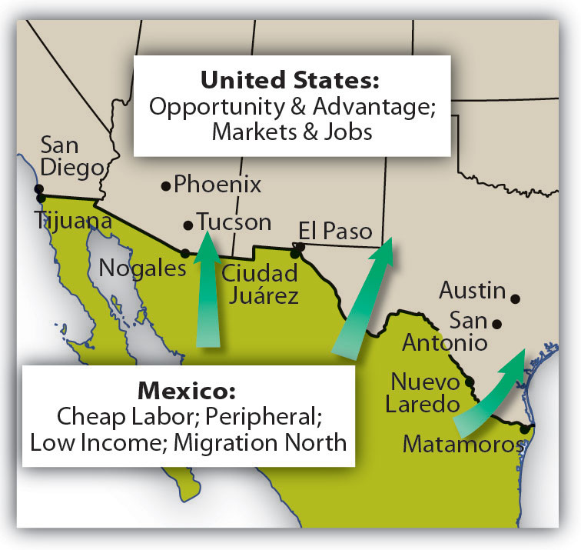
Environmental
- _________
  - Irish Migration
  - Potato Famine
- Environmental ____________
  - Earthquakes, hurricanes, volcanic eruptions, flood, drought
- Can make _______________ migration ____________________
Economics
- Better ________ opportunities
- __________________
- US & Canada have been prominent _______________________ for economic migrants
  - Most recently ____________ America & _____________ are primary senders for economic reasons
Distance Decay
- Comes into play with ______________ factors of migration
- Migrants likely to have more complete _______________________ of _________________ places than of farther ones
- Leads many migrants to _______________ to a locale ____________________ to home than they originally contemplated.
Intervening Obstacles
- Hinder migration
- Historically, environmental
  - Mountain, Oceans, Distance, etc.
- Modern, political
  - Proper documentation to leave &/or enter countries
Find an example of a modern political Intervening Obstacle in a news article. Write a “tweet” summary of the article & attach a copy to the packet

Global Migration Flows
- Between _________ & 1950, major global migration flows were influenced largely by
  - _____________________________
  - Colonization
  - The Atlantic __________________ Trade
Regional Migration Flow
- Migrants go to _____________________ countries
  - ________________ term economic opportunities
  - ________________ with cultural groups across borders
  - Flee political conflict or war
Economic Opportunities
- Islands of _______________________________
  - Places within a region or country, where __________________ investments, jobs, & infrastructure are
____________________________.
- _______________________________ migration to ______________ (Late 1800s to Early 1900s)
  - Work in ______________________, commerce, & financing.
Reconnect cultural groups
- Between 1900 to 1948
  - About 700,000 ________________ migration to _____________________________
- After _________________
  - 600,000 Palestinian Arabs _________________ or were pushed out of newly designated _________________ territories.
National Migration Flows
- Also known as ________________ migration
- ___________
  - _____________ Americans moved north during early 20th century
  - Attraction of the “_________________” region
- __________
  - ________________ workers move to larger cities
Guest Workers
- Migrants whom a country _______________ to fill a ______________ need
- Assume the workers will go “______________” once the labor need subsides
  - Short term work ______________
  - Send ____________________ to home country
US Immigration Patterns
- _____________ foreign-born residents than any other country
  - Approx. _____ million as of 2010
- ____________ main eras
  - ___________________ settlement in 17th & 18th centuries
  - Mass __________________ immigration in the late 19th & early 20th centuries
  - _____________ & Latin American integration in the late 20th & early 21st centuries
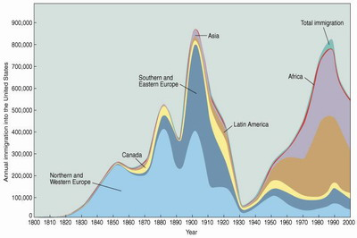

Forced Migration – draw and label on the below three maps that historic forced migration movements
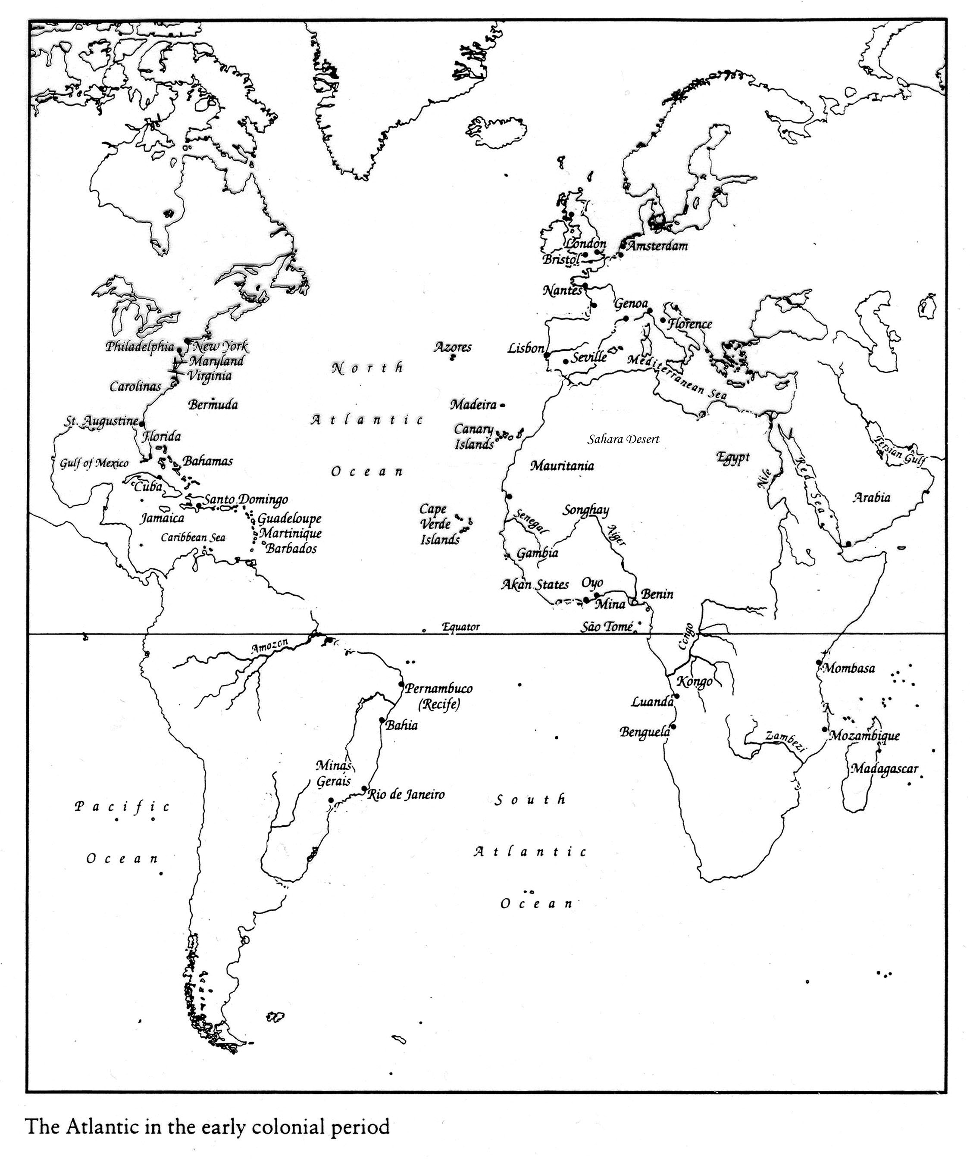

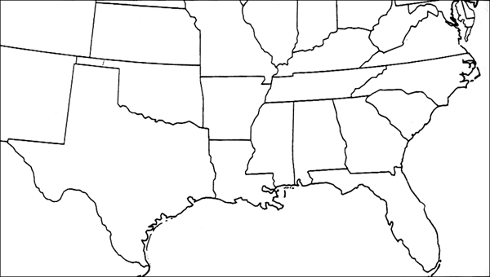
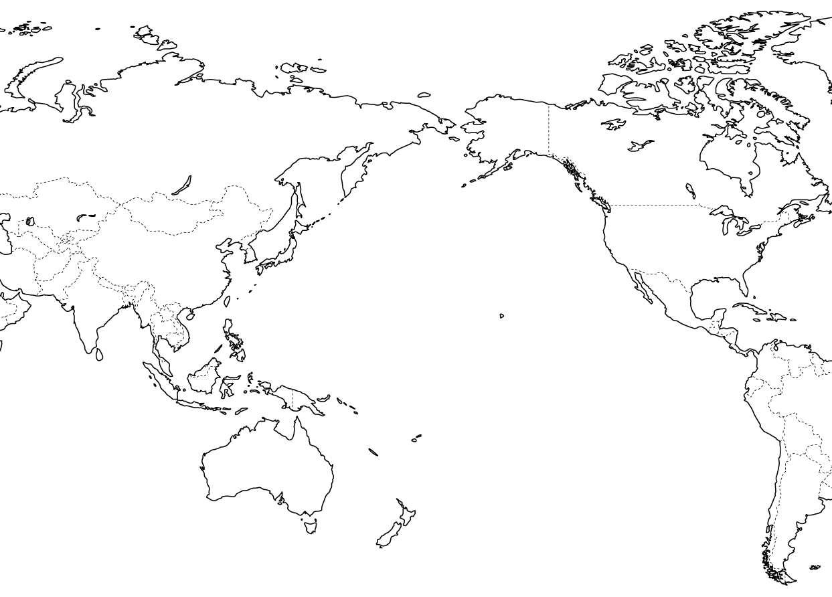

One-Pager – must contain the following: 1 visual per key issue 2 vocab per issue; Text in your own terms “I learned...; I believe...”
Key 2
Key 1

Chapter 3
Migration

Key 4
Key 3

Major Refugee Source Countries – draw and label on the below map the locations and provide information about the push & pull factors of the major refugee source countries (please see canvas review page for map)

Documented Migration from Middle & South America to the US – draw arrows and label the below map with information about the flow of legal immigrants from Latin America into the United States.

Chapter 4 – Folk & Popular Culture
Culture Big Ideas
- Pop Culture vs Folk Culture
- Material vs Non-Material Culture
- Acculturation, Assimilation, Syncretism
- Cultural Hearths & regions
- Cultural landscape
  - Placelessness & convergence of
- Housing
- Diffusion of Culture
- Distance Decay & Time-space compression
- Effects of Globalization
What is Culture
- The _________________________ of three things
  - Customary beliefs & _______________________
  - Material artifacts
  - Social forms (political institutions)
Population Culture vs. Folk Culture
- Popular culture
  - Large, incorporates _________________________________ population
  - Typically, _________________
  - Experiences quickly changing cultural traits
  - Encompasses clothing, music, ____________________, food, religious practice, & aesthetic values
- Folk
  - Small, incorporates a _________________________________ population
  - Typically, ____________
  - Cohesive in cultural traits
Material vs. Non-Material Culture
- ________________ Culture
  - Things that we _________________
  - Art, houses, clothing sports, dance, & foods
- Non-material culture
  - The __________________, aesthetics, & values of a group of people
- Your material culture will _____________________ your nonmaterial culture
  - I.E. the Chinese _____________________ has historically been the symbol of the Chinese Emperor. Currently it is used as a symbol of the Chinese culture.
Acculturation
- When one group of people adopt the cultural traits of another culture

Acculturation is the process of social, psychological, & cultural changes that stem from blending between cultures. Historically, it is the direct change of one’s culture through dominance over another’s culture.
- Group level – results in changes to culture, customs, religious practices, diet, healthcare, & other social institutions
- Individual level – refers to the socialization, process by which foreign-born individuals adopt the values, customs, norms, attitudes, & behaviors, of the dominant hot culture.

Assimilation
- The process by which people ______________ originally differentiating ________________, when they come into contact with another society or ___________________.
  - I.E. Native Americans 1800s to the 1900s – the US government wanted to ___________________ the indigenous people into the _____________________ culture.
Syncretism
- The ____________________ of traits from two different cultures to make a _________________ culture.
  - I.E. Most of the traditions we associate with ___________________ come from early ____________________ symbols for springtime & rebirth.
Cultural Hearths
- Areas from which important cultural traits ______________________
  - Mesopotamia – creation of writing, innovations in mathematics & astronomy, & architectural developments (built large temples)
  - The ____________________ – known for building thousands of miles of roads in the mountains. Legacy is the persistence of Quechua (official language of the ________________).; Mayans – elaborate pyramids; Aztec – complex religious systems, detailed calendar, & an effective bureaucracy.
  - West Africa – wealthy empire allowed art, _______________, & other components to flourish.
  - Greco-Roman – (Greek) most remembered for their contributions to art, _______________________, & science. (Roman) achievements in government, military, engineering, & bureaucracy.
  - Indus Valley – communal baths, early working _________________ system, importance of agriculture
  - North China – domestication of grains, fruits, & vegetables; later dynasty remembered for bronze art, first Chinese ______________________ systems, & well organized political system
  - Nile River – complex ____________________, political, & social systems; cultivated a variety of grains & had a complex _______________________ system. Science, math, & technological influences around the Mediterranean.
Early cultural hearths were almost completely determined by their physical environment – I.E. Environmental determinism

Cultural Regions
- An area that ___________________ a large number of cultural traits
  - I.E. North America – similarities in ______________________ & religion
Cultural Landscapes
- Refers to the cultural ______________________ on an area, including buildings, agricultural patterns, roads, signs, & nearly everything else that _______________________ have created.
- Basically, the human ______________________ on an area
  - How have we changed the landscape?
  - What buildings, statues, & so forth have we erected?
- _______________________ – the loss of uniqueness in a cultural landscape
  - One place looks like the next.
Convergence of Cultural Landscapes
- _____________________ of architectural forms & planning ideas around the world
  - Property management companies that have worldwide holdings may ______________________ the same companies to lease space in all their buildings
- Widespread _________________________ of businesses & products create distinctive landscape stamps around the world.
- ________________________ of idealized landscape images blurs place distinctiveness
  - Las Vegas Strip – Caesar’s Palace, Paris, etc.
Housing
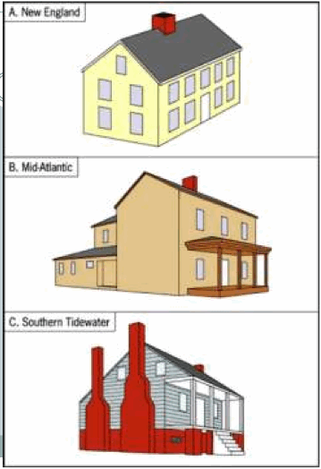
- ______________Housing
  - Environment influence – available building materials (wood, brick, ___________, sod, etc.)
  - Climate & _______________ influences
  - Form may derive from religious or other ____________________________ belief (walls, door orientation, etc.)
  - ____________ - style of pioneer homes reflected whatever upscale style was prevailing on the East Coast from where the people migrated.
    - ________________________________ – “I” house. One room deep, two rooms wide
    - Lower Chesapeake/Tidewater – one story, steep roof & chimney at either end
    - ____________________________ – box shaped with a central hall
  - Mid ___________ century
    - Display popular culture, rather than __________________ influences
    - Most houses are mass-produced by construction companies
    - Show the influences of shapes,
_____________________, detailing, & other feature of architectural style in vogue (in the current fashion or style) at any one point in time.
Cultural Diffusion
- Cultural traits ________________ from a point of origin, or hearth.
- Two ways for _______________________
  - Expansion
    - Contagious – nearly all adjacent individuals are affected (Flu)
    - Hierarchical – occurs through a ____________________ of people (Louis Vuitton)
    - Stimulus – not all the ideas are going to readily & directly be adopted (India McDonalds)
  - Relocation
    - Movement of the ________________________ who have already adopted the idea or innovation
- Independent Invention
  - Developments that can be traced to a specific civilization or hearth (democracy)
Distance Decay & Time Compression
- During the past century, the pace of diffusion ___________ to months, weeks, days, & in some instances even hours.
  - The _________________ extent of diffusion has also expanded
- Distance Decay – likelihood of diffusion ______________ with time and distance from the hearth.
  - Altered by ___________________________ & communication technologies
- Time-Space compression – diffusion depends upon the ________________________ of the places.
  - Through modern ______________________________, major world cities have become more and more connected
  - Create the _________________________ through which innovations diffuse.

One-Pager – must contain the following: 1 visual per key issue 2 vocab per issue; Text in your own terms “I learned...; I believe...”
Key 2
Key 1

Chapter 4
Folk & Popular Culture

Key 3
Key 4

Cultural Hearths – locate and label the cultural hearths on the map below. Underneath list the important traits, ideas, technologies, religions, & social structures.

Artifacts & Mentifacts – on the Venn diagram below, draw some of your cultural artifacts & write about some of your mentifacts. There are times where our artifacts represent our mentifacts. Draw those in the shared space

Chapter 5 – Languages Review
Languages Big Ideas
- Language
  - Language Families
  - Dialects
  - Divergence
  - Convergence
- Diffusion of language
- Distribution of language families
- Disappearance of Languages
  - Endangered & extinct
- Revived & artificial languages
- Spatial interactions
  - Lingua franca, pidgin, Creole
- Toponym
What is Language?
- A system of ___________________________ through speech, a collection of __________________ that a group of people understands to have the same __________________.
- Many __________________ designate at least one __________________ language to be used for official documents & public objects (I.E. road signs & money)
- Organized into:
  - _______________ – collection related through common ancestral language
  - Branches – __________________ within a family
  - _____________________ – collection within a branch that share common origin in the relatively recent past. Display ________________ grammar & vocabulary
Language Families
- At the _______________________ scale, we classify languages into language __________________
  - The languages have a ___________________ by fairly distant origin
- Families are broken down into ____________ families
  - _________________ within a language family
  - Commonalities are more definite & origins are more recent
  - Consist of individual ___________________
  - Smaller ________________ extent
Classification of Languages
- _________of the world’s population speak a language that belongs to the ___________________________________________or Sino-Tibetan language family
- ________________of the world’s population speak a language that fits into one of _________other language families.
- ________________________of population speaks a language belonging to one of ___________smaller families.
Dialects
- ____________________________of a standard language, along ______________________________or ethnic lines
  - Vocabulary, ____________________________ Pronunciation, Cadence, Pace of speech
- Linguists think about dialects in terms of ______________________
  - Distributed across _____________________________
  - Those __________________________to each other geographically will be the most similar.
- Can be marked by actual differences in _______________________________
  - Linguistic geographers ________________________the extent of particular words marking their ____________________________as isoglosses.
  - _____________________________ - a geographic boundary within which a particular linguistic feature occurs.
Go to www.slanguage.com
Take a look at some of the phrases used in different places throughout North America. Think about some that you or a friend/relative might use every day and come up with two different examples/translations from some different places.

Language Divergence
- When a ____________________of spatial ____________________________among speakers breaks the language into _______________________ & then ____________languages.
  - I.E. When the ___________________________Empire disintegrated, places with the region discontinued ___________________, prompting a round of linguistic divergence.
Language Convergence
- If people with ______________________languages have consistent ________________________ interaction, convergence can take place.
  - ______________________languages become ________________.
  - I.E. Frankish traders revitalized the ports of the Eastern Mediterranean. Local traders did not speak the language. Frankish was mixed with Italian, Greek, Spanish, & Arabic.
- Create special _________________________for researchers because the rules of _______________________may not apply or may be unreliable.
Language Diffusion
- Several ________________________hypothesize how, why & where languages _____________________ over time.
  - Each ________________________according to the impetus for diffusion
  - One commonality is a ___________________on ____________________________
  - Conquest Theory
  - Agriculture Theory
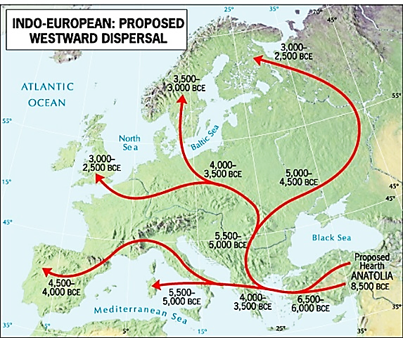
  - Dispersal Theory
  - Renfrew hypothesis
Conquest Theory
- _____________________speakers of Proto-Indo-European ________________________________ from east to west on horseback, ______________________________earlier inhabitants & beginning the _____________________________ differentiation of Indo-European tongues.
  - Sound shifts in derivative languages represent a long period of ___________________________ in languages as one moves __________________________through Europe.
Agriculture Theory
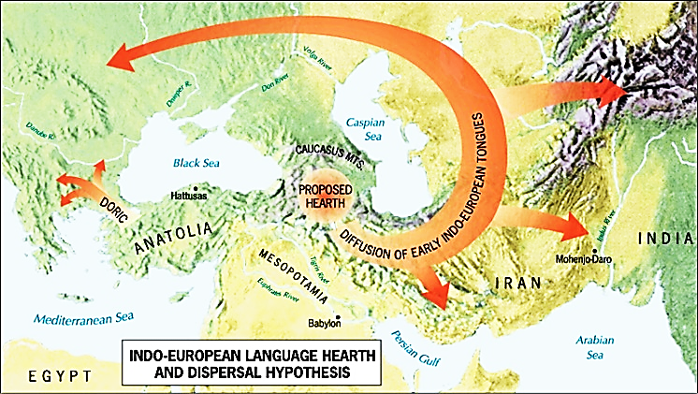
- With increased ______________________________& increased ____________________________, speakers from the hearth of Indo-European languages ____________________________into Europe.

Dispersal Hypothesis
- Indo-European languages first __________________ from the hearth ___________________into present-day Iran & then ___________________the Caspian & into ________________________
Renfrew Hypothesis
- Proto-Indo-European ______________________ in the _____________________ Crescent
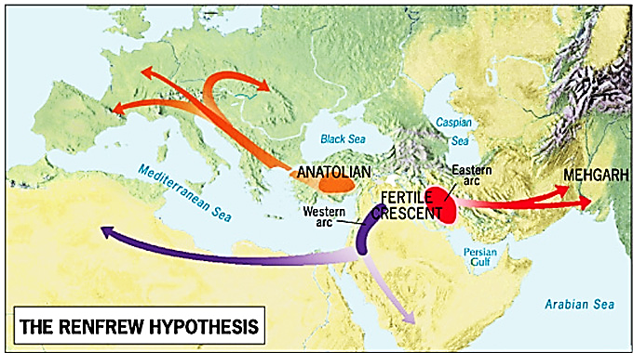
  - From _____________________ diffused Europe’s languages
  - From the Western Arc, diffused North __________________& Arabia’s languages
  - From the _________________________Arc, diffused SW Asia & S. ____________________ languages.
Mutual Intelligibility
- Means _____________________people can ___________________ each other when speaking.
  - _______________________________ between languages or dialects. Different by related varieties can readily ______________________ each other.
  - _____________________________:
    - Cannot ________________________mutual intelligibility
    - Many “languages” ________________the test of mutual intelligibility
    - Standard languages & governments __________________________what is a “language” & what is a “dialect”
Distribution of Language Families
- Two _______________________language families are….
  - Indo-European
    - Predominate language family in _________________ S. Asia, N. America, & Latin America
  - ______________________________
    - Encompasses languages spoken in the People’s Republic of ___________________& several smaller countries in SE Asia.
      - No _______________________Chinese language
      - ________________________________is the most-used language in the world & the official language of both the PRC & Taiwan. Most _______________________of native speakers.
Indo-European Distribution
- ___________________most widely spoken branches
  - ________________________________
    - Spoken primarily in NW Europe & North _____________________________
    - Divides into High & Low Germanic Subgroups
      - _____________________________is classified in the Low Germanic group
  - Indo______________________________
    - Spoken primarily in S. __________________________
    - Most speakers of the language branch
    - ____________________________into eastern (Indic) & western (Iranian)
  - Balto_______________________________
    - Spoken primarily in _____________________________Europe
    - Divided into…
      - East Slavic & Baltic Groups - _______________________, Ukrainian, & Belarusian
      - West & South Slavic Groups – Polish, Czech, _______________________________________________________ & Serbo-Croatian.
  - ________________________________
    - Spoken primarily in ______________Europe & Latin America
    - Most widely used are ______________________ Portuguese, _______________________________ & Italian
      - Regions where spoken language tend to ________________________to political ________________________________of Spain, Portugal, France, & Italy.
Disappearance of Languages
- Language _____________________________creates branches on the language tree with dead ends.
  - Representing a ___________________________in interaction between the extinct language & languages that continued.
- Linguists predict that at least _______________of the world’s 7,000+ languages with be _______________ or dying by ___________________.
Endangered Language
- Anthropologist Wade Davis estimated that __________________of the world’s languages are ________________________________.
- Most are lost because one group ___________________________another, and the dominant language is _____________________________________
- Two ___________________________to characterization of endangerment…
  - Number of ______________________who identify with a particular language
  - Number & ________________________of the users or functions for which the language is employed.
Extinct Language
- Languages can become ___________________________when all descendants _______________________________or when they choose to ____________________another language
- Does not __________________________________overnight
  - Takes place across _________________________________
- Presently _______________languages
  - 46 in Africa, 182 in ___________________________, 84 in Asia, 9 in ____________________________, & 152 in Pacific
- Possible to ____________________a large part of an extinct language.
  - ________________________reconstruction – track sound shifts & hardening of consonants “backwards” ____________________the original language.
Spatial Interactions Create:
- Lingua Franca
  - A ________________________________used among speakers of _____________________ languages for the purpose of _____________________& commerce.
  - Can be a _____________________language, or a ________________of two or more.
  - ______________________became lingua franca during colonial period.
- ________________________Language
  - A language created when people _______________________parts of two or more languages into a ________________________structure & vocabulary
- Creole Language
  - A ____________________language that has developed a more ___________________structure & vocabulary & has become the ______________________language of a group of people.
Toponym
- Cultural geography Yi-Fu Tuan, studied the ________________________& function of language in shaping of ________________________
  - By ____________________a place, people in effect call that place into _____________________
- Geographers call place names __________________________
  - Imparts a certain ______________________________a place.
  - ________________the social ____________________________on a place
  - Can give us a glimpse of the _______________________of a place.
Changing Toponyms
- When people ____________________the toponym of a place, they have the power to ______________________________ out the _______________________
- Major reasons people change toponyms
  - After __________________________
  - After a political revolution
  - To _____________________________people or events
  - To commodify or brand a place
- Example:
  - Small town in Wales
  - Feared loss of the Welsh language & despised the role English had played in diminishing the Welsh language.
  - Wanted to boost their local economy & attract tourists
  - Renamed their town: Llanfairpwllgwyngyllgogerchwyrndrobwllllantysiliogogogoch

One-Pager – must contain the following: 1 visual per key issue 2 vocab per issue; Text in your own terms “I learned...; I believe...”
Key 2
Key 1

Chapter 5
Language

Key 3
Key 4

Chapter 7 – Identity: Race, Culture, Gender, & Ethnicity
Identity Big Ideas
- Identity
- Ethnicity
  - Distribution
  - Ethnic islands, Ethnic neighborhoods, ethnic conflict
- Race
  - Segregation
- Gender
  - Gendered space
  - Power Relationships
- Sexuality
Identity
- How we make __________________of ourselves
- We ______________________our own identity
- ________________across ____________________, & affect others across scales
- Are ________________, constantly changing, shifting, & becoming
- We works towards an identity that _____________with who & where we are at any given _____________________in time.
- We also define other
  - Identifying __________________ - we define the “_____________________” & define ourselves as “not the other”
What is Ethnicity?
- Often ________________________with culture
  - ______________________culture, but also encompasses many other ______________
- Based on how people __________________________to identify themselves
  - A social __________________that defines itself based on ________________________such as ______________________________culture traits or a common history, race or geographic region.
Ethnicity
- Groups define what constitutes _______________________________
- Several __________________________exist why humans organize themselves into ethnic groups
  - Some believe people are ____________with an instinctive sense of ethnic identity
  - Pervasiveness of _______________________________ - attitude of cultural superiority
  - Ethnicity is _______________________constructed. Ethnic identity is a result of the _________________________________among different groups of people.
Ethnic Neighborhoods
- At the smallest geographic _________________, we can identify ethnic neighborhoods in many towns and cities.
  - Areas with __________________________________________populations of a particular ethnic group
  - Can ______________________their ethnic identity over time
- Ethnic groups can be ________________________into a distinct geographic area
  - Historically, European Jews were restricted to certain areas - ____________________
  - Reflected the mistrust & ethnic __________________, but can provide a degree of _______________________________
- ______________________reasons for segregation
  - New __________________can be passed
  - Segregated groups can ______________________to live together rather than ___________________________or moving.
Ethnic Neighborhoods – US
- _______ - every 10 years, ______________________conducts an enumeration of the population
  - Survey identifies _______main ethnicities
    - _______________Americans – from countries in Asia
    - ___________________Americans – identify as a group with cultural origins in Africa
    - Hispanic – from ____________________-speaking countries
- Ethnic groups may __________________________in different regions & particular ____________________________________
  - Hispanics – clustered in Southwest
  - African Americans – clustered in Southeast
  - Asian Americans – clustered in the West
Ethnic Neighborhoods
- African American & Hispanic are highly ________________________________in urban areas
  - I.E. ____________________________ - neighborhoods in the south & ______________ side have extensive African American clusters
  - I.E. _______________________________ - African Americans in south-central; Hispanics in east; Asian Americans in south & west.
Ethnic Islands
- ______________________than ethnic neighborhoods or _____________________________
- Areas of ethnic concentration in _________________, or non-urban areas.
  - Settled __________________the mid-____ century (____ & Canada)
  - ______________________migration – the settlement of a whole area en masse by a particular ethnic group
  - Chain __________________________also assisted in creation of ethnic islands.
Ethnic Conflict – Competition
- Ethnicity & __________________________________are similar concepts in that membership is defined through shared values
  - Nationality ________________from ethnicity in terms of legal standing
  - Defined specifically through shared experiences derived from ________________, obtaining a passport, and performing __________________duties.
- ____________________________between the two can lead to violent conflicts.
  - ___________________________ - 60% Muslim & 40% Christian. Christians consider themselves ethnically descended from the Ancient Phoenicians. When the government system was created Christians controlled a majority.
  - ___________________________ - 3 principal ethnicities (Sinhalese, Tamil, and Moors) dispute between Sinhalese and Tamil date back more than 2000 years. Tamil feel discriminated against by Sinhalese.
Ethnic Conflict – division
- South __________________
  - _______________________________& India – basis of separation was ethnicity
    - India majority ___________________
    - _______________________majority Muslim
- ____________________________
  - Live in the Caucasus Mountains
  - After WWI, created an independent state of ______________________________________
  - ___________- became part of Turkey
  - Today, the Kurds are _____________among several countries
  - Turkey has tried repeatedly to __________________________the Kurdish ______________________, including outlawing their language.
Ethnic Conflict – Cleansing and Genocide
- Ethnic _____________________ - process where a more powerful ethnic group __________________________removes a less powerful one to create ethnically __________________________________region.
  - Removal of _________members of less powerful ethnicity – men & women, young & old.
  - In recent years, carried out primarily in Europe & Africa
- _____________________Europe – deportation of Jews, Gypsies, & other undesirable groups
- Bosnia (1993) – ethnic cleaning of the ________________________Muslims
  - Serbs & Croats fought to ____________________the portions that they inhabited with Serbia & Croatia, respectively
- ______________________(late 1990s)
  - Part of Serbia, with ethnic ________________________________compromised 90% of the population
  - Serbs launched a 4 part campaign of ethnic cleansing
  - BY 1999, had forced ____________________of the 2 million Albanians from their homes
Ethnic Cleansing & Genocide (continued)
- Widespread in Africa because of the ______________________boundaries
- Northeastern Africa - _______________________
  - Arab nomads (_____________________________) crushed Darfur’s black population
  - 480,000 killed; ________million forced to live in refugee camps
- _________________________
  - Several different ____________________groups _________________________for control
- Rwanda (1994) – Hutus vs Tutsi
- __________________(late 1990s) – Hutus & _____________________________vs Tutsi
- Widespread in Africa because of the ______________________boundaries
- Northeastern Africa - _______________________
  - Arab nomads (_____________________________) crushed Darfur’s black population
  - 480,000 killed; ________million forced to live in refugee camps
- _________________________
  - Several different ____________________groups _________________________for control
- Rwanda (1994) – Hutus vs Tutsi
- __________________(late 1990s) – Hutus & _____________________________vs Tutsi
Race
- A _______________________________of humans based on skin _____________& other physical characteristics
- Categories are social & ____________________________constructions because they are based on _____________________that some biological ___________________________are more important than others.
- An identity that is often ______________________________.
Segregation
- __________________________________Segregation
  - Historically states, cities, & towns passed ____________________outlining residential segregation
  - ______________________________the migration of certain racial ________________into neighborhoods
  - Douglas Massey & Nancy Denton – defied as a degree to which two or more groups live ___________________________from one another, in ______________________parts of the urban environment.
  - ___________residentially segregated large metropolitan areas for African Americans is _________________________________Wisconsin
    - Second, Detroit Michigan
  - ________________segregated areas is ________________Country, California; following by San Jose, California.
Gender
- Refers to the societal __________________& behaviors that are ________________________ of males or females.
- Geographers have increasingly looked at gender as a source of ________________________.
- Believe that society ____________________spaces based on socially defined gender _________________& that gender affects the way we interact with the world.
  - ________________________________ - places designed for women or for men.
- Gender roles are not the __________________in all countries.
Power Relationships
- ______________________________& structures about who is in _____________________, who has power over others.
- Affect _________________________directly & cultural landscapes
- Can also ______________________________entire groups of people
  - Society enforces ideas about the ways people should ____________________
- Women in ____________________________________Africa
  - Populate much of the rural areas
  - Society & _______________________________work in conjunction to subjugate women
  - Have heavy ___________________________________and few rights
  - Produce estimate ______% of the regions food.
India – Dowry Deaths
- _______________________of brides (often by burning) when a ___________________arises over dowry.
- Difficult to “_________________________away” the power relationships that lead to dowry deaths.
  - Women still remain disempowered in much of Indian societies
  - Female ______________________________is also tied to the disempowerment of women.
- ___________________________issues to the global scale has the potential to draw _______________________________________to the social ills.
One-Pager – must contain the following: 1 visual per key issue 2 vocab per issue; Text in your own terms “I learned...; I believe...”
Key 2
Key 1

Chapter 7
Ethnicity

Key 3
Key 4

Eight Stages of Genocide – fill in the below with information, in your own words, about the 8 stages of genocide (see document in canvas)

Chapter 6 - Religion
Religion Big Ideas
- Religion
  - Role in society
  - Secularism
  - Monotheistic, Polytheistic, Animistic
- Diffusion of Religions
- Major World religions
- Hearths of religion
  - S. Asia
  - China
  - Eastern Mediterranean
- Religious Landscapes
- Religious conflicts
What is Religion?
- According to geographers, Robert Stoddard & Carolyn Prorak, religion is “a system of ______________& practices that attempts to ________________life in terms of culturally ________________________ultimate ____________________.
  - “__________________” people explain & justify how they & others “should” _____________________based on their religious beliefs.
- A __________________________force in societies, especially those less dominated by ______________________________.
- _____________over time
- Have been ___________________across cultural ____________________& language boundaries.
Role in Society
- In some _______________________, it practically constitutes __________________
- Religion _______________________itself in many different ways.
  - ____________________of souls of ancestors in living natural objects.
  - Belief that certain living persons possess capacities granted by a ______________________power
  - Belief in deity or _______________.
- In _________________________, industrialized, urbanized societies, religion has become ____________________________to secular culture & government.
- Effect on Culture
  - “good” life has rewards & “bad” behavior risks punishment – controlling individual behavior.
  - Modes of ________________acceptable & ________________a person can or cannot eat.
  - Commercial practices
  - Location & structure of ____________.
Secularism
- The ______________________________to or rejection of formal religion
- Most secular countries in ________________________
  - 2009 Pew Survey – How important is religion in their lives?
    - 13% in France
    - 8% Sweden
    - 7% in Czech Republic
- Even if your society is _______________________& regardless of your religious beliefs, what you eat, when you work, when you shop, & what you are allowed to do, are all influenced by ______________________.
Monotheistic, Polytheistic, Animistic
- Despite the wide ______________________of religions found around the world, they are commonly classified into ______categories.
- Based on their approaches to the concept of ________________________
  - _________________________ - worship a single deity, a God, or Allah
  - Polytheistic – worship more than one ___________, even thousands.
  - ________________ - centered on the belief that inanimate objects, such as mountains, boulders, rivers, & trees possess __________________& should be revered.
- Throughout much of human history, virtually _____________religions were either animistic, polytheistic, or ____________
  - Approx. _________yrs. ago monotheistic religion developed in SW Asia - ______________________________________.
Diffusion of Religions
- Religions diffuse through…
  - ___________________ - including both contagious & hierarchical
  - ____________________
- With either of these, ___________________or followers ___________________with people who do not espouse the religion
  - Sometimes lead to __________________________
- _____________________interaction occurs because of migration, missionary efforts, & even ___________________.
Major World Religions
- Any map of world religions is a _______________________
  - ___________________must be used when making observations from the map.
  - _______________minority religions, many of which have a significant number of followers
  - Some of the regions shown as belonging to a particular ____________________are places where faiths have penetrated relatively ___________________.
- Each of the widespread religions _____________in one ________________________
  - They are all ___________________________
    - Actively seek converts because they view themselves as offering belief systems of universal appropriateness & appeal.
Hearths of Religion – S. Asia
Hinduism
- ________largest after Christianity & Islam
- Monotheistic ______ polytheistic.
- ____________religion – appeals primarily to one group of people living in one place
  - Do not actively seek converts
- Dates back over ____________years
- No _____________founder, theology, or agreement on its origins
  - Recognize the sacredness of the _____________ - texts that make up the sacred books
  - _____________
  - Doctrines are closely tied to Indian society’s _____________system
- Sacred River - ________________River
Buddhism
- Splintered from _____________________over 2500 years ago
  - _________________to questions about Hinduism’s teachings
- Prince Siddhartha - __________________
- Preached _______________________could be attained by anyone
  - Knowledge; _____________________of greed, craving, & _____________; complete honesty; & never hurting another person or animal
- Various ____________________have an estimated ______million adherents
  - Mahayana & Theravada claiming most adherents
- ________________________________religion
- Nonevangelical
Diffusion Of…
- Hinduism __________________________from present-day Pakistan to the Ganges River.
  - ______________________through S Asia & into SE Asia.
  - First attached itself to _____________________faiths & then slowly replaced them.
  - Over the last two centuries, through migration
  - During colonialism, ___________________________diffusion to British colonies.
- ____________________first spread due to Emperor Asoka
  - Sent ________________________to distant peoples
  - Spread as far south as Sri Lanka
  - Later advanced to ___________________________, Tibet, China, Korea, Japan, ___________________, & Indonesia over 10 centuries.
  - Changed as it grew & is strongly _____________________with different forms
  - Has become a _________________religion
Hearths of religion – Huang He River Valley
Taoism
- Beginning _______________
- Trace the religion to an older __________________________of Confucius, _______________
  - Focused on the __________________form of political rule & on the oneness of humanity & nature
- Gave rise to the concept of _______________Shui.
  - Nothing should be done to nature without consulting the geomancers.
- Virtues are _____________________, spontaneity, tenderness, & tranquility.
- War should be __________________________
What is the main difference between Confucianism & traditional religions?
Confucianism
- Addressed the traditional Chinese tenets that included ________________in heaven & the existence of the soul, ancestor ________________________, sacrificial rites, & ___________________________.
  - Held that the meaning of life lay in the __________________________
  - __________________to one’s fellow humans should supersede service to spirits.
- Mainly a ____________________________of life.
- Had great & lasting impacts on Chinese life
- _________________________as a spiritual leader after his death.
Diffusion Of…
- ____________________________diffused throughout East & SE _______________
  - Has long ____________________________the practice of Buddhism
- Diffusion ________________China has been tempered by ______________________ efforts to suppress religion
- Both so entrenched in Chinese culture that government _______________________ have not had desired __________________
- More recently, Chinese __________________________expanded influence in parts of SE Asia, Europe, & N. ___________________________.
Shintoism
- ______________religion
- Focuses particularly on _____________________& ___________________worship
- Japanese emperor made state religion in 19th century
- ___________________religion
- Mostly found in _________________________
Hearths of religion – Eastern Mediterranean
Judaism
- ___________________________
- Ethnic
- Grew out of the belief system of the Jews about _________________years ago
- Traditions lie in teachings of ____________________
- Not limited to contiguous territories
  - ________________________through parts of Middle East & N. Africa, Russia, Ukraine, Europe, & parts of North & South America.
  - Only country where this religion is the majority is Israel
- __________branches
  - Reform – developed with objective of adjusting Judaism & practices to current times.
  - ________________ - sought to retain old precepts
  - Conservative – less strictly orthodox, but not as liberal as reform.
Diffusion of…
- Jewish _______________ - scattering of the Jews after Roman destruction of _________________________________.
  - Now signifies the spatial dispersion of members of any ethnic group
- _________________ - idea of a homeland for the Jewish people
  - Popular during the _________century
- _________
  - UN created _____________& Palestine
  - Many Jews moved to Israel after establishment
  - __________ - 10000 __________former Soviet Union; 4000 Jews from Africa; over 2000 from western Europe & North America each.
- _____ million Jews worldwide
  - 40.5% US; 40.2 Israel
Christianity
- ______________back to same hearth as Judaism
- Stems from a _______________founder, Jesus
- Teachings hold that Jesus was placed on Earth to teach people to live according to God’s plan.
- ______________________
- Universalizing
- First __________between Roman Catholic & Eastern Orthodox
  - Divided for purposes of ___________________
  - Roman _________________________claims most adherents (more than ___ billion)
- 15th & 16th centuries lead to _________________________Reformation
Diffusion of…
- _______________________combined with relocation diffusion
  - Christianity declined in Western Europe after fall of the Roman Empire
- _______________________diffusion as religion ideas spread from coastal Ireland & Scotland throughout western Europe
- Eastern Orthodox – contagious diffusion from the religion’s hearth in ____________________________to north & northwest.
- Protestantism – contagious diffusion to several parts.
  - ___________________________into northern & central Europe as political leaders converted.
- Worldwide diffusion occurred during European _____________________
- Has always been characterized by aggressive & persistent _____________________
  - Attempt to _________________people to their beliefs.
Islam
- ______________________of the major religions
- _____largest to Christianity
- Monotheistic
- Traced back to a single founder, ______________________________
  - Received the truth directly from __________________
- Precepts of Islam ___________________Judaic & Christian beliefs & traditions
  - One god; earthly matters are profane; ___________________& omniscient
- ____pillars of faith
- ______ main branches – occurred almost immediate after death
  - _________________ - great majority
  - _________________ - concentrated in Iran
Diffusion of …
- Converted Arabian Kings utilized ______________to spread faith across Arabian _______________________
  - Diffused throughout North Africa
- Early _____century included parts of Africa, Europe, Arabia, Middle East, & present-day _________________________
- Through ______________, later spread across ___________________Ocean
  - Established new ______________________hearths & worked to diffuse contagiously
- Recent diffusion into Europe, S. Africa, & the Americas has largely been through _____________________
  - Relocation diffusion
Indigenous & Shamanist
- ____________________________religions – reverence for _______________, passed through _________________units & groups (tribes) of indigenous people
  - No central tenet or belief
  - __________________because they share the same ______________from diffusion of global religions
- ______________________ - community __________in which people follow their shaman (religious leader)
  - Appeared at various times to various peoples in Africa, Native America, SE Asia, & E Asia
  - _______________________religion
Religious Landscapes
- Marks cultural ____________________with houses of worship, cemeteries, icons, stores for religious goods, ____________________________________
  - _______________________ - act of voluntary travel to a religious/sacred site
- Sacred Sites
  - _________________________ - sacred to Jews, Christians, & Muslims
  - Hinduism & Buddhism – pilgrimages to follow prescribed routes
    - Hinduism – temples & shrines are sacred
    - Buddhism - _____________tree
  - Christianity – medieval churches, cathedrals, or monasteries
  - Islam – mosque with towering ________________. Holy _________ in the Grand Mosque.
Religious Conflicts
- Usually _________________more than differences in spiritual practices & ________________
- Functions as a _____________________of a wider set of cultural & political differences
- _____________________boundaries – boundaries between the world’s major faiths
  - Subject to potentially divisive cultural forces – particularly when people ________ their religious differences as a _____________of social _________________ in their country.
- _____________________boundaries – boundaries within a _____________major faith
  - Include divisions between Christian Protestants & Catholics, Muslim Sunni & Shi’ite
Places of religious Conflict
- _____________________ - Muslim & Jews
- Nigeria – Muslims & Christians
- _______________________ - Muslims, Eastern Orthodox, & Roman Catholic
- Ireland - _________________________& Catholic
- Religious _____________________________ - born out of frustration over the perceived _________________________of society’s more & values, lack of religious authority, failure to achieve economic goals, etc.
  - Holds religious _______________as nonnegotiable & ______________________
- Religious ______________________ - fundamentalism carried to the extreme
  - Christianity
  - ________________
  - Islam

One-Pager – must contain the following: 1 visual per key issue 2 vocab per issue; Text in your own terms “I learned...; I believe...”
Key 2
Key 1

Chapter 6
Religion

Key 3
Key 4

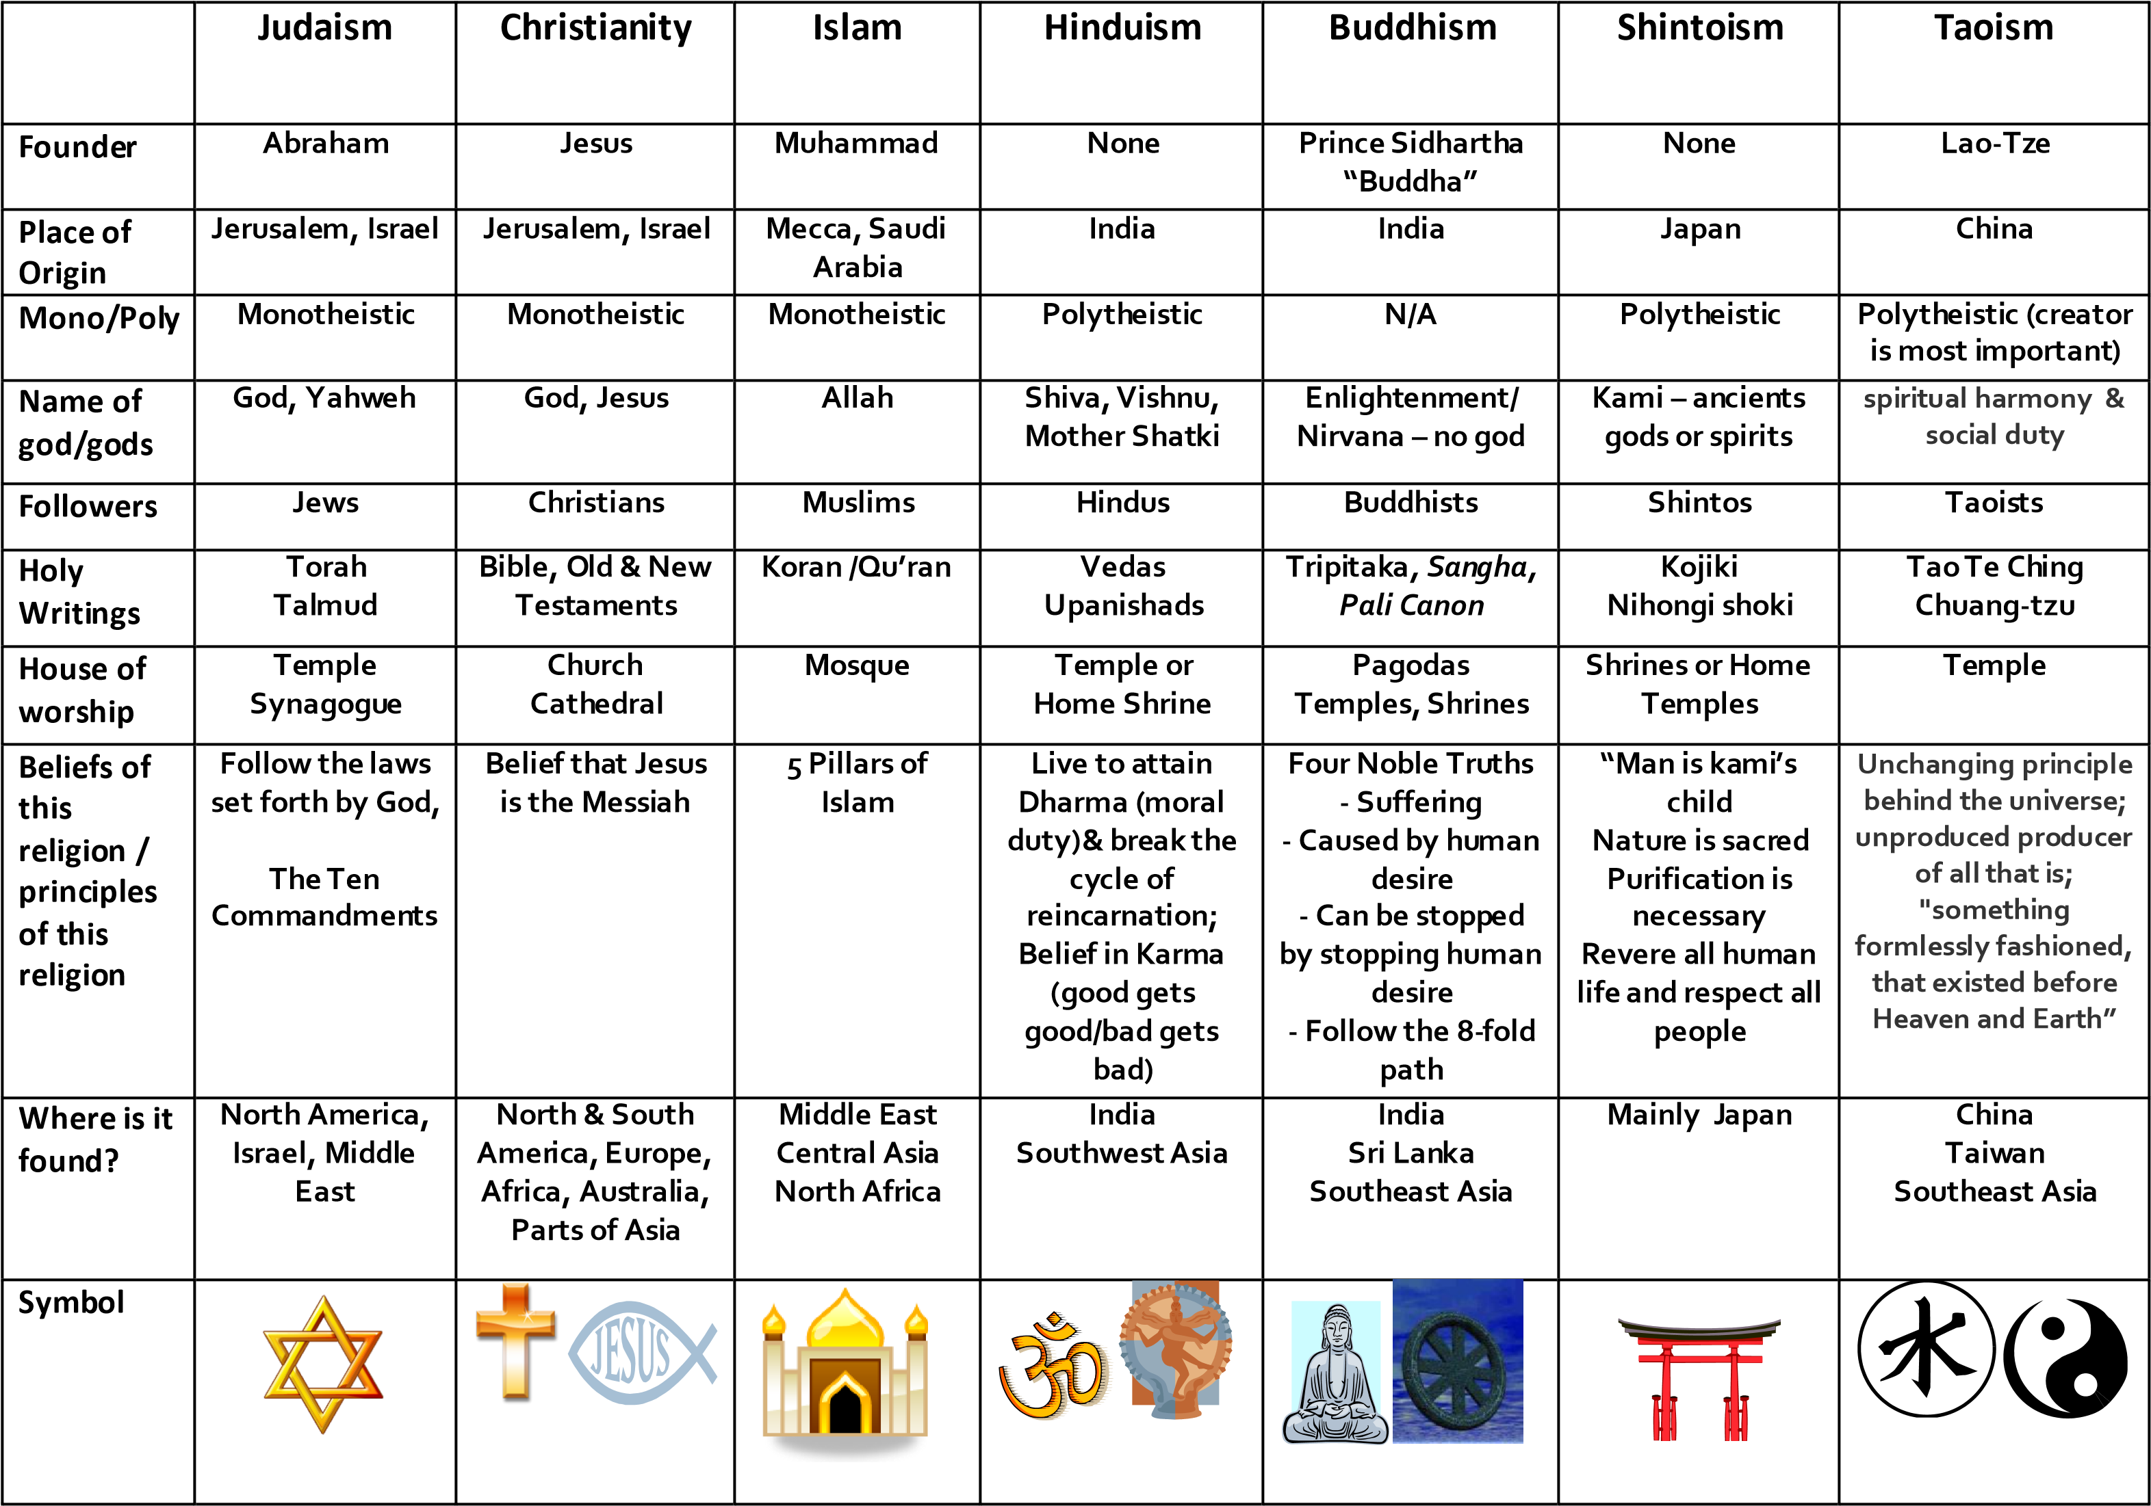

Chapter 8 - Political Geography
Big Ideas
- State, nation, nation-state
- Multinational states & multistate nations
- Shapes of states
- _________________________
- Territoriality
- Heartland vs. Rimland
- Types of boundaries
- ______________________________ & Redistricting
- Centripetal & Centrifugal forces
- UN Law of the Seas
- Federal v. ___________________________ state
- Devolution
States, Nations, Nation-states
- State must haves:
  - ____________________, established government, control over internal & foreign affairs, defined territory with a __________________________ population
  - Nation are culturally defined group of _____________________ with a shared past & common future who ________________ to a territory and government
- Nation-states is a state whose __________________ corresponds to that particular ______________________
Multinational State
- A multinational state is a country that contains more than ____________ ethnicity with traditions of self-determination.
  - World’s largest: ______________
  - What are some other multinational states?
Multistate nation
- A group of _________________ who share a common ________________________ and live in __________________ states
  - I.E. Basque, Russian, Korean, Kurds, Arabs etc.
State Shapes
- Compact: _________________________
  - Distance from the center to any boundary does not vary significantly
  - Can be a beneficial characteristic for smaller states because good _________________________ can be more easily established
- _________________________: Potential Isolation
  - Long narrow shape
  - Can suffer from poor communications; capital may be __________________
- Prorupted: Access or disruption
  - Compact state with a large ____________________ extension
  - Created for 2 reasons: provide access to a ________________________ or separate states
- ________________________: South Africa
  - A state that completely surrounds another
- Fragmented: ________________________________
  - Includes several _________________________ pieces of territory
  - Two kinds and both may face problems and costs associated with communication & maintaining national ______________________
- Enclaves & Exclaves
  - ______________________ – a piece of land totally surrounded by a foreign territory (Vatican City, San Marino, Lesotho)
  - _______________________ – land politically attached to a larger piece by not physically attached. (Kaliningrad)
Supranationalism
- Where individual states come _____________________________ to work together toward ______________________ goals.
  - UN, EU, NAFTA
  - Pro: brings countries together to help aid each other
  - Con: __________________ of cultural ____________________________
Territoriality
- A country’s sense of ______________________ and ______________________ toward its territory, as expressed by its determination to keep it inviolable & strongly ________________________.
- According to Robert Sack:
  - The attempt by an individual or group to affect, influence, or control people, phenomena, or relationships, by delimiting and asserting control over a geographic area.
Heartland v Rimland
- ________________________________ Theory (Mackinder)
  - Believed a ____________________ based power would ultimately rule the ______________________.
  - ___________________________ was the most important area in the world, containing a “pivot area” extending from Eastern Europe to eastern Siberia
    - Who rules East Europe rules the Heartland
    - Who rules the Heartland rules the world island
    - Who rules the _____________________________ rules the world.
- ___________________________ Theory (Spykman)
  - Believed the Eurasian ____________, not its heart, held the key to global power
    - Who controls the Rimland rules Eurasia
    - Who rules Eurasia controls the destinies of the world
  - Saw a ________________________ Rimland as a _________________ to the world’s balance of power. (Todays Rimland includes Western Europe & China)
Boundaries
- __________________ boundaries
  - Coincide with the _________________________ landscape
- ___________________________ boundaries
  - Follow the distribution
- ___________________________ boundaries
  - Coincide with latitude & _____________________________ lines
Gerrymandering
- _________________________ legislative boundaries (aka redistricting) for the purpose of __________________________ the party in power.
- Three types
  - ___________________ vote – _________________ opposition supporters across many districts, but in the minority
  - _____________________ vote – _______________________ opposition supporters into a few districts
  - ____________________ vote – _______________ distant areas of like-minded voters into oddly shaped boundaries
Centripetal & centrifugal
- ________________________ forces – hold a state ____________________.
- _______________________ forces – ____________________________ a state
UN Law of the Seas
For Shame!!! There has yet to be an FRQ about UNCLOS!!! Maybe something to really study here?!?!
- Under the Law of the Sea – defines the ___________________ & _________________________________________ of nations with respect to their use of the world’s _________________
  - __________________ Seas – permits states to delimit territory up to ____ miles and sovereignty extends in all forms in this zone
  - Exclusive Economic Zone (_______) – state has ________________ rights to 200 nautical miles; right to control ___________________________/exploitation of natural resources in the water, seabed, and subsoil below. Includes fish, minerals on the seafloor, oil, etc. all belong to the state. If _____ extends beyond 200nm from the shore, the coastal state can go up to 350 nm from shore.
  - Common _________________ Clause – minerals belong to “___________________” and their exploitation is subject to UN management.
Federal v unitary
- ____________________ state – allocates strong power to units of ______________ government within the country
  - Local governments possess considerable ________________________ to adopt their __________________ laws.
  - More suitable for very ______________________ states due to the national capital may be too remote
- __________________________ State – places most power in the hands of _____________________ government officials
  - In principle, works best in ______________________________ characterized by few internal cultural differences & strong sense of national _______________.
    - Especially common in Europe
Devolution
- The _______________________ of a country into ______________________ countries due to a _______________________ within the country.
  - Balkanization
- _______________________________ - a form of nationalism in which the “_____________________” is defined in terms of ____________________________.
- _______________________ – movement intended to ______________________ & reoccupy a lost homeland
  - Russian annexation of Crimea to “protect” ethnic Russians

One-Pager – must contain the following: 1 visual per key issue 2 vocab per issue; Text in your own terms “I learned...; I believe...”
Key 2
Key 1

Chapter 8
Political Geography

Key 3
Key 4

Supranational Organizations – label the different Supranational Organizations on the below map. Color each of the countries within that organization a separate color (i.e. all NAFTA countries would be one color, CARICOM, etc.). Make sure to include a map key.

☐NAFTA
☐CARICOM
☐Mercosur
☐European Union
☐African Union
☐Gulf Cooperation Council (GCC) ☐ASEAN

Chapter 10 - Agriculture
Big Ideas
- Agricultural Revolutions
- ______________ Revolution
- Responses to modern agriculture
- Types of Agriculture
- Agricultural __________________
- Von Thünen
- Women in agriculture
First Agricultural Revolution
- The _________________________ of seed crops marked the beginning
  - Seems to have developed in more than one area & at different _________________
  - Majority view is that the ___________________ development took place in SW Asia
- As new sites are excavated, archeologists change their assumptions on the ___________________ of agricultural hearths
  - _______________ – new evidence shows much earlier development
  - Africa – much more ___________________
- _______________________ on how to farm crops diffused quickly outward from the hearths
2nd Agricultural Revolution
- Would move agriculture beyond ____________________________ to generate ___________________ needed
The Second agricultural revolution coincided with what?
- Composed of a series of ________________________, improvements, & techniques
  - Initially found in ____________________________, the Netherlands, Denmark, & other neighboring countries.
  - Seed drill, new _______________________, artificial feed, advances in livestock breeding, innovations in machinery & transportation
  - Increased ____________________ made it possible to feed a much larger urban population
3rd/Green Revolution
- Associated with the use of _____________________________ to expand agricultural production
  - Science enabled farmers to produce crops more _____________________________ on the land & to bring more, marginal land into production
  - Relies on the _________________________________ of seeds, intensified use of technology & irrigation, & expanded use of land
- Dates back to the ___________________
  - _________________ Mexico – hybrid corn
  - 1960s India – _________________ (IR8)
  - Also brought new high-yield varieties of _________________ & corn from the U.S.
- At a time of increased concern about _________________________ hunger, so the promise of increasing food production has been seen favorably
Gene Revolution
- New _____________________________ revolution
  - Altering the ______________________ makeup of crops & modifying the _______________ of plants to create new crops through biotechnology
- Production of genetically modified organisms has accelerated over the past ______ yrs.
  - Found in ___________% of all processed foods
- Major debate
  - _______________________ argue that they help feed an expanding world population
  - Opponents state that companies are releasing ________________________ into the environment without understanding the environmental, health, or socioeconomic ____________
    - Impact of pollen dispersal on other organisms & the potential for disease resistant plants to spur the evolution of super-pests
Organic, Non-GMO, Eat Local
- Organic agriculture now accounts for just over _____% of all food sales in the country
  - Fields are devoted to __________________________ all kinds of food stuff
  - Has ____________________ some farmers in the core countries to extract themselves from the control of large, external corporate interest
  - Some ____________ environment benefits
  - Non-GMO
- Eat ____________
  - Aims to ______________________ producers & consumers in the same geographic region
  - Develop self-reliant & resilient food networks & improve ________________________
Commercial Agriculture
- Non subsistence farming was profoundly shaped by ________________________ in many poorer countries
  - Implemented a system to ___________________ their needs & tended to lock the poorer countries into producing one/two “_______________” crops
- Producing countries consider forming a cartel in order to present a __________________ front to the importing countries
  - Collective action is _____________________________ to coordinate, as the importing countries can buy from other countries
- Cash crops grown on large estates are termed ____________________________ agriculture
  - Colonial ___________________ that persist in poorer, primarily tropical countries, along with subsistence
  - Many productive plantations are ___________________ by European or American individuals or corporations.
What crops are primarily grown on plantations?
Subsistence Agriculture
- Has taken hold where farmers feel production for the _________________ market has not benefited them ________________________ or culturally
- ________ forms of subsistence agriculture: sedentary & shifting cultivation
  - _______________________ cultivation is primarily found in ________________/subtropical areas, where farmers have had to abandon plots of land after the soil became ___________________
    - Slash-and-burn agriculture (__________________, milpa, or patch agriculture) – reflects the central role of the controlled use of fires in places where this technique is used.
While swidden, milpa, & patch agriculture are all slash-&-burn, what is the difference between the three?
Agricultural Regions
- Derwent Whittlesey identified ___________ agricultural regions, plus _________ area where agriculture was non-existent
- Regions were _________________ between 5 that were important in the ____________________ region & 6 in the ________________________ region
- Developing
  - ________________ nomadism –drylands of N Africa, & SW, Central, & East Asia
  - Shifting Cultivation –tropical regions of Latin America, sub-Saharan Africa, & SE Asia
  - Intensive subsistence, wet ____________ dominant –the large population concentrations of East & South Asia
  - Intensive subsistence, crops other than rice dominant –the large populations concentrations of East & South Asia, where growing rice is difficult
  - __________________ – tropical & subtropical regions of Latin America, sub-Saharan Africa, South Asia, & SE Asia.
- Pastoral nomadism – based on the _____________________ of domesticated animals
  - Depend primarily on _________________ rather than crops for survival
  - Do not wander randomly, but rather have a strong sense of _________________________
  - ______________________ – seasonal migration of livestock between mountains & lowland pasture areas
- Shifting Cultivation
  - Two ____________________ features – farmers clear land and then grow crops on said land until soil nutrients are ______________________.
- Intensive ag, wet rice – farmers work __________________________ to subsist on a parcel of land
  - Waste virtually _______________ land
  - Wet rice refers to rice planted on dry land in a nursery and then moved as ___________________ to flooded fields to promote growth.
- Intensive ag, crops other than rice
  - Where ___________________________ levels are too low & winter weathers too harsh
  - Much of the interior of ______________ & northeastern China
  - ___________________ is the most important
- Plantation
  - Generally situated in developing countries, but often ________________ or operated by European or North American companies
  - Crops processed at the plantation & then shipped as processed goods are less _______________
  - Cotton, _____________________, coffee, rubber, tobacco, cocoa, jute, bananas, ________, coconuts, & palm oil
  - Must ________________ workers & provide them with food, housing & social services.
Agricultural Regions
- Developed
  - ________________ crop & livestock – primarily the US Midwest & central Europe
  - Dairying – primarily near ___________________________ clusters in the northeastern US, southeastern Canada, & NW Europe
  - _______________ – primarily the north-central US, south-central Canada, & Eastern Europe
  - Ranching – primarily the __________________ of western North America, southeastern Latin America, Central Asia, sub-Saharan Africa, & Chile
  - _________________________ – primarily lands surrounding the Mediterranean Sea, the western US, the southern tip of Africa, & Chile
  - Commercial ___________________ – primarily the southeastern US & southeastern Australia
- Mixed crop & livestock – most ________________________ form of commercial ag in the US
  - Most crops ___________ to animals; livestock supply manure to improve soil fertility for crops
  - Nearly all land area _______________________ to growing crops
  - Permits farmers to __________________________ the workload more evenly over the year
  - __________________ is most frequently planted in the US & typically involves crop rotation
- Dairying – most important practiced on farms _____________ large urban areas
  - In developed countries, the most important in the first _______________ outside large cities
  - Farmers face ______________________ difficulties due to declining revenues & rising costs
- Grain – the ____________________ crop on most farms
  - Commercial grain ag is ________________________________ from mixed crop, because crops on grain farms are grown primarily for consumption by humans
  - Most important: ___________________
  - Increase in developing country ____________________ due to growth in large-scale commercial ag.
  - Large scale production is heavily _________________________, conducted on large farms, & oriented to consumer preferences
  - Generally located in regions too _____________ for mixed crop & livestock
  - North America, is concentrated in three areas –
    - ________________ wheat: Kansas, Colorado, & Oklahoma – planted in autumn
    - ________________ wheat: Dakotas, Montana, and southern Saskatchewan
    - Palouse region of Washington State
- Ranching – the commercial grazing of __________________________ over an extensive area
  - Importance of ranching in the US extends beyond the people, importance in popular culture (i.e. Hollywood films) has helped to draw attention & to illustrate the ___________________ role it plays in the history & settlement
  - Spread of crop farms has ___________________________ the US from ranching to crop growing
  - Growth of ____________________ has been seen more in developing countries
    - China is the leading producer of meat
- Mediterranean – exists ______________________ on the lands that border the Mediterranean Sea
  - Areas share a similar physical ____________________________ with prevailing winds that provide moisture & moderate the winter temperatures
  - Most crops are grown for _____________________ consumption
  - Most important cash crops: _________________ & grapes
    - US: citrus fruits, tree nuts, & deciduous fruits
- Commercial gardening & fruit farming – _______________________ type of ag in the _________________________ US
  - Region has a long growing season & __________________ climate
  - Accessible to the large markets in the eastern US urban areas
  - _______________ farming is frequently practiced in the region
    - Highly efficient large-scale operations that take full advantage of machines at every stage.
    - Willing to ____________________________ with new varieties, seeds, fertilizers, & other inputs to maximize efficiency
    - Hire ______________________ workers
    - Tend to specialize in few crops
  - ________________________ farming has spread to New England
    - Growing crops that have ________________________ but increasing demand
      - Asparagus, peppers, mushrooms, strawberries, & nursery plants
      - Represents a _________________________ alternative to dairying.
Von Thünen model
- First proposed in _______________
  - Which crops to ___________________ & which animals to raise based on market location
  - Farmers compares ___________ costs: land & transportation of product
- Grown in different _________________ around the city
  - 1st ring: market-oriented gardens & milk producers. Delivery costs were expensive & must reach market fast due to _________________________
  - 2nd ring: _________________ lots; closeness to market is important due to weight
  - 3rd ring: various crops & pasture; __________________________ from one year to the next
  - 4th ring: devoted exclusively to animal __________________________.
- Assumed that all land had ________________________ site characteristics & was of ________________ quality
- Model could _______________ based on topography & other distinct physical conditions
Women in Agriculture
- On average, women comprise _______% of agricultural labor force in developing countries
  - Typically work longer _______________ than men
  - Tend to be employed for _____________________________________ tasks
  - _______________ workers dominate employment in areas of export-oriented high-value agriculture

One-Pager – must contain the following: 1 visual per key issue 2 vocab per issue; Text in your own terms “I learned...; I believe...”
Key 2
Key 1

Chapter 10
Agriculture

Key 3
Key 4

US Agricultural Regions – label and color the below map (to the best of your ability) with the US Agricultural Regions. (Utilize the map on Canvas for reference)

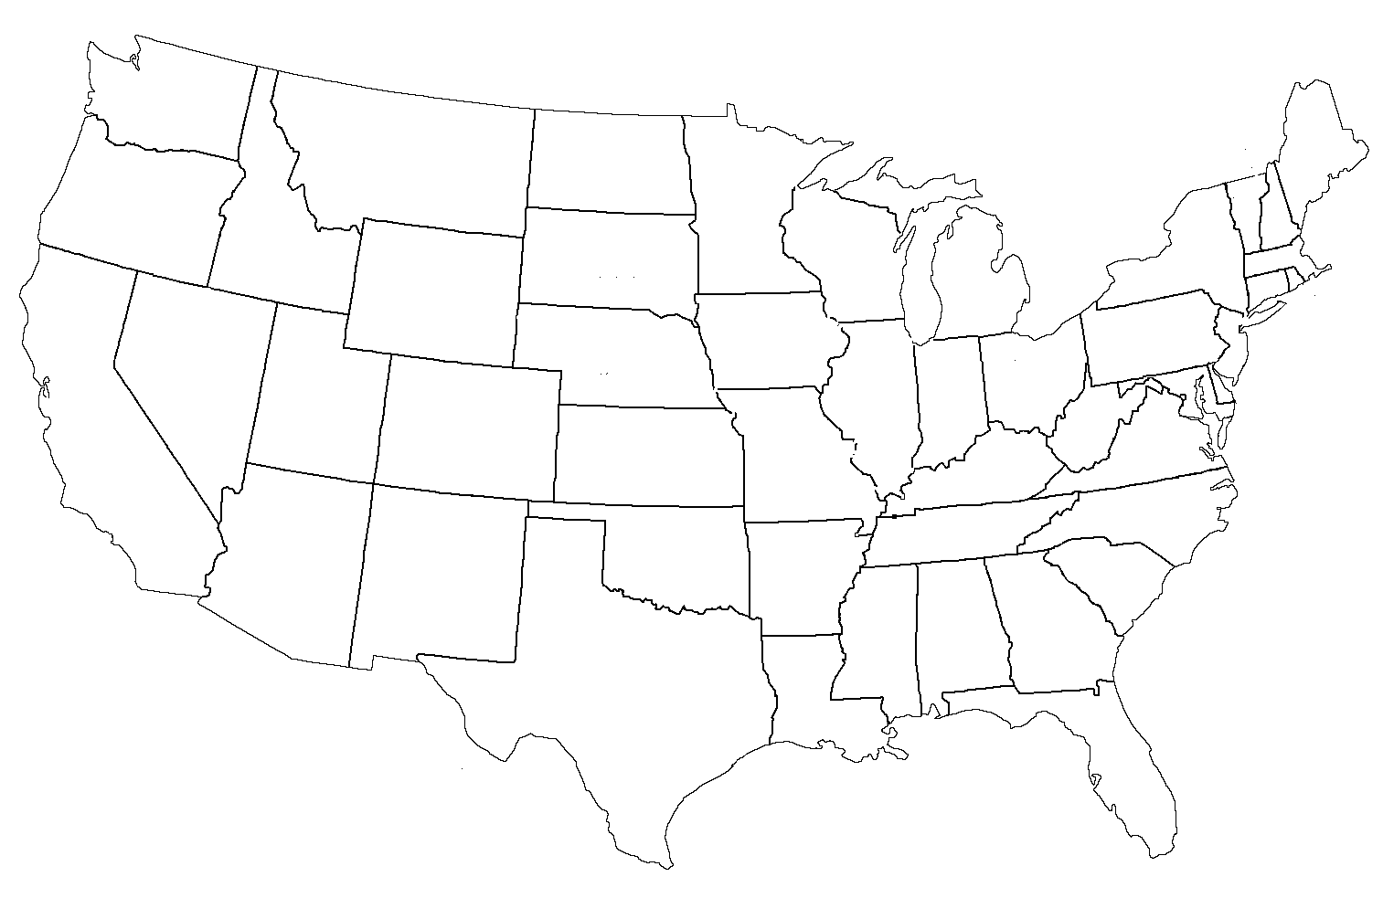

This map is for your reference – please make sure to study the different agricultural/climate regions. There have been FRQs in the past that have referenced these specific regions.
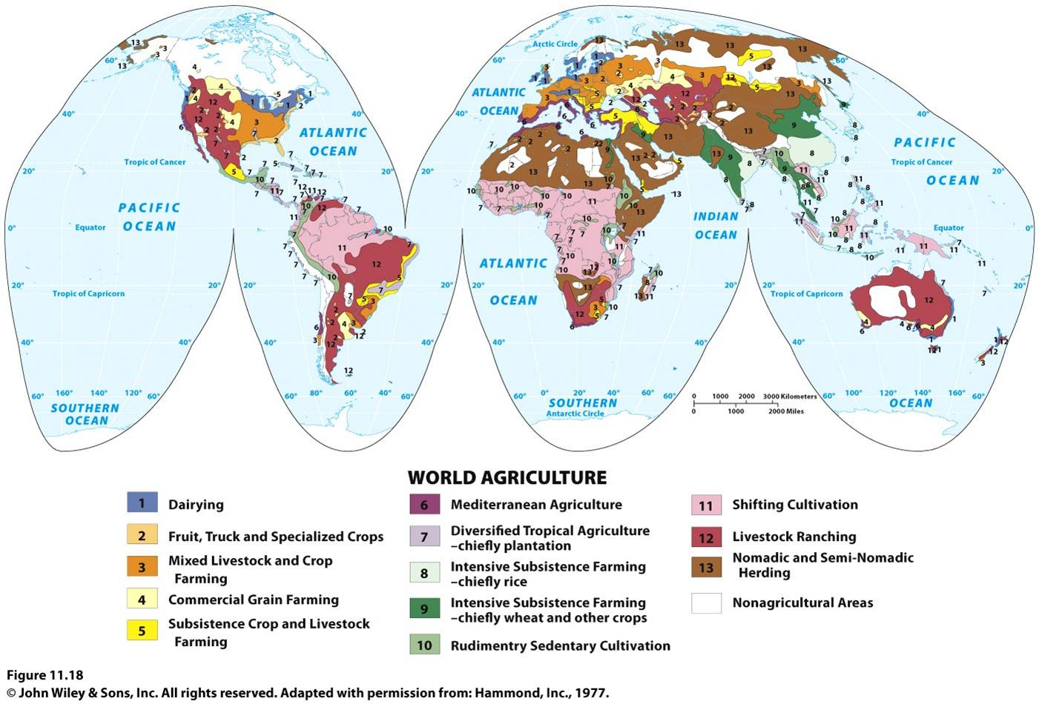

Chapter 9 - Development
Big Ideas
- Measures of development
- __________________ Model
- Wallerstein World ______________________ Theory
- UN Millennium Goals
- ___________ Trade
- Microfinance
- ____________
- UN Sustainable Development Goals
Measure of Development
- Countries are grouped into _____ classes
  - Very ___________ developed
  - High developing
  - ____________________ developing
  - Low developing
Measure of Development
- Every place lies at some __________________ in development
  - _________________________ process
- To measure development, the UN created the ____________ Development Index (HDI)
  - Has computed HDIs since the ____________
  - Highest possible score __________
  - Development is a function of ______________ factors:
    - Decent standard of living
    - Long & healthy life
    - Access to knowledge
Decent Standard of Living
- UN measures the standard of living through the annual gross ________________ income per capita at ________________________________ power parity
  - Gross National Income (________): value of the _________________ of goods & services produced in a country in a year, including the __________________ that leaves & enters the country
  - Purchasing Power Parity (_________): adjustment made to the GNI to account for _____________________ among countries in the cost of goods
Decent Standard of Living
- Avg. per capita is ____________________ in developed countries because people typically earn their living by different means
- Jobs fall into ____ categories/sectors
  - Primary – natural resource ___________________
  - Secondary – ______________________________ that process, transform, and assemble raw material
  - _________________ – the provision of goods & services in exchange for payment
- Contribution to GNI among the sectors ________________ between developed & developing
- Part of the wealth generated in developed countries is to ________________________ goods & services
  - Especially ____________________ are goods & services related to transportation & communication
- Every person should have access
  - _________________________ adjusted HDI (IHDI) ___________________ the HDI to account for inequality within a country
  - ___________________ scores in Sub-Saharan Africa & S. Asia
A Long & Healthy Life
- Good _______________ is an important measure
  - Goal is to provide the nutrition & medical services needed
- Life expectancy at birth is the HDI health indicator
  - With longer life expectancies, developed countries have a higher ______________________ of retired people & a lower percentage of children under _____
Access to Knowledge
- UN believes that access to ____________________________ is essential for people to have the possibility of leading lives of _____________
  - Years of _______________________ is the most critical measure of the ability of an individual to gain access to knowledge
  - Also measures the ____________________ of education
    - Pupil/Teacher ______________ & Literacy rate
Gender Inequality
- To measure extent of _________________________, UN created the Gender Inequality Index
  - Combines _____________ measures, including empowerment, labor, & reproductive health
  - __________________ - % of seats held by women in national legislature & % who have completed high school
  - _________________ – female participation rate
  - Reproductive health – _________________ mortality ratio (# who die giving birth per 100,000) & adolescent ____________________ rate (# per 1000 women 15 – 19)
- Gender inequality has declined since the ________ in nearly every country
- ________ GII has increased
  - Points to ___________ factors
    - Reproductive rights are _______________________ than in any other very high HDI country
    - Percentage of women in national ______________________________ is lower
Rostows Model
- Proposed in __________________
  - ____________________________ – society has not yet started development
  - Preconditions to takeoff – _______________________ leadership moves the country toward greater productivity
  - Takeoff – country experiences something akin to an ____________________________ revolution. Sustained growth takes hold, urbanization increases
  - Drive to maturity – __________________________ diffuses, modernization is evident
  - Age of _______________ consumption – high incomes, widespread production, majority work in service sector
Wallerstein
- Depicted the ______________________________ between the developed & developing countries
- In an increasingly _______________________ world, developed countries form a _____________ area, whereas developing countries occupy __________________ locations
World-Systems Theory
- North America, Europe, & ________________ account for a higher percentage of the world’s ___________________________ activity & wealth
- __________________________ countries have less access to the world centers of _________________________________, communications, wealth, & power.
UN Millennium Goals
- To reduce ___________________ between developed & developing countries
Fair trade
- Proposed as a ________________________ of the international trade model of development.
- Commerce in which products are _______________ & traded according to standards to ________________ workers & small ____________________.
Microfinance
- Alternative source of _________________________
  - _____________ loans & other financial services
  - Aids in the _________________________ of small businesses
  - _________________________ of loans allows for future lending

One-Pager – must contain the following: 1 visual per key issue 2 vocab per issue; Text in your own terms “I learned...; I believe...”
Key 2
Key 1

Chapter 9 Economic Development

Key 3
Key 4

Brandt Line – Label &color the below map according to the developed & developing world. Answer the following questions.
- What is the Brandt Line? What are 5 factors that would explain the economic disparity between the two areas? Since the maps creation (1980) how might it have changed?

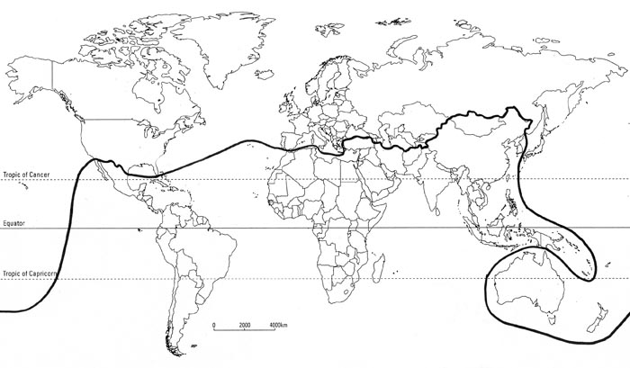
Chapter 11 – Industry
Big Ideas
- ______________________ Revolution
- Industrial Regions
- Site & Situation
- _____________________ locational model
- Weber least cost theory
- August _______________
- Pollution
Industrial Revolution
- Series of __________________________ in industrial technology that transformed the process of ______________________________ good
  - Transformation was for more than industrial
  - Changes involved a ________________________ diffusion of new ideas & techniques
- Commonly used to define the process that began in the __________ in the late 1700s
Industrial Region
- Europe
  - Rhine-Ruhr Valley: iron & steel due to proximity of ______________ fields
  - ___________________: most centrally located.
  - Po Basin: numerous workers & inexpensive __________________________________
  - NE Spain: fastest growing ______________________________
  - _________________: oldest industrial region
  - St. Petersburg – _______________________
  - Urals – proximity to minerals has attracted chemical, machinery, & metal fabricating
  - Volga – largest ________________________ & natural gas
  - Silesia – skilled by low paid workforce & proximity to wealthy markets
- North America
  - New England: _____________________ textile till the early 19th century
  - Middle Atlantic: attracts industries with a need for proximity to consumers
  - Mohawk Valley: takes advantage of inexpensive ____________________________
  - Pittsburgh-Lake Erie: leading ________________ producer till late 19th due to proximity of coal & iron
  - Western Great Lakes: hub of _______________________
  - SE Ontario: Canada’s most important industrial area
- Asia
  - ______________: initially became industrial power by producing goods that could be sold in large quantity
  - China: largest supply of low-cost labor & world’s largest market for many _______________________ products
  - South Korea: __________________-oriented. Leading producer of ocean going _______________.
Site & Situation
- Site factors – result from the ____________________ characteristics of a location
- ________________________ – involves transporting materials to & from a location
  - Proximity to Inputs: optimal location is as close as possible to inputs if the cost of ___________________________________ raw material is greater than the product to consumer
    - Bulk ____________________ industries – “take something out during manufacturing”
  - Proximity to ____________________ – optimal location is close to consumers if the cost of transporting to consumers is higher
    - Bulk ________________________ industries – “add something in during manufacturing”
    - _______________________________ products
Hotelling
- ____________________ cannot be understood without reference to other industries of the same kind
  - Businesses depend on the geographic _____________________ to other businesses, attractions, etc. to stay in business or the ____________________ wants/needs the company in a specific location
Weber
- _______________________ equivalent to the Von Thünen Model
- Manufacturing will locate where _________________ are the least
  - ____________________________ – best site is where cost to transport material & finished product if lowest
  - Labor – high labor costs reduce profit-location. Location near __________________ labor can offset transportation
  - Agglomeration – when a group of industries _____________________ for mutual benefit
What are some common industries that benefit from agglomeration?
Losch
- Determine the locations manufacturing plants could choose to _____________________ profit
  - Firms will try to identify a ________________ in which some kind of profit can be expected
    - To left & right, ____________________ decay will make sales unprofitable
    - Will try to situate themselves _______________ from the margins of that zone
    - Other businesses can always change the _________________________ of that zone
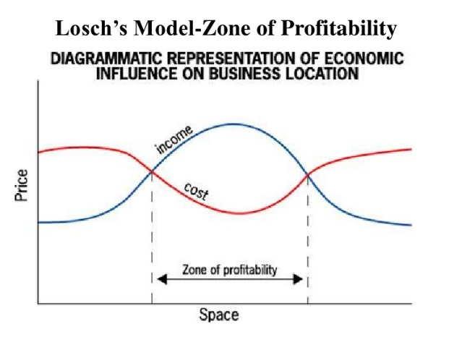

One-Pager – must contain the following: 1 visual per key issue 2 vocab per issue; Text in your own terms “I learned...; I believe...”
Key 2
Key 1

Chapter 11 Industrial Development

Key 3
Key 4

Chapter 12/13 – Urban Patterns
Big Ideas
- US Urban Models
- _______________________________
- Urban Revival
- ______________________ City v. Rank Size Rule
- Central Place Theory
- ______________________ Model
- Urban Hierarchy
- City sizes
Urban Models
_____________________ Concentric Zone
  - 1st to explain the _______________________ of different social groups within urban areas
  - Cities grow ___________________ from a central area in a series of ______________________________ rings
  - Zone 2: contains __________________________& poorer quality housing
  - Zone 3: contains modest older houses occupied by _____________________class
  - Zone 4: contains newer & more ________________________houses for middle class
  - Zone 5: beyond the _______________________________built up area (commuter zone)
Hoyt Sector Model
- A city develops in a series of _________________
  - Certain areas are more ______________________________ for various activities
  - As cities grow, activities _______________ outward in a wedge.
Multiple nuclei model
- A city is a ______________________ structure that includes more than ________ center around which activities revolve.
  - Some activities are attracted to particular _________________, whereas others try to _______________ them
SE Asian City
- Also known as the _______________________ Model
- No _______________, but several components of the CBD are present in separate areas in the city
  - Old _____________________ port
  - Western commercial zone
  - ________________________ sectors & zones
  - New Industrial parks on the ________________________
Latin American City
- ______________________________ model
- Cities in Latin America are built around a _______________ CBD.
  - Commercial ___________________ surrounded by elite housing
  - Areas surrounded by three ______________________ zones of housing that ________________ in quality
Sub-Saharan Africa City
- _______________________ model
- Impact of European ______________________________
  - Central city has _____________ CBDs
    - Former ________________________ CBD has vertical development
    - _______________________ CBD is usually a zone of one story buildings
    - ____________________ CBD is open-air, informal
Urban Realms Model
- _________________ Model
- A “_____________________” multiple nuclei model
  - Includes _____________________ Cities
  - Allows for the ____________________________________ of a growing population
Suburbanization
- Trend of city dwellers moving to __________________________ areas away from the core
  - Exploded after ____________ with transportation
- An element of ___________________
  - Indicated a “white flight”
  - ________________________ covenants barring African Americans from buying homes
Urban revival
- ___________________________ – the process by which middle class people move into deteriorated inner city neighborhoods & renovate the housing
  - Houses may be ____________________
  - Possess attractive architectural detail
  - Eliminates the ___________________ of commuting
  - Near recreational facilities
- New __________________________ – promotes __________________________________ friendly habits
  - __________________________ neighborhoods containing a wide variety of housing & job types
  - ____________________ spaces
  - Bike trails
- Encourage people to ride, _____________________, or take the train.
Aside from what is listed above, what are some other aspects of new urbanism?

Rank Size and primate
- _________________ size rule
  - Your second largest city will be ___________ the size of your largest city
  - Your fourth largest will be ¼
- ________________ city
  - Your largest city will be more than _______________________ the size of your second largest
- Rank size rule
  - Example:
    - Largest City : 100,000
    - 2nd largest: 50,000
- Primate city
  - Example
    - Largest city : 100,000
    - 2nd largest : 10,000
Central Place theory
- Selecting the right________________________ is the most important factor in ________________________
- Central place is a _________________________ center for the exchange of goods & services
  - Area surrounding is the market area
  - People prefer to get services from the ___________________________ location
Gravity model
- Predicts that the optimal ___________________________ of a service is directly _____________________ to the number of people in that area & inversely related to the ____________________ people must travel
  - Best location will ______________________________ the distance for all potential consumers.
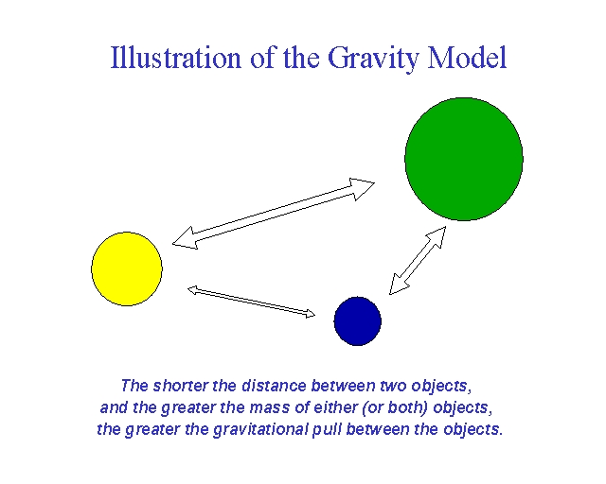
Urban hierarchy
- ________________________ of places on the basis of what _______________________ are available.
  - Certain services require a large customer ________________, so they can only be found in larger cities

One-Pager – must contain the following: 1 visual per key issue 2 vocab per issue; Text in your own terms “I learned...; I believe...”
Key 2
Key 1

Chapter 12 Services & Settlements

Key 3
Key 4

Urban Models – Draw and label each of the below models.
Burgess – Concentric Zone

Hoyt-Sector Model

Multiple-Nuclei Model

Urban Realms Model

Types of Services – List and Describe the different types of Services offered
Consumer Services

Business Services

Public Services

Central Place Theory – draw and describe the aspects of the Central Place Theory. Make sure to include the Range and Threshold

World Cities – the below image is the world cities
- What are world, or global, cities?

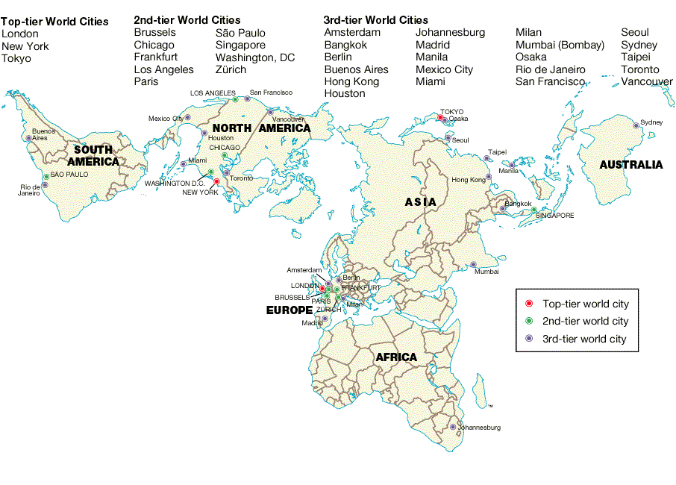

Rural Settlements – draw and describe the different rural settlements
Circular Rural Settlement

Linear Rural Settlement

Dispersed Rural Settlement

Food Deserts – research & identify a nearby food desert (yes there are some). What are the four criteria that makes a food desert? What are some ways to decrease food deserts?

One-Pager – must contain the following: 1 visual per key issue 2 vocab per issue; Text in your own terms “I learned...; I believe...”
Key 2
Key 1

Chapter 13 Urban Patterns

Key 3
Key 4

