ORGANIC STATE THEORY
The organic state theory was originally proposed by the German geographer Friedrich Ratzel in
1896. According to his theory, which is based on the theories of Darwin, the State can be compared to an organism in nature. It can be summarized as: “states are like organisms and need food to survive, so they must takeover territories (like eating food) to become stronger”. Therefore, for example, States, like plants and people, do not do well in desert or polar regions. States need food in the form of Lebensraum (living space) and resources, and they constantly compete for them. States, like organisms, must grow or die. They live through stages of youth, maturity, and old age, with possible rejuvenation. The vitality of a State can generally be gauged by its size at a given time.
The Swedish geographer Rudolf Kjellin took Ratzel's ideas to an extreme. He declared that the State, in fact, is an organism. Kjellin maintained that it was absolutely necessary for States to grow and expand their territory, population, and resource base for survival. The larger States would consume the weaker ones, until only a few large States remained. It is largely the association of Geopolitik with Nazi aggression that discredited the study of geopolitics for many years.

Mackinder's Heartland
Mackinder first proposed his Heartland theory in 1904. In his view, the entire continent of Eurasia was viewed as one landmass, with Europe being one of its peninsulas. He also described the combined continents of Eurasia and Africa as the World-Island. Mackinder designated the north central area of Eurasia as the Heartland. He also referred to it as the "Pivot Area," since control of this area was essential to control of the entire continent. He predicted that Russia, the owner of the Heartland, with its massive land power and abundant natural resources would have the capacity to challenge British and Japanese sea power and obtain control of all of Eurasia. Outside of the central Eurasian "Pivot Area" lay the "Inner or Marginal Crescent," which, on Mackinder's Eurasia-centered map, spanned from the Baltics around the European and Asian coasts to eastern Siberia. Control of this area would ensure the dominance of the Heartland power over the entire world. He proclaimed:
"Who rules East Europe commands the Heartland, Who rules the Heartland commands the World- Island, Who rules the World-Island commands the world."

Mackinder's Heartland concept as originally presented is illustrated in Figure 1. As can be seen from this illustration, the Heartland includes virtually all of the Soviet Union. Another map of Mackinder's concept is in Figure 2. At the end of WWII, it seemed as though Mackinder's prediction was coming true. One War Department analyst wrote: "'With Germany crushed, there is no power in Europe to oppose her [the Soviet Union's] tremendous military forces . . . The conclusions from the foregoing are obvious . . . without question she will dominate Europe on the defeat of the Axis.'" The Soviet Union had also made large territorial gains in Asia, obtaining portions of Manchuria, North Korea, and some Japanese islands.
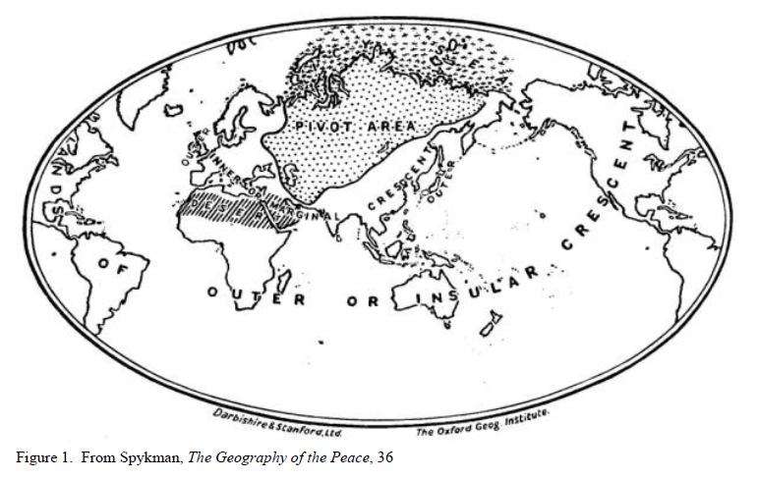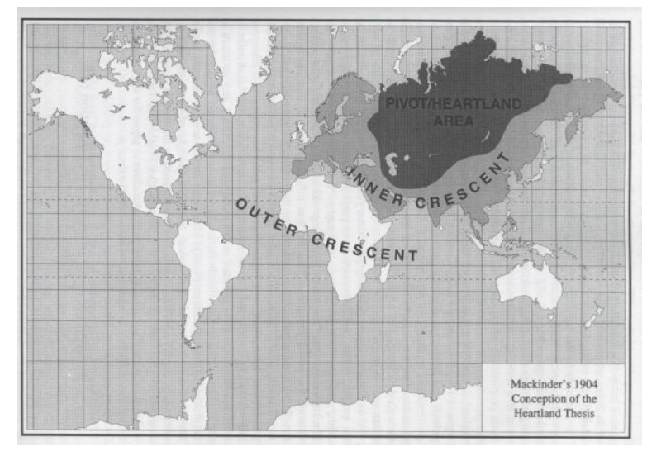

Spykman's Rimland
Mackinder’s Hearthland Theory was countered in 1944 by Spykman's Rimland theory. Spykman contended that the Heartland power would be immobilized by difficulties with internal lines of communication and lack of
mobility to expand beyond the physical barriers along its borders. Spykman felt that the domination of the Rimland (Mackinder's Marginal Crescent) would guarantee a naval and air power complete dominance over the earth. Spykman concluded, "Who controls the rimland rules Eurasia; who rules Eurasia controls the destinies of the world." Spykman's Rimland is depicted in Figure 3.

As can be seen in Figure 3, Spykman's Heartland and Rimland areas closely matched those depicted by Mackinder. However, the emphasis was on the Rimland and its position between the Heartland and the seas. The Rimland must be capable of contending both with the Heartland's land power, and the naval powers on its coasts. This unique advantage of the Rimland to compete with both forms of power is a significant advantage. In addition, the Rimland contains large material and population resources. 