

World History II 2008 SOLs
Students Worksheets

Standard WHII.2a
The student will demonstrate an understanding of the political, cultural, geographic, and economic conditions in the world about 1500 a.d. (c.e.) by
a) locating major states and empires.
1500s Geography

Write the letter of the location of some of the major states and empires in the Eastern Hemisphere in the next to the correct label.

_____England _____France _____Spain _____Russia

_____Ottoman Empire _____Persia _____China _____Mughal India

_____Songhai Empire

Location of major states and empires in the Western Hemisphere

_____Incan Empire _____Aztec Empire
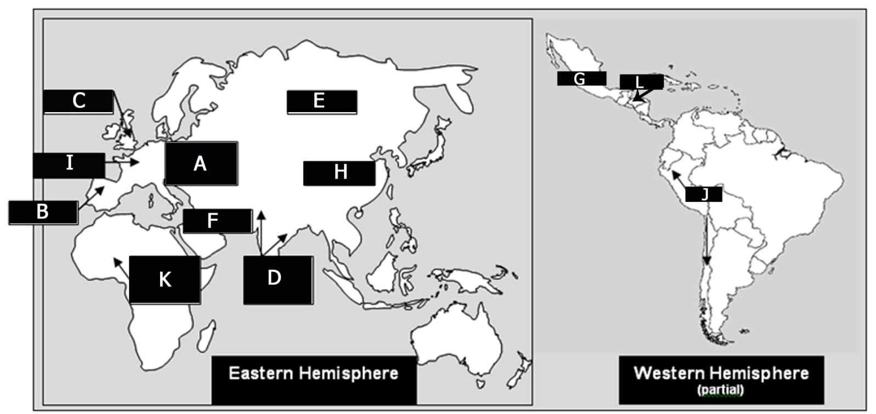

Standard WHII.2b
The student will demonstrate an understanding of the political, cultural, geographic, and economic conditions in the world about 1500 a.d. (c.e.) by
b) describing artistic, literary, and intellectual ideas of the Renaissance.
1500s European Culture
Renaissance
- “Rebirth” of ________________ knowledge (from Greece and Rome)
- “birth” of the ___________________ world (after Middle Ages)
- Spread of the Renaissance from _________________________to ___________________________

Contributions of the Renaissance
- Accomplishments in the visual arts: ________________________, ____________________________
- Accomplishments in literature (sonnets, plays, essays) were written by England’s famous playwright: __________________________
- Accomplishments in intellectual ideas (humanism): _______________________________ wrote the satire, Praise of Folly

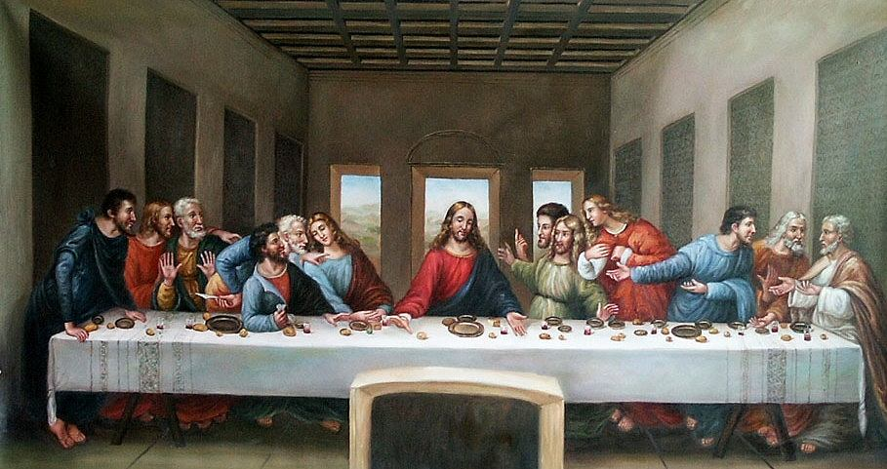
Match the works with their artists:
____________________
____________________

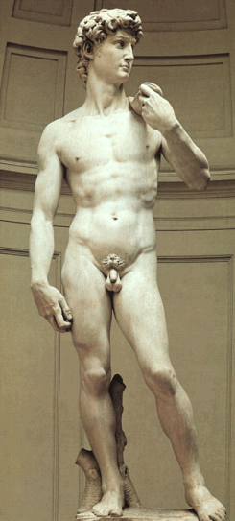
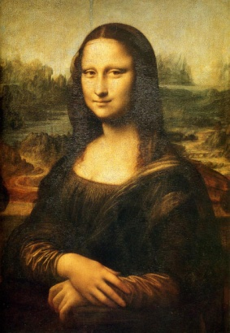

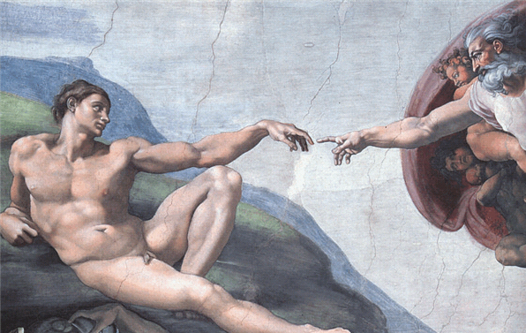

_______________

__________________

SOL WHII.2c
The student will demonstrate an understanding of the political, cultural, geographic, and economic conditions in the world about 1500 a.d. (c.e.) by
c) describing the distribution of major religions.
1500s Religion
Location of world religions in 1500 a.d. (c.e.)

- Judaism: Concentrated in _______________ and _______________

- Christianity: Concentrated in _______________ and _______________

- _______________: Parts of Asia, Africa, and southern Europe

- Hinduism: _______________ and part of Southeast Asia

- Buddhism: East and Southeast _______________

SOL WHII.2d
The student will demonstrate an understanding of the political, cultural, geographic, and economic conditions in the world about 1500 a.d. (c.e.) by
d) analyzing major trade patterns.
1500s Trade
Traditional trade patterns linking Europe with Asia and Africa
- Silk Routes across ___________ to the Mediterranean basin

- Maritime routes across the _____________ Ocean

- _______________________ routes across North Africa

- Northern European links with the ______________ Sea

- Western European sea and river trade

- ___________________ Sea and lands of Southeast Asia

Importance of trade patterns
- Exchange of _______________ and _______________

SOL WHII.2e
The student will demonstrate an understanding of the political, cultural, geographic, and economic conditions in the world about 1500 a.d. (c.e.) by
e) citing major technological and scientific exchanges in the Eastern Hemisphere.
1500s Technology and Trade
Advancements exchanged along trade routes

- _______________, _______________, _______________, _______________ (from China)

- Textiles, numeral system (_______________ and _______________)

- Scientific knowledge—medicine, astronomy, _______________

SOL WHII.3a
The student will demonstrate knowledge of the Reformation in terms of its impact on Western civilization by
a) explaining the effects of the theological, political, and economic differences that emerged, including the views and actions of Martin Luther, John Calvin, Henry VIII, and Elizabeth I.
Reformation
Conflicts that challenged the authority of the Church in Rome
- Merchant wealth challenged the Church’s view of _______________.
- German and English nobility disliked _______________ domination of the Church.
- The _______________ great political power and wealth caused conflict.
- Church corruption and the sale of _______________ were widespread and caused conflict.

Name the Protestant Reformers according to their descriptions

_______________
- Views: Salvation by faith alone, Bible as the ultimate authority, all humans equal before God
- Actions: 95 theses, birth of the Protestant Church

_______________
- Views: Predestination, faith revealed by living a righteous life, work ethic
- Actions: Expansion of the Protestant Movement

_______________ (the Anglican tradition)
- Views: Dismissed the authority of the Pope in Rome
- Actions: Divorced; broke with Rome; headed the national church in England; appropriated lands and wealth of the Roman Catholic Church in England

_______________
- Anglican Church
- Tolerance for dissenters
- Expansion and colonialism
- Victory over the Spanish Armada (1588)

SOL WHII.3b
The student will demonstrate knowledge of the Reformation in terms of its impact on Western civilization by
b) describing the impact of religious conflicts, the Inquisition, and Catholic Reformation on society and government actions.
Religious Turmoil
Reformation in Germany
- Princes in Northern Germany converted to _______________, ending the authority of the Pope in their states.
- The _______________ family and the authority of the Holy Roman Empire continued to support the Roman Catholic Church.
- Conflict between Protestants and Catholics resulted in devastating wars (e.g., The _______________ War).

Reformation in France
- Catholic monarchy granted Protestant Huguenots freedom of worship by the ________________________(which was later revoked).

- _______________ changed the focus of the Thirty Years’ War from a religious to a political conflict.

Catholic Reformation
- Dissenters prior to Martin Luther: Jan Huss, John Wycliffe
- Counter-Reformation:
  - The Council of _______________ reaffirmed most Church doctrine and practices.
  - The Society of Jesus (also known as the _______________) was founded to spread Catholic doctrine around the world.
  - The _______________ was used to reinforce Catholic doctrine violently.

SOL WHII.3c
The student will demonstrate knowledge of the Reformation in terms of its impact on Western civilization by
c) describing changing cultural values, traditions, and philosophies, and assessing the role of the printing press.
The World Wide Printing Press
Changing cultural values, traditions, and philosophies
- Growth of _______________ (worldly concerns)
- Growth of _______________ (focus on the individual)
- Eventual growth of religious tolerance

Role of the printing press
- Growth of literacy was stimulated by the printing press that was invented by _______________.
- The Bible was printed in _______________, _______________, and _______________.
- These factors had an important impact on spreading the ideas of the Reformation and the Renaissance.

Standard WHII.4a
The student will demonstrate knowledge of the impact of the European Age of Discovery and expansion into the Americas, Africa, and Asia by
a) explaining the roles and economic motivations of explorers and conquistadors.
The Impact and Economics of Exploration
Factors contributing to the European discovery of lands in the Western Hemisphere
- Demand for _______________, spices, and natural resources in Europe
- Support for the diffusion of the _______________ religion
- Political and economic competition between European empires
- Innovations of European and Islamic origins in navigational arts
- Pioneering role of _______________the Navigator of Portugal

Establishment of overseas empires and decimation of indigenous populations

Fill in the blanks with the European Explorers that best fit the descriptions:

Sailed for Name Description
Portugal |  | Sailed around Africa’s Cape of Good Hope and across the Indian Ocean to the coast of India. He made huge profits when he brought back spices.
Spain |  | An Italian who sail westward to reach Asia. He persuaded Queen Isabella of Spain to sponsor him. In October 1492 he reached the Americas. Columbus made four trips to the area he called the Indies.
Spain |  | He and his forces overthrew the Aztec Empire (in only three years). The Spanish had gained control of northern Mexico by 1550.
Spain |  | He and his forces conquered the Incan Empire. Much of South America came under Spanish control over the next few years.
Spain |  | His crew was the first to cross the Pacific Ocean and to circumnavigate (or sail around) the globe. He also explored the Philippine Islands turning the Philippines into a major Spanish base for trade in the Pacific.
England |  | He was the first Englishman to circumnavigate the globe. He also helped defeat the Spanish Armada.
France |  | He explored the St. Lawrence River to Montreal. His explorations led to France laying claim to Canada.

SOL WHII.4b
The student will demonstrate knowledge of the impact of the European Age of Discovery and expansion into the Americas, Africa, and Asia by
b) describing the influence of religion.
Religion in new Lands
Means of diffusion of Christianity
- Migration of _______________to new lands

- Influence of _______________and _______________colonists, who carried their faith, language, and cultures to new lands

- Conversion of _______________peoples

SOL WHII.4c
The student will demonstrate knowledge of the impact of the European Age of Discovery and expansion into the Americas, Africa, and Asia by
c) explaining migration, settlement patterns, cultural diffusion, and social classes in the colonized areas.
Migration
Americas
- Expansion of overseas territorial claims and European emigration to _______________and _______________
- Demise of _______________and _______________Empires
- Legacy of a rigid _______________and dictatorial rule in Latin America
- Forced migration of _______________who had been enslaved
- Colonies’ imitation of the culture and social patterns of their parent countries

Africa
- European trading posts along the coast
- Trade in _______________, _______________, and other resources

Asia
- Colonization by small groups of _______________ (in India, the Indies, China)
- Influence of trading companies (such as the _______________, _______________, and British)

SOL WHII.4d
The student will demonstrate knowledge of the impact of the European Age of Discovery and expansion into the Americas, Africa, and Asia by
d) describing the Columbian Exchange, including its impact on native populations.
Early Globalism
Columbian Exchange
- Western Hemisphere agricultural products, such as ______________, ______________, and ______________, changed European lifestyles.
- European ______________and ______________changed the lifestyles of American Indians.
- European diseases, such as ______________, killed many American Indians.

Impact of the Columbian Exchange
- Shortage of labor to grow cash crops led to the use of ______________.
- Slavery was based on ______________.
- European ______________system in the Caribbean and the Americas destroyed indigenous economics and damaged the environment.

SOL WHII.4e,f
The student will demonstrate knowledge of the impact of the European Age of Discovery and expansion into the Americas, Africa, and Asia by
e) mapping and explaining the triangular trade;
f) describing the impact of precious metal exports from the Americas.
Triangle Trade
The ______________trade linked Europe, Africa, and the Americas.

______________, ______________, and ______________were traded.

Export of precious metals
- ______________and ______________exported to Europe and Asia
- Impact on indigenous empires of the Americas
- Impact on Spain and international trade

SOL WHII.5a
The student will demonstrate knowledge of the status and impact of global trade on regional civilizations of the world after 1500 a.d. (c.e.) by
a) describing the location and development of the Ottoman Empire.
The Ottomans and Trade
Original location of the Ottoman Empire
______________

Expansion and extent of the Ottoman Empire
- Southwest Asia
- Southeastern Europe, Balkan Peninsula
- North Africa
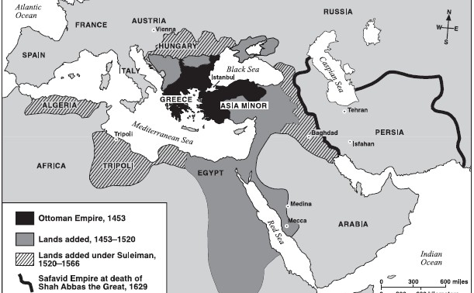

Development of the Ottoman Empire
- Capital at Constantinople renamed ______________
- ______________religion as a unifying force that accepted other religions
- Trade in ______________and ______________

SOL WHII.5b
The student will demonstrate knowledge of the status and impact of global trade on regional civilizations of the world after 1500 a.d. (c.e.) by
b) describing India, including the Mughal Empire and coastal trade.
Trade and India
Location of the Mughal Empire
________________

Contributions of Mughal rulers
- Spread of ________________into India
Art and architecture: ________________
- Establishment of European trading outposts
- Influence of Indian textiles on British textile industry

Trade with European nations
- ________________, ________________, and ________________competed for the Indian Ocean trade by establishing coastal ports on the Indian sub-continent.
- Southern India traded ________________, ________________, and ________________.

Standard WHII.5c
The student will demonstrate knowledge of the status and impact of global trade on regional civilizations of the world after 1500 a.d. (c.e.) by
c) describing East Asia, including China and the Japanese shogunate.
Trade and Asia
China
- Creation of ________________to control trade
- Imperial policy of controlling foreign influences and trade
- Increase in European demand for Chinese goods (such as ________________ and ________________)

Japan
- Feudal system
- Characterized by a powerless ________________controlled by a military leader (known as the ________________)
- Adopted policy of ________________to limit foreign influences

SOL WHII.5d
The student will demonstrate knowledge of the status and impact of global trade on regional civilizations of the world after 1500 a.d. (c.e.) by
d) describing Africa and its increasing involvement in global trade.
Africa and Trade
African exports
- ________________ (triangular trade)
- Raw materials (such as ________________ and ________________)

African imports
- ________________from Europe, Asia, and the Americas
- New food products (such as ________________ and ________________)

Standard WHII.5e
The student will demonstrate knowledge of the status and impact of global trade on regional civilizations of the world after 1500 a.d. (c.e.) by
e) describing the growth of European nations, including the Commercial Revolution and mercantilism.
Business
Terms to know
- ________________: An economic practice adopted by European colonial powers in an effort to become self-sufficient.
It is based on the theory that colonies existed for the benefit of ________________________________

Commercial Revolution
- European maritime nations competed for overseas markets, colonies, and ________________.
- A new economic system emerged:
  - New money and ________________systems were created.
  - Economic practices such as mercantilism evolved.
  - ________________economies were limited by the economic needs of the mother country.

SOL WHII.6a
The student will demonstrate knowledge of scientific, political, economic, and religious changes during the sixteenth, seventeenth, and eighteenth centuries by
a) describing the Scientific Revolution and its effects.
A Revolution in Science
Name the following pioneers of the scientific revolution

- ________________developed heliocentric theory.

- ________________discovered planetary motion.

- ________________used telescope to support heliocentric theory.

- ________________formulated law of gravity.

- ________________discovered circulation of the blood.

Importance of the scientific revolution
- Emphasis on reason and systematic observation of ________________
- Formulation of the ________________method
- Expansion of scientific knowledge

SOL WHII.6b
The student will demonstrate knowledge of scientific, political, economic, and religious changes during the sixteenth, seventeenth, and eighteenth centuries by
b) describing the Age of Absolutism, including the monarchies of Louis XIV and Peter the Great.
Absolute Rule
Characteristics of absolute monarchies

- ________________of power (all focused on one person)

- Concept of rule by ________________ (God selected the king to keep power no matter what)

Examples of Absolute monarchs

- Louis XIV of France: had the Palace of ________________ built as a symbol of royal power
What is the Roman numeral “XIV” in Arabic numerals?: _____

- Czar ________________ of Russia: Westernized Russia

SOL WHII.6c
The student will demonstrate knowledge of scientific, political, economic, and religious changes during the sixteenth, seventeenth, and eighteenth centuries by
c) assessing the impacts of the English Civil War and the Glorious Revolution on democracy.
The Evolution of Democracy
Place the letter of the following developments of English rights in the proper box below.

- Glorious Revolution (William and Mary)
- Increase of parliamentary power and decrease of royal power
- Oliver Cromwell and the execution of Charles I
- English Bill of Rights of 1689
- Development of political parties/factions
- The restoration of Charles II

The English Civil War was basically a power struggle between the English monarchy beginning with James I of the Stuart dynasty and Parliament. When the war broke out, a Puritan leader led Parliament’s troops (known as the Roundheads) against the Cavaliers or supporters of King Charles I.
After Parliament’s victory in the war, Oliver Cromwell ruled as “Lord Protector” for a series of years. His rule was dictatorial and he did not have a clear successor. When he died the Stuart dynasty was restored with a king sometimes known as the “Merry Monarch.”
The Tories supported the king’s policies and the Whigs supported Parliament.
James II (brother to Charles II) was an unpopular King who was an open and devout Catholic and made religion a cause of conflict between the Parliament and the King. When James and his second wife had a son in 1688, a group of English noblemen asked the Dutch leader, (along with his wife) to invade England. (his wife was James II’s Protestant daughter). James II fled the country, and with almost no bloodshed, The king and queen assumed the throne.
The English Civil War and the Glorious Revolution both resulted in an increase in power for the Parliament. This idea of a limited monarchy was very different than the absolute monarchy seen in other countries at this time—with France being one example.
When Parliament offered the throne to William and Mary, William and Mary had to agree to sign a document which laid out specific rights of Parliament and placed limits on royal power.

SOL WHII.6d
The student will demonstrate knowledge of scientific, political, economic, and religious changes during the sixteenth, seventeenth, and eighteenth centuries by
d) explaining the political, religious, and social ideas of the Enlightenment and the ways in which they influenced the founders of the United States.
A Revolution in Thought
The Period known as the _________________
- Applied reason to the human world, as well as to the rest of the natural world
- Stimulated religious tolerance
- Fueled democratic revolutions around the world

Enlightenment thinkers and their ideas
- _________________ wrote Leviathan: Humans exist in a primitive “state of nature” and consent to government for self-protection.
- _________________ wrote Two Treatises on Government: People are sovereign and consent to government for protection of natural rights to life, liberty, and property.
- _________________ wrote The Spirit of Laws: The best form of government includes a separation of powers.
- _________________ wrote The Social Contract: Government is a contract between rulers and the people.
- _________________: Argued that religious toleration should triumph over religious fanaticism; separation of church and state.

Influence of the Enlightenment
- Political philosophies of the Enlightenment fueled revolution in the Americas and _________________.
- The Declaration of Independence, written by _________________ incorporated Enlightenment ideas.
- The _________________ of the United States of America and Bill of Rights incorporated Enlightenment ideas.

SOL WHII.6e
The student will demonstrate knowledge of scientific, political, economic, and religious changes during the sixteenth, seventeenth, and eighteenth centuries by
e) describing the French Revolution.
The French Revolution
Causes of the French Revolution
- Influence of _________________ ideas
- Influence of the _________________ Revolution

Events of the French Revolution
- Storming of _________________
- Reign of _________________

Outcomes of the French Revolution
- End of the absolute monarchy of _________________
- Rise of _________________

SOL WHII.6f
The student will demonstrate knowledge of scientific, political, economic, and religious changes during the sixteenth, seventeenth, and eighteenth centuries by
f) describing the expansion of the arts, philosophy, literature, and new technology.
Who’s who?
Representative composers, artists, philosophers, and writers
- __________________________________: Baroque composer
- __________________________________: Classical composer
- _________________: Philosopher (French)
- _________________: Novelist (Spanish)
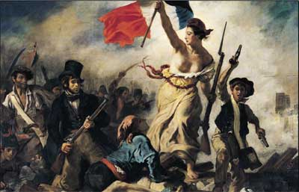
- _________________: Painter (transition to the Romantic School of the nineteenth century; Liberty Leading the people)

Liberty Leading the People
New schools of art and forms of literature
- Painting depicted classical subjects, public events, natural scenes, and living people (portraits).
- New forms of literature evolved, such as the novel (e.g., Don Quixote, written by ____________________).

Technologies
- ____________________improved year- round transport and trade.
- New designs in farm tools increased productivity (known as the ____________________ revolution).
- Improvements in ____________________design lowered the cost of transport.

SOL WHII.7a
The student will demonstrate knowledge of the Latin American revolutions of the nineteenth century by
a) describing the colonial system as it existed by 1800.
Colonies in 1800
Characteristics of the colonial system
- Colonial governments mirrored the home governments.

- ____________________had a strong influence on the development of the colonies.

- A major element of the economy was the mining of ____________________for export.

Examples of Major cities that were established as outposts of colonial authority.

  - _______________ in Cuba

  - _______________ in Mexico

  - _______________ in Peru

  - _______________ in Brazil

  - _______________ in Argentina

Rigid class structure
- Viceroys / colonial officers

- ____________________ (people of European descent born in the Americas)

- ____________________ (people of Native American and European heritage)

SOL WHII.7b
The student will demonstrate knowledge of the Latin American revolutions of the nineteenth century by
b) identifying the impact of the American and French Revolutions on Latin America.
Revolutions
Influence of the American and French Revolutions on Latin America
- Slaves in the country of _______________ rebelled, abolished slavery, and won independence.
- Father _______________ started the Mexican independence movement.
- _______________, _______________, and _______________ colonies gained independence.

Selected countries that gained independence during the 1800s
- Mexico
- Haiti
- Colombia
- Venezuela
- Brazil

SOL WHII.7c
The student will demonstrate knowledge of the Latin American revolutions of the nineteenth century by
c) explaining the contributions of Toussaint L’Ouverture and Simón Bolivar.
Revolutionary Leaders
Contributions of ________________________
- Former slave who led Haitian rebellion against French
- Defeated the armies of three foreign powers: Spain, France, and Britain

Contributions of _________________________
- Native resident who led revolutionary efforts in Latin America
- Liberated the northern areas of Latin America
- Bolivia bears his name

SOL WHII.7d
The student will demonstrate knowledge of the Latin American revolutions of the nineteenth century by
d) assessing the impact of the Monroe Doctrine.
US Foreign Policy
Impact of the Monroe Doctrine
- The Monroe Doctrine was issued by President ______________________ in 1823.

- ___________________ nations were acknowledged to be independent.

- The United States would regard as a threat to its own peace and safety any attempt by European powers to impose their system on any independent state in the ________________ Hemisphere.

Standard WHII.8a
The student will demonstrate knowledge of political and philosophical developments in Europe during the nineteenth century by
a) assessing the impact of Napoleon and the Congress of Vienna, including changes in political boundaries in Europe after 1815.
Napoleon and the Congress of Vienna
Legacy of Napoleon
- _______________ attempt to unify Europe under ____________________
- ___________________________
- Awakening of feelings of ____________________ and growth of _______________________

Legacy of the Congress of Vienna

Standard WHII.8b
The student will demonstrate knowledge of political and philosophical developments in Europe during the nineteenth century by
b) describing unsuccessful revolutions on the continent and political reform in the United Kingdom.
Political Developments in Europe
National pride, economic _________________, and ________________ideals stimulated the growth of ________________.

The terms of the Congress of Vienna led to widespread discontent in Europe, especially in __________ and the ____________ states. Unsuccessful revolutions of 1848 ________________ nationalistic tensions.

In contrast to continental Europe, the ________________________ expanded political rights through _____________ means and made slavery illegal in the British Empire.

Standard WHII.8c
The student will demonstrate knowledge of political and philosophical developments in Europe during the nineteenth century by
c) explaining events related to the unification of Italy and the role of Italian nationalists;
Unification of Italy
Unification of Italy
- Count Cavour unified _________________________.
- Giuseppe Garibaldi joined ___________________________ to northern Italy.
- The ___________________________ (including Rome) became the last to join Italy.

Locate and shade in unified Italy on the map of Europe below:
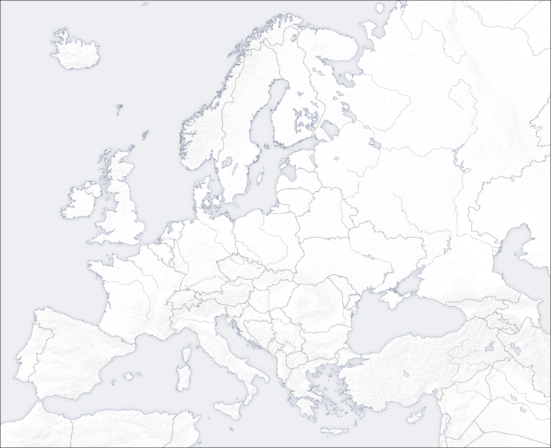
http://upload.wikimedia.org/wikipedia/commons/f/f4/Template_europe_map.png

Standard WHII.8d
The student will demonstrate knowledge of political and philosophical developments in Europe during the nineteenth century by
d) explaining events related to the unification of Germany and the role of Bismarck.

Unification of Germany
Unification of Germany
- Otto von Bismarck led _______________ in the unification of _______________ through ______ and by appealing to _______________ feelings.
- Bismarck’s actions were seen as an example of _______________, which justifies all means to achieve and hold power.
- The ______________________________ led to the creation of the German state.

Locate and shade in unified Germany on the map of Europe below:
http://upload.wikimedia.org/wikipedia/commons/f/f4/Template_europe_map.png

Standard WHII.9a
The student will demonstrate knowledge of the effects of the Industrial Revolution during the nineteenth century by
a) citing scientific, technological, and industrial developments and explaining how they brought about urbanization and social and environmental changes.
Industrial Revolution

Industrial Revolution
- Originated in _______________ because of its natural resources (e.g., ______, ______ ore) & the invention & improvement of the ___________ _________________.
- Spread to Europe and the __________ ______________.
- Role of __________ textile, ________, and _________ industries
- Relationship to the British ___________________ ___________________
- Rise of the _________ system and demise of ____________ industries
- Rising economic powers that wanted to ____________ raw materials and markets throughout the world

Technological advances that produced the Industrial Revolution
- Spinning jenny: ___________________
- Steam engine: ___________________
- Cotton gin: ___________________
- Process for making steel: ___________________

Advancements in science and medicine
- Development of smallpox vaccination: ___________________
- Discovery of bacteria: ___________________

Impacts of the Industrial Revolution on industrialized countries
- ___________________
- ______________________________________
- ___________________
- ___________________
- ___________________
- ___________________
- _________________________________________________________
- ______________________________________

Standard WHII.9b
The student will demonstrate knowledge of the effects of the Industrial Revolution during the nineteenth century by
b) explaining the emergence of capitalism as a dominant economic pattern, and the subsequent development of socialism and communism.
Economic Systems
Capitalism
- Adam Smith’s ______________________________
- Role of market _______________ and _______________ abilities
- Impact on ______________________________ and the growth of the __________________
- Dissatisfaction with poor _______________ conditions and the _______________ distribution of wealth in society
Socialism and communism
- Karl Marx’s ______________________________ (written with Friedrich Engels) and __________________
- Response to the _______________ of _______________
- Importance to communists of _______________ of wealth

Standard WHII.9c
The student will demonstrate knowledge of the effects of the Industrial Revolution during the nineteenth century by
c) describing the evolution of the nature of work and the labor force, including its effects on families, the status of women and children, the slave trade, and the labor union movement.
Effects of the Industrial Revolution

The nature of work in the factory system
- Family-based cottage industries displaced by the _______________ system
- ___________ working conditions with men competing with _______________ and _______________ for wages
- Child labor that kept costs of production _____ and profits _______
- _______________ of mines and factories who exercised considerable control over the lives of their laborers

Impact of the Industrial Revolution on slavery
- The ___________________ increased demand for __________ labor on American plantations.
- The United States and Britain _______________ the slave trade and then slavery.

Social effects of the Industrial Revolution
- Women and children entering the workplace as ______________________
- Introduction of _______________ to end child labor
- Expansion of _______________
- Women’s increased demands for _______________

The rise of labor unions
- Encouraged worker-organized ____________ to demand increased _______________ and improved working conditions
- _______________ for laws to improve the lives of workers, including women and children
- Wanted workers’ rights and _______________ _______________ between labor and management

Standard WHII.9d, e
The student will demonstrate knowledge of the effects of the Industrial Revolution during the 19th century by
d) explaining the rise of industrial economies and their link to imperialism and nationalism;
e) assessing the impact of European economic and military power on Asia and Africa, with emphasis on the competition for resources and the responses of colonized peoples.
European Imperialism
_______________ motivated European nations to compete for colonial _______________. European _______________, _______________, and _______________ power forced colonized countries to trade on _______________ terms. _______________ goods flooded colonial markets and displaced their _______________ industries. Colonized peoples resisted European domination and responded in diverse ways to Western influences.
Forms of imperialism

Imperialism in Africa and Asia
- _______________ domination
- European conflicts carried to the _______________
- _______________ missionary efforts
- Spheres of influence in _________
- _______________ in Africa
- ______________________________ domination of Indian states
- America’s opening of ___________ to trade
Responses of colonized peoples
- Armed conflicts (e.g., events leading to the __________ Rebellion in China)
- Rise of nationalism (e.g., first _____________________________ founded in the mid-1800s)

Standard WHII.10a
The student will demonstrate knowledge of the worldwide impact of World War I by
a) explaining economic causes, political causes, and major events and identifying major leaders of the war, with emphasis on Woodrow Wilson and Kaiser Wilhelm II;
World War I
Causes of World War I
- __________ that divided Europe into competing camps
- N__________ feelings
- Diplomatic __________
- __________
- __________ over colonies
- M__________
Major events
- __________ of Austria’s Archduke Ferdinand
- United States enters the war
- __________ leaves the war
Major leaders
- Woodrow __________
- __________ Wilhelm II

Standard WHII.10b
The student will demonstrate knowledge of the worldwide impact of World War I by
b) explaining the outcomes and global effect of the war and the Treaty of Versailles.
WWI Outcomes and the Treaty of Versailles
Outcomes and global effect
- _________ participation in the war, which _________ demands for independence
- End of the _________ Imperial, _________, _________, and __________________ empires
- Enormous _____ of the war in lives, property, and social disruption
Treaty of Versailles
- Forced _________ to accept responsibility for war and loss of territory and to pay _________
- Limited the German _________
- _________ of _________

Standard WHII.10c
The student will demonstrate knowledge of the worldwide impact of World War I by
c) citing causes and consequences of the Russian Revolution.
Russian Revolution
Causes of 1917 revolutions
- Defeat in war with _________ in 1905
- _________ peasantry
- Incompetence of Tsar __________________
- Military defeats and high casualties in __________________
Rise of communism
- _________ Revolution and civil war
- Vladimir Lenin’s _________ _________ _________
- Joseph _________, Lenin’s successor

Standard WHII.11a
The student will demonstrate knowledge of political, economic, social, and cultural developments during the Interwar Period by
a) describing the League of Nations and the mandate system.
League of Nations and Mandate System
League of Nations
- _____________ cooperative organization
- Established to prevent future ________
- United States _______ a member
- Failure of League because it did not have power to _____________ its decisions
The mandate system
- During World War I, ___________ and ___________ agreed to divide large portions of the ___________ Empire in the Middle East between themselves.
- After the war, the “mandate system” gave Great Britain and France control over the lands that became Iraq, Transjordan, and Palestine (___________ controlled) and Syria and Lebanon (___________ controlled).
- The division of the Ottoman Empire through the ___________ ___________ planted the seeds for future conflicts in the Middle East.
Label the countries that were part of the mandate system. Those controlled by France, shade blue. Those controlled by Britain, shade red. Or create your own key.
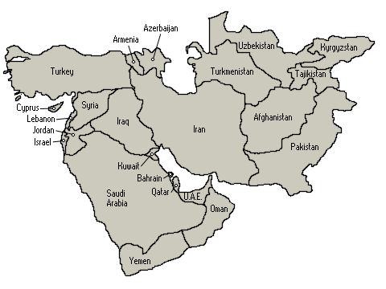

http://www.map-zone.net/img/continent/middle-east/map.gif
Standard WHII.11b
The student will demonstrate knowledge of political, economic, social, and cultural developments during the Interwar Period by
b) citing causes and assessing the impact of worldwide depression in the 1930s.
Interwar Period
Causes of worldwide depression
- _______________________
- Expansion of production capacities and dominance of the ______________________ in the global economy
- ________ protective tariffs
- Excessive expansion of ________
- ________________________ of 1929
Impact of worldwide depression
- High ________________ in industrial countries
- ________ failures and collapse of credit
- Collapse of ________ in world trade
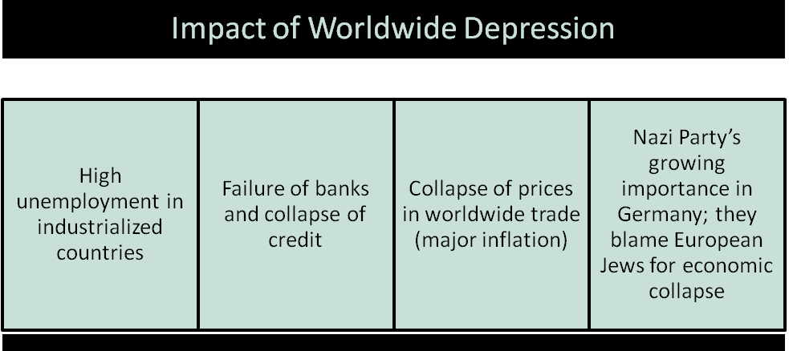
- ________ Party’s growing importance in ________; Nazi Party’s blame of European ________ for economic collapse

Standard WHII.11c
The student will demonstrate knowledge of political, economic, social, & cultural developments during the Interwar Period by
c) examining events related to the rise, aggression, and human costs of dictatorial regimes in the Soviet Union, Germany, Italy, and Japan, and identifying their major leaders, i.e., Joseph Stalin, Adolf Hitler, Benito Mussolini, Hirohito, and Hideki Tojo.
Interwar Period

U.S.S.R. during the Interwar Period — Joseph Stalin
- Entrenchment of __________
- Stalin’s policies: Five-year plans, __________ of farms, state industrialization, secret __________
- Great __________

Germany during the Interwar Period — Adolf Hitler
- Inflation and __________
- Democratic government __________
- Anti-__________
- Extreme __________
- National __________ (Nazism)
- German __________ of nearby countries

Italy during the Interwar Period — Benito Mussolini
- Rise of __________
- Ambition to restore the glory of __________
- Invasion of __________

Japan during the Interwar Period — Hirohito and Hideki Tojo
- M____________________
- Industrialization of Japan, leading to drive for raw __________
- Invasion of __________, Manchuria, and the rest of __________

Standard WHII.12a
The student will demonstrate knowledge of the worldwide impact of World War II by
a) explaining economic and political causes, describing major events, and identifying leaders of the war, with emphasis on Franklin D. Roosevelt, Harry Truman, Dwight D. Eisenhower, Douglas MacArthur, George Marshall, Winston Churchill, Joseph Stalin, Adolf Hitler, Hideki Tojo, and Hirohito.
World War II

Economic and political causes of World War II
- Aggression by the ___________ powers of Germany, Italy, Japan
- N___________
- Failures of the Treaty of ___________
- Weakness of the ___________ of Nations
- A___________
- Tendencies towards ___________ and ___________ in Europe and the United States

Major events of the war (1939–1945)
- German invasion of ___________ (193__ )
- Fall of ___________ (194__ )
- Battle of ___________ 194__ )
- German invasion of the ___________ ___________ (194__ )
- ___________ attack on Pearl Harbor (194__ )
- D-Day (Allied invasion of ___________) (194 __)
- Atomic bombs dropped on ___________ and ___________ (194__ )

Major leaders of the war
- Franklin D. Roosevelt: U.S. ___________
- Harry Truman: U.S. ___________ after death of President Roosevelt
- Dwight D. Eisenhower: Allied commander in ___________
- Douglas ___________: U.S. general
- George ___________: U.S. general
- Winston Churchill: ___________ prime minister
- Joseph Stalin: ___________ dictator
- Adolf Hitler: ___________ dictator of Germany
- Hideki Tojo: ___________ general
- Hirohito: Emperor of ___________

Standard WHII.12b
The student will demonstrate knowledge of the worldwide impact of World War II by
b) examining the Holocaust and other examples of genocide in the twentieth century.
Holocaust and Genocide
Terms to know
___________: The systematic and purposeful destruction of a racial, political, religious, or cultural group
Elements leading to the Holocaust
- Totalitarianism combined with ___________
- History of anti-___________
- Defeat in World War I and economic ___________ blamed on German Jews
- Hitler’s belief in the ___________ race
- Final solution: Extermination ___________, gas ___________
Other examples of genocide
- ___________ by leaders of the Ottoman Empire
- Peasants, government and military leaders, and members of the elite in the Soviet Union by ___________ ___________
- Artists, technicians, former government officials, monks, minorities, and other educated individuals by Pol Pot in ___________
- Tutsi minority by Hutu in ___________

Standard WHII.12c
The student will demonstrate knowledge of the worldwide impact of World War II by
c) explaining the terms of the peace, the war crimes trials, the division of Europe, plans to rebuild Germany and Japan, and the creation of international cooperative organizations and the Universal Declaration of Human Rights (1948).
World War II Outcomes

Outcomes of World War II
- Loss of ___________ by European powers
- Establishment of two major powers in the world: The ______________________ and the ___________
- War crimes ___________
- Division of Europe, ______________________
- Establishment of the ______________________
- The Universal Declaration of __________________
- ___________ Plan
- Formation of North ___________ Treaty Organization (NATO) and ___________ Pact

Efforts for reconstruction of Germany
- ___________ government installed in West Germany and West Berlin
- Germany and Berlin divided among the four ___________powers
- Emergence of ________ Germany as economic power in postwar Europe

Efforts for reconstruction of Japan
- United States occupation of ___________ under MacArthur’s administration
- ___________ and economic development
- Elimination of Japanese ___________ military capabilities; guarantee of Japan’s security by the ____________________
- Emergence of Japan as dominant economy in ______

International Cooperative Organizations

The Universal Declaration of Human Rights
- Established and adopted by members of the ______________________
- Provided a code of conduct for the treatment of people under the ________________ of their government

Standard WHII.13a,b
The student will demonstrate knowledge of major events in the second half of the twentieth century by
a) explaining key events of the Cold War, including the competition between the American and Soviet economic and political systems and the causes of the collapse of communism in the Soviet Union and Eastern Europe;
b) assessing the impact of nuclear weaponry on patterns of conflict and cooperation since 1945.
Cold War

Beginning of the Cold War (1945–1948)
- The ___________ Conference and the Soviet control of Eastern Europe (Divided Germany)
- Rivalry between the ___________ ___________ and the ___________ (Superpowers)
- ___________ and the free enterprise system vs. ___________ and communism
- President Truman and the Policy of ___________ (keep Communism where it existed)
- Eastern Europe: Soviet satellite nations, the _____ ________

Characteristics of the Cold War (1948–1989)
- North ___________ Treaty Organization (NATO) vs. ___________ Pact
- ___________ Conflict (1950-1953)
- ___________ War (1964-1973 for US)
- Berlin and significance of ________ Wall
- ________ Missile Crisis
- Nuclear weapons and the theory of ___________

Collapse of communism in the Soviet Union and Eastern Europe
- ___________ economic collapse
- ___________ in Warsaw Pact countries
- Tearing down of ___________ Wall
- ___________ of the Soviet Union
- ___________ of NATO

Standard WHII.13c
The student will demonstrate knowledge of major events in the second half of the twentieth century by
c) describing conflicts and revolutionary movements in eastern Asia, including those in China and Vietnam, and their major leaders, i.e., Mao Tse-tung (Zedong), Chiang Kai-shek, and Ho Chi Minh.
Revolutions in Eastern Asia
Terms to know
___________: A policy for preventing the expansion of communism
Conflicts and revolutionary movements in China
- Division of China into two nations at the end of the ___________ civil war
- Chiang Kai-shek (Jiang Jieshi): ___________ China (island of ___________)
- Mao Tse-tung (Mao Zedong): ___________ China (mainland China)
- Continuing conflict between the two Chinas
- Communist China’s participation in ___________ Conflict
Conflicts and revolutionary movements in Vietnam
- Role of ___________ Imperialism
- Leadership of ______________________
- Vietnam as a ___________ nation
- Influence of policy of ___________
- The ___________ ___________ and their involvement in the Vietnam War
- Vietnam as a reunited ___________ country today

Standard WHII.13d
The student will demonstrate knowledge of major events and outcomes of the Cold War by
d) describing major contributions of selected world leaders in the second half of the twentieth century, including Indira Gandhi, Margaret Thatcher, Mikhail Gorbachev, and Deng Xiaoping.
Late 20th Century Leaders
Indira Gandhi
- Closer relationship between ___________ and the Soviet Union during the Cold War
- Developed ___________ program
Margaret Thatcher
- ___________ prime minister
- Free trade and less government regulation of ___________
- Close relationship with ___________ ___________ and U.S. foreign policy
- Assertion of United Kingdom’s ___________ power
Mikhail Gorbachev
- G___________ and p___________
- Fall of the ___________ Wall
- Last president of ___________ ___________
Deng Xiaoping (pronounced: Dung-Shou Ping the “Shou” is like shower)
http://inogolo.com/pronunciation/d1064/Deng_Xiaoping
- Reformed ___________ China’s economy to a market economy leading to _________ economic growth
- Continued ___________ control of government

India’s Independence

Regional setting for the Indian independence movement

Evolution of the Indian independence movement
- __________ rule in India
- Indian National __________
- Leadership of Mohandas __________
- Role of civil __________ and passive __________
- Political division along __________ -__________ lines — Pakistan/India
- Republic of __________
- World’s largest __________ nation
- Federal system, giving many __________ to the states

Indian democracy
- Jawaharlal __________, a close associate of Gandhi, supported western-style __________.
- 1950 Constitution sought to prohibit __________ discrimination.
- Ethnic and religious __________ caused problems in the development of India as a democratic nation.
- New economic development has helped to ease __________ problems of the nation.

Standard WHII.14b
The student will demonstrate knowledge of political, economic, social, and cultural aspects of independence movements and development efforts by
b) describing Africa’s achievement of independence, including Jomo Kenyatta’s leadership of Kenya and Nelson Mandela’s role in South Africa.
20th Century Africa
The independence movement in Africa
- Right to self-___________ (U.N. charter)
- Peaceful and violent ___________ after World War II
- Pride in ___________ cultures and heritage
- Resentment of ___________ rule and economic exploitation
- Loss of ___________ by Great Britain, France, Belgium, and Portugal; influence of ___________ rivalry during the Cold War
Examples of independence movements and subsequent development efforts
- West Africa: ___________ transition
- Algeria: _____ of Independence from France
- Kenya (Britain): Violent struggle under leadership of _________ ___________
- South Africa: Black South Africans’ struggle against ___________ led by Nelson ___________, who became the first black ___________ of the Republic of South Africa
Locate and label Kenya, Algeria and South Africa on the Africa map. Shade in the region of West Africa.
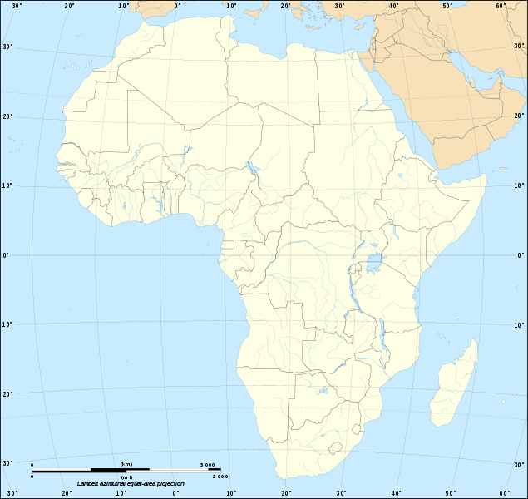
http://upload.wikimedia.org/wikipedia/commons/7/79/Africa_map_blank.svg
Standard WHII.14c
The student will demonstrate knowledge of political, economic, social, and cultural aspects of independence movements and development efforts by
c) describing the end of the mandate system and the creation of states in the Middle East, including the role of Golda Meir and Gamal Abdul Nasser.
Creation of Middle East States
Mandates in the Middle East
- Established by the League of ___________
- Granted ___________ after World War II
- Resulted in Middle East ___________ created by ___________ differences
French mandates in the Middle East
- ___________
- ___________
British mandates in the Middle East
- ___________ (originally Transjordan)
- ___________ (a part became independent as the State of Israel)
Golda Meir
- Prime Minister of ___________
- After initial setbacks, led Israel to victory in ______________________
- Sought support of ___________ ___________
Gamal Abdul Nasser
- President of ___________
- Nationalized _______ ________
- Established relationship with ________ _________
- Built _________ High Dam

Standard WHII.15a
The student will demonstrate knowledge of the influence of Judaism, Christianity, Islam, Buddhism, and Hinduism in the contemporary world by
a) describing their beliefs, sacred writings, traditions, and customs.
World Religions

Judaism
- M______________
- Ten ______________of moral and religious conduct
- __________: Written records and beliefs of the Jews

Christianity
- M______________
- __________ as Son of God
- Life after death
- New ______________: Life and teachings of Jesus
- Establishment of Christian doctrines by early ____________ ____________

Islam
- M______________
- Muhammad, the ___________
- Qur’an (Koran)
- _______ ________ of Islam
- Mecca and Medina

Buddhism
- Founder: _____________ _______________ (Buddha)
- Four Noble Truths
- Eightfold Path to ______________
- Spread of Buddhism from India to China and other parts of Asia, resulting from ______________ missionaries and their writings

Hinduism
- ______ _________of one God
- ______________: Rebirth based upon karma
- ___________: Knowledge that all thoughts and actions result in future consequences

Standard WHII.15b
The student will demonstrate knowledge of the influence of Judaism, Christianity, Islam, Buddhism, and Hinduism in the contemporary world by
b) locating the geographic distribution of religions in the contemporary world.
Geography of World Religions
Geographic distribution of world’s major religions
- Judaism: Concentrated in ______________ and ___________ _______________
- ______________: Concentrated in Europe and North and South America
- Islam: Concentrated in the Middle East, ______________, and Asia
- ______________: Concentrated in India
- Buddhism: Concentrated in East and Southeast ___________
Locate and label on the map where these religions are highly concentrated.
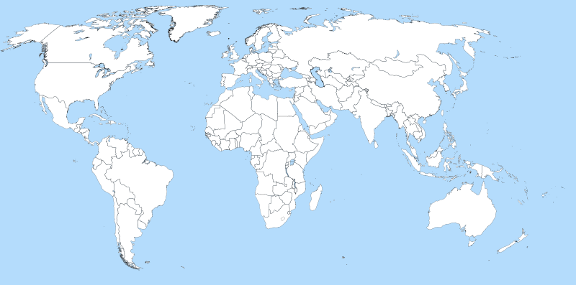http://wikimediafoundation.org/wiki/File:A_large_blank_world_map_with_oceans_marked_in_blue.svg

Standard WHII.16a
The student will demonstrate knowledge of cultural, economic, and social conditions in developed and developing nations of the contemporary world by
a) identifying contemporary political issues, with emphasis on migrations of refugees and others, ethnic/religious conflicts, and the impact of technology, including chemical and biological technologies.
Contemporary Issues
Migrations of refugees and others
- ______________as an issue in international conflicts
- Migrations of “guest workers” to ______________cities
Ethnic and religious conflicts

Impact of new technologies
- Widespread but unequal access to ______________ and instantaneous communications
- ______________ engineering and ______________

Standard WHII.16b
The student will demonstrate knowledge of cultural, economic, and social conditions in developed and developing nations of the contemporary world by
b) assessing the impact of economic development and global population growth on the environment and society, including an understanding of the links between economic and political freedom.
Developed and Developing Nations

Contrasts between developed and developing nations
- __________ locations of major developed and developing countries
- __________ conditions
- Social conditions (__________, access to _________ ________)
- Population size and rate of __________

Factors affecting environment and society
- __________development
- Rapid __________ growth

Environmental challenges

Social challenges

Relationship between economic and political freedom
- Free market economies produce __________ standards of living and an expanding __________ class, which produces growing demands for political __________ and individual rights. Recent examples include __________ and __________ __________.

Standard WHII.16c
The student will demonstrate knowledge of cultural, economic, and social conditions in developed and developing nations of the contemporary world by
c) describing economic interdependence, including the rise of multinational corporations, international organizations, and trade agreements.
Economic Interdependence
Economic interdependence
- Role of rapid transportation, communication, and __________ networks
- Rise and influence of __________ corporations
- Changing role of international __________
- Regional integration, e.g., __________ __________
- Trade agreements, e.g., North __________ Free Trade Agreement (NAFTA), World __________ Organization (WTO)
- International organizations, e.g., United __________ (UN), International __________ Fund (IMF)

Standard WHII.16d
The student will demonstrate knowledge of cultural, economic, and social conditions in developed and developing nations of the contemporary world by
d) analyzing the increasing impact of terrorism.
Terrorism
Examples of international terrorism
- Munich __________
- Terrorist attacks in the United States (e.g., 9/11/2001) motivated by __________ (Osama bin Laden).
- Car __________
- __________ bombers
- Airline __________
Governmental responses to terrorist activities
- S__________
- Review of __________rights
- Security at ports and __________
- __________ badges and photos

