Abolition of Gerrymandering
We have discussed how ridiculous and bias gerrymandering is. It will be our job, as a class, to completely redistrict the entire United States within the U.S. House of Representatives. The only information that may be used is the 2010 census report that deals only with total population. No other variables will be considered. However, certain rules must be followed to keep the redistricting as non-bias as possible.

Rules
- Each district should be as close to 710,000 citizens as possible. However, each state will have a slightly different number, based on their population. -309,000,000/435=approximately 710,000
- Congressional Districts should follow county or county subdivision lines. -Certain urban areas must be broken up into county subdivisions
- Each district must be connected and must hold a general shape.
- Each state must keep the same number of congressional seats as the 2010 census has granted.
- Every state must have at least 1 representative.

Current Number of U.S. Representatives Per State

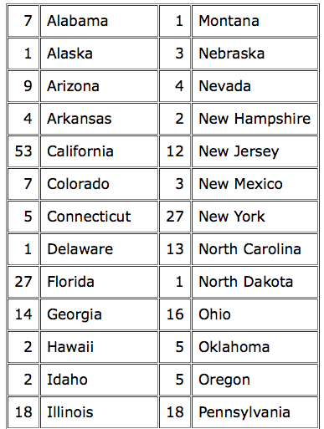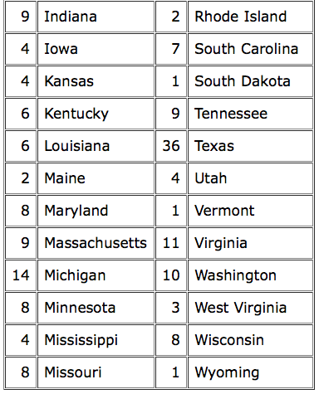

Choose 1 of 17 regions in which you will be redistricting.

1. California 2. Texas 3. Florida 4. New York
Arkansas

5. Illinois 6. Pennsylvania 7. Ohio 8. Michigan
Iowa West Virginia Kentucky Indiana

9. South Carolina 10. Washington 11. Maine 12. New Jersey
Georgia Oregon Vermont Delaware
Alaska New Hampshire Maryland
Idaho Massachusetts
Nevada Connecticut
Utah Rhode Island

13. Virginia 14. Tennessee 15. Wisconsin 16. Missouri
North Carolina Alabama Minnesota Oklahoma
Mississippi North Dakota Kansas
Louisiana South Dakota
Nebraska
Montana
Wyoming
17. Hawaii
Arizona
New Mexico
Colorado

Directions
*To access the U.S. census page, type in www.census.gov/2010census/popmap/

*Click on the “TOTAL POPULATION” icon 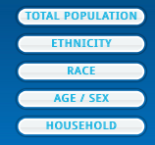

*Enter your given state in the “Enter a location” box

*Click on your chosen state to unveil the total population of the state. Once found, divide that number by the number of districts within your state to compute the number of people within each district. For example, Texas has a population of 25,145,561 and 36 districts. Once divided, each district will have around 698,000 people within each of the 36 districts.

*Click on the County icon in the Geographical Levels menu. 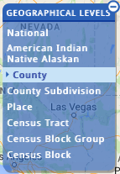

*Scroll over each county to decipher the 2010 county population. Manipulate the size with

*If the county is too large, click on the County Subdivision in the same Geographical Levels menu.

* Redistrict your state by drawing in lines on your blank state maps with only counties represented. Label each district in a numerical order. Please begin with a pencil and the final product should utilize different colors for each district.

